PR Catalogue
Individual First Aid Kit – IFAK.
Quantity Required – 15 Kits.
Kits MUST Include the Following:

- Lightweight, Durable First Aid Bag.
- Molle design with rip-away panel for easy access.
- RED Colour preferred.
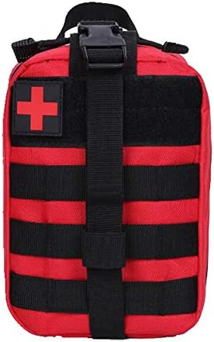

- Non-Sterile Examination Gloves.
- Nitrile Gloves Preferred.
- BLUE Colour Preferred.
- 3 Pairs Per Kit.

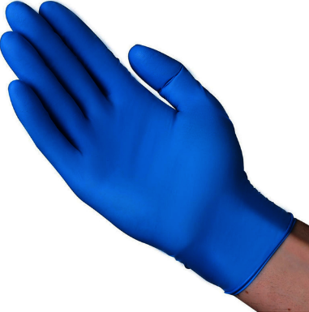
- Combat Application Tourniquet.
- 2 PER KIT.
- TQ-Dnipro Gen 2, CAT Gen 7 or SICH are the only acceptable brands.
- Orange Colour Preferred.
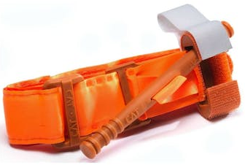
- Permanent Marker.
- Sharpie or Equivalent Quality.
- RED or BLACK ink preferred.
- 1 Per Kit.
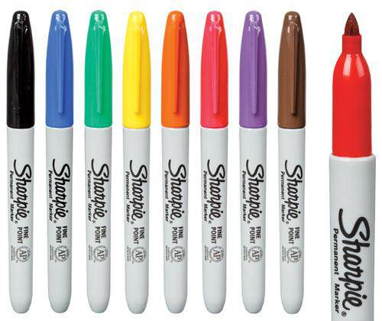
- High Quality Paramedic Shears.
- 14 cm total length at a minimum.
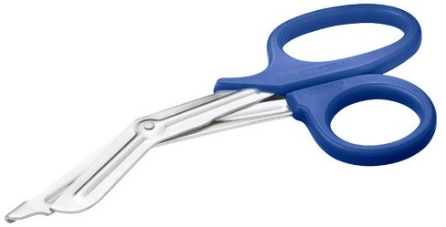
- Emergency Trauma Bandage 4” – with Mechanical Advantage.
- Preferably not OLAES bandage.
- 1 Per Kit.
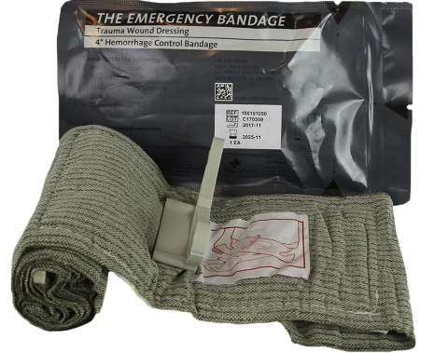
- Emergency Trauma Bandage 6” – with Mechanical Advantage.
- Preferably not OLAES bandage.
- 1 Per Kit.
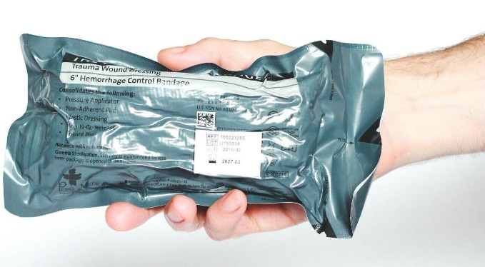

- Haemostatic Gauze – Z-Fold.
- QuickClot Combat Gauze preferred, but local analogues are acceptable.
- Not Single Napkins – 7.62cm x 3.66m Required.
- 1 Per Kit.
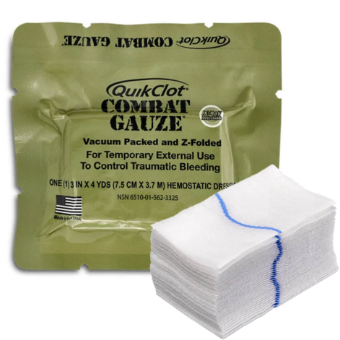

- Sterile Compressed Gauze – Z-Fold.
- 1 Per Kit.
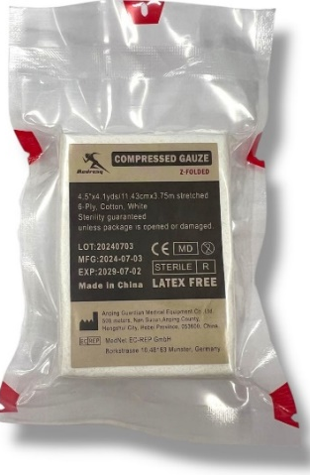
- Occlusive Chest Seal – Combination Pack.
- Includes 1x Vented and 1x Non-Vented Chest Seal.
- Beacon Preferred.
- 1 Per Kit.
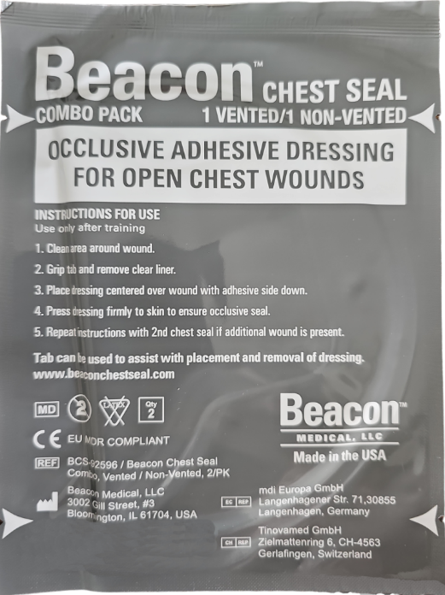
- Elastic Crepe Bandage – 75mm.
- 1 Per Kit.
