ANNEX 2. SPECIFICATION OF METAL-PLASTIC PRODUCTS FOR REPAIR OF WINDOW AND DOOR OPENINGS OF REDKIVSKY LYCEUM OF NOVOBILOUSK VILLAGE COUNCIL OF CHERNIGIV DISTRICT OF CHERNIGIV REGION
(DOORS)
Quantity
pcs./м2
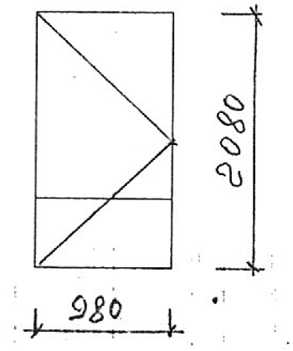 | 1/2,04
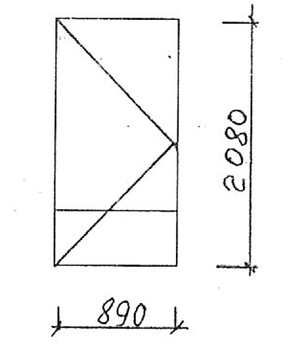 | 1/1,85
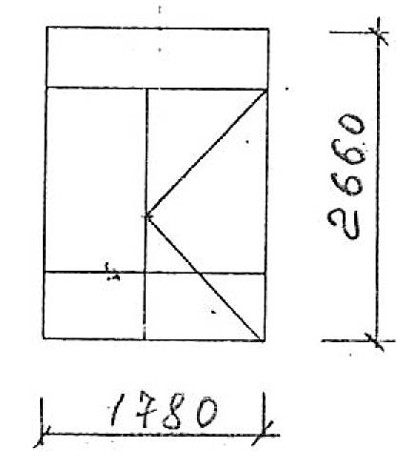 | 1/4,73
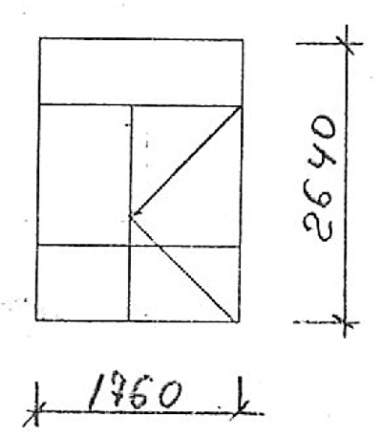 | 1/4,66
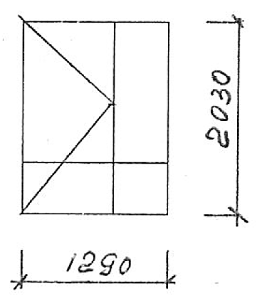 | 1/2,62

