ANNEX 1. SPECIFICATION OF METAL-PLASTIC PRODUCTS FOR REPAIR OF WINDOW AND DOOR OPENINGS OF REDKIVSKY LYCEUM OF NOVYI BILOUS VILLAGE COUNCIL OF CHERNIHIV DISTRICT OF CHERNIHIV REGION
(Windows)
Quantity
pcs./м2
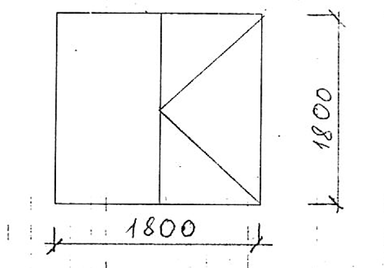 | 2/6,48
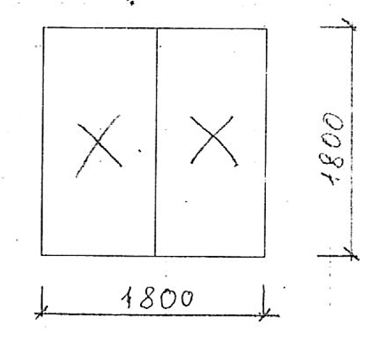 | 3/9,72
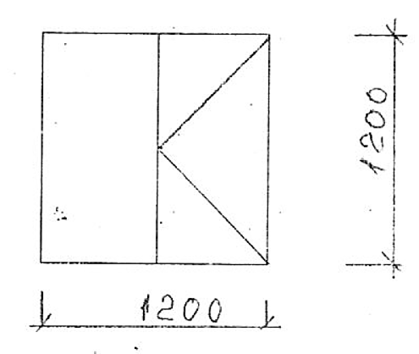 | 2/2,88
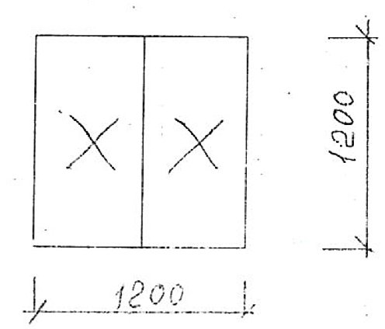 | 1/1,44

