expression of interest forM
I – Identification of the contracting authority
Expertise France (SAS)
A simplified joint-stock company with share capital of €828 933
40 Boulevard de Port-Royal, 75005 PARIS
II – Purpose of the call for tenders
This call for tenders pertains to Development the online interactive course on EU Law Advanced for judges and prosecutors.
III – Identification of the tenderer
[Specify the status, the trade name and the company name of the tenderer, the addresses of its establishment and its registered office (if it is different from that of the establishment, its e-mail address, telephone and fax numbers and SIRET number; otherwise, a European or international identification number or an ID specific to the country of origin of the tenderer.]
IV – Purpose of the expression of interest
This expression of interest is submitted as part of the call for tenders for Development the online interactive course on EU Law Advanced for judges and prosecutors.
V – Information on registration with a professional register
The tenderer must provide proof that it is registered with a professional register (e.g.: ‘extrait Kbis’ for company established in France or an equivalent document).
VI – Information on the economic and financial capacity of the tenderer
[The economic and financial capacity of the tenderer will be assessed on the basis of the relevant information provide details about its implementation capacity qualifying the eligibility of the expression of interest as defined in the notice].
VII – Information on the tenderer’s references
[The technical and professional capacity of the tenderer will be assessed on the basis of the relevant information provide details about its implementation capacity qualifying the eligibility of the expression of interest as defined in the notice].
VIII – Proof of fulfilment of tax and social security obligations
The tenderer shall prove that it has fulfilled its tax and social security obligations, by providing any means of proof (latest URSSAF certificate or available equivalent, last tax certificate or an available equivalent, etc.)
IX – Sworn statement
The tenderer fills in, dates and signs the sworn statement relating to the exclusion criteria and the absence of conflict of interest provided in the Appendix to this form.
X - Tenderer identification sheet and Bank account details
The tenderer fills in, dates and signs the “third party identification sheet” provided in the Appendix and must include bank account details.
Some countries or banks do not issue bank account details. In this case, the tenderer also gets the “Third party identification sheet” signed from the banking establishment.
SIGNATURE
Signature of the person authorised to engage and represent the tenderer
Last name:  First name:  Role: | I declare that I am applying as part of the call for tenders referred to in point II above.  Date:  Signature:

SWORN STATEMENT ON EXCLUSION CRITERIA, THE ABSENCE OF CONFLICT OF INTEREST
[Fill-in or remove the greyed-out, italicised parts in brackets]

Purpose of the contract: Development the online interactive course on EU Law Advanced for judges and prosecutors

The undersigned (name of the signatory of this form):
- full official name:
- official legal form:
- full official address:

- acting in his/her own name (in the case of an application by a physical person with legal personality):
or
- acting as representative of the following legal entity:

- declares that he/she/it is not in any of the situations referred to in articles L. 2141-1 to L 2141-11 of the French Public procurement code, and in particular those in which he/she/it:
- has been sentenced by a judgment of a competent authority of a Member State having the force of res judicata for any offense affecting his/her/its professional integrity;
- or any member of the management, administrative, executive or supervisory or a physical person who has powers of representation, of decision or of control over the abovementioned legal person has not been convicted as referred to in point (a);
- has not complied with his/her/its obligations relating to the payment of social security contributions or obligations relating to the payment of taxes in accordance with the legal provisions of the country where he/she/it is established or those of the contracting authority’s country or those of the country where the contract is to be executed;
- is in a state or is the subject of bankruptcy, liquidation, judicial settlement proceedings or an arrangement with creditors, cessation of activity, or is in any similar situation resulting from proceedings of the same kind under the national laws and regulations;
- has been subject to an administrative penalty issued by a State, by the European Union, by Expertise France, by any Developing Bank or by any International Organization;
In the hypothesis of such a decision of exclusion, we can join to the present declaration on honor the additional information which would allow to consider that this decision of exclusion is not relevant within the framework of the market.

- declares that he/she/it:
- is not in a conflict of interest in relation to the contract;
- will promptly inform the contracting authority about any situation constituting a conflict of interest or likely to lead to a conflict of interest;
- has not granted, sought, requested or accepted, and undertakes not to grant, seek, request, or accept, financially or in kind, any benefit for or on behalf of any person where such benefit is an illegal practice or amounts to corruption, directly or indirectly, in the form of a gift or reward in relation to the award of the contract;
- has provided accurate and complete information to the contracting authority in the context of this procurement procedure;

- acknowledges that he/she/it may be subject to judicial, administrative and financial penalties if it is established that misrepresentations have been made or that false information has been provided.
- In the event of award of the contract, the following details must be provided upon request and within the deadline set by the contracting authority:
For the cases mentioned in points (1), a recent extract from the criminal record is required or, failing that, a recent equivalent document, issued by a judicial or administrative authority of the country of origin, showing that the requirements concerned are met.
With regard to the situations described in points (1), when a document referred to in the two paragraphs above is not issued in the country concerned, it may be replaced by a sworn statement or, failing that, a solemn declaration, made by the person concerned before a judicial or administrative authority, a notary or a qualified professional body of the country of origin.
If the tenderer is a legal entity, information concerning individuals having the power of representation, decision or control over that legal entity must be provided only at the request of the contracting authority.

- declares that he/she:
- do not acquire and don't supply/will not acquire or supply equipment and do not intervene/will not intervene in sectors under embargo by the United Nations, the European Union or France;
- is not included in the lists of financial sanctions adopted by the United Nations, the European Union, France and/or the United States, notably in the fight against the financing of terrorism and against attacks on national peace and security. For information, the lists can be consulted at the references below:
- for the United Nations, the United Nations Security Council sanctions lists: https://www.un.org/securitycouncil/content/un-sc-consolidated-list,
- for the European Union, the lists can be consulted at the following address: https://www.sanctionsmap.eu,
- for France, see: https://gels-avoirs.dgtresor.gouv.fr/List ;
- for the United States, see: https://home.treasury.gov/policy-issues/financial-sanctions/sanctions-programs-and-country-information,
- is not subject to a World Bank exclusion order and are not on the list published by the World Bank. For information, the list can be consulted at the following address: https://www.worldbank.org/en/projects-operations/procurement/debarred-firms

- acknowledge and accept that the above-mentioned situations may lead to the automatic termination of the contract.

- undertake to inform Expertise France without delay of any change in our situation during the execution of the Contract with regard to the present declaration.

- declares that it has read the provisions of this statement and undertakes to comply with them throughout the procurement procedure.

Signature of a person authorised to engage and represent the tenderer
This insert is to be signed in the case of an expression of interest filed by a legal entity
Last name:  First name:  Role: | Date:  Signature:

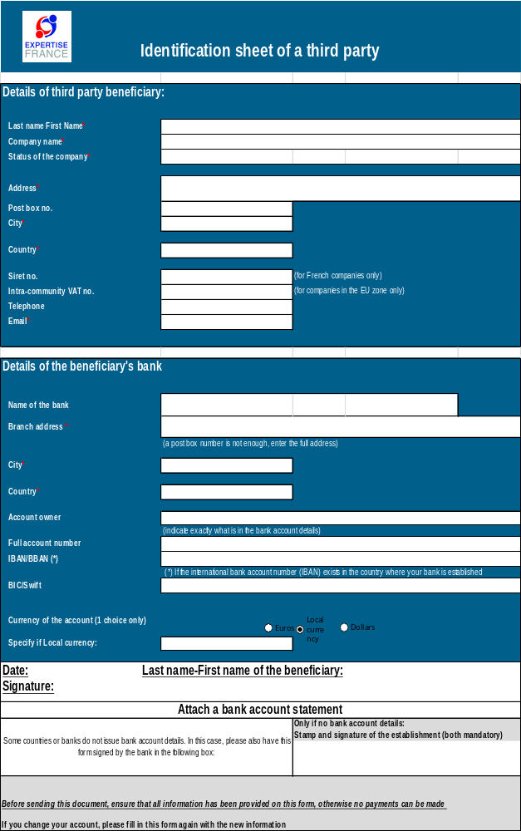


Recent certificates or letters issued by the competent authorities of the relevant State are required. These documents must provide proof of payment of all taxes, duties and social security contributions for which the tenderer is liable, including VAT, income tax (individuals only), corporation tax (legal entities only) and social security costs.
a conflict of interest may result from economic interests, political or national affinities, family or emotional ties, or any other type of relationship or common interests;
If the tenderer is a legal entity and the national law of the country in which it is established does not provide for the provision of such proof for legal entities, these documents are required for the relevant individuals, such as company managers or any person having the power of representation, decision or control of the tenderer.

