TERMS OF REFERENCE

TC9: TC Project Support - Monitoring, Evaluation and Project Management Consultant

Ukraine Reforms Architecture (URA 2.0)
Location: Kyiv Regional Office, EBRD (remote as needed)
Duration: 12 months, with a possibility of extension

- Background

The Ukraine Reforms Architecture (URA) is a comprehensive technical assistance programme deployed by the EBRD, in partnership with the European Union, to support critical reform processes in Ukraine. It is financed from the Ukraine Stabilisation and Sustainable Growth Multi-Donor Account (MDA) managed by the EBRD.
URA was designed as a holistic mechanism for stimulating systemic change in Ukraine’s public institutions and improving the business climate in the country. URA fills the critical capacity gaps in Ukraine’s public institutions by supplying reform talent at all levels of government. Since 2016, more than 200 Ukrainian reformers have worked in the project’s various components and contributed to dozens of reform outcomes, strategies and policies.
URA’s operations rest on a number of cornerstone principles: providing support to committed reform champions, ensuring sustainability of reform capacity-building efforts through implementation of Public Administration Reform (PAR), drawing on Ukrainian reform talent and ensuring local ownership of the reform process, and offering demand-driven, results-oriented and flexible assistance in focal points of Ukraine’s public administration.

- The Project – Extension of “Support for Institutions under the Ukraine Reforms Architecture (URA) project for Ukraine”, phase - URA 2.0

Project Overview
The “Support for Institutions under the Reform Support Architecture for Ukraine” (Ukraine Reforms Architecture - URA) project is a comprehensive framework designed to stimulate implementation and delivery of critical reforms in Ukraine. It is composed of two mutually reinforcing components:
• The Reforms Delivery Office (RDO) placed in the Cabinet of Ministers of Ukraine, coordinating and overseeing the reform processes across the Ukrainian administration
• Reform Support Teams (RSTs) currently embedded in nine Ministries and agencies to manage the implementation of sectoral reforms. RSTs are a group of Ukrainian experts, hired from outside the public administration, with the overall objective of facilitating implementation of key reforms and establishing a new generation of reform-oriented Ukrainian citizens motivated to enter public service in support of processes of change and modernisation of Ukraine’s Government at all levels. They provide targeted, temporary expert support to assist Ministries and agencies in the design and implementation of priority sectoral reforms and restructuring of the Ministries themselves. RSTs are active at the Ministry of Finance, Ministry for Development of Economy, Trade and Agriculture, Ministry of Communities and Territories Development, Ministry of Infrastructure, Ministry of Energy and Environment Protection, Ministry of Education and Science, State Agency of Automobile Roads (Ukravtodor), State Customs Service and State Customs Service.

URA 2.0 organisational structure

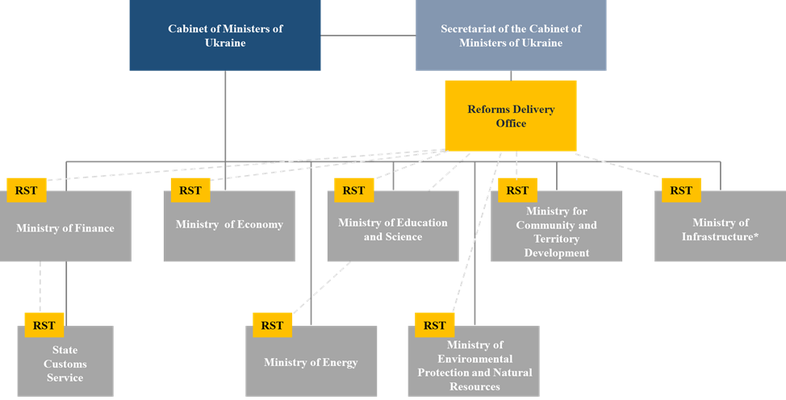

Our teams are working on the wide array of priority reform areas, among which are Public Finance Management, Tax and Customs, State-owned Banks and Improvement of International Financial Cooperation Process, Privatization and State-owned Enterprises, Business Climate Improvement, Public Administration Reform, E-governance and Anticorruption, Climate Policy, Water Resources and Waste Management, Energy Efficiency, Transport (Railway, Road, Maritime, Inland Waterways, Aviation), Construction Industry, Education (secondary and vocational), Social Security System and Land Reform.

Phase - URA 2.0 Outline
The project will continue to facilitate transition to a modern, effective and efficient public administration by temporarily filling existing capacity gaps and helping to develop structures, processes, practices and capacity of the new civil service.
URA 2.0 will:
- Provide focused support to a narrowed range reform priorities
- Reinforce sustainability
- Strengthen results management with comprehensive results-focused monitoring and evaluation

- Objectives of the Consultancy Assignment

In light of the growing project scope and the increasing demand from various Ministries and
institutions to receive support under the second phase of the URA project, the need for a Monitoring, Evaluation and Project Management Consultant (the ‘Consultant’) remain essential.

The Consultant will:
- support the design of new assignments under the URA and other governance projects in Ukraine;
- ensure effective implementation of the current ones;
- support the mobilization and utilization of funding;
- liaise with a number of teams inside the Bank (Donor Co-Financing, Grant Review, the Procurement Team, Communications, Banking and others);
- monitor and evaluate progress achieved;
- maintain liaison;
- coordinate and monitor of the project with the “Ukraine Reforms Architecture Foundation” (the Foundation);
- support the policy dialogue with key external stakeholders (including Ukrainian government counterparts, the EU and other international donors).

The Consultant will belong to the EBRD Kyiv Regional Office, with possibility of remote work as required by the security situation in Ukraine.

- Scope of Services and Tasks
The Consultant will be responsible for the following:

- Ensure the smooth running and implementation of current assignments under the URA and other MDA governance projects, jointly with other members of the Project team (Operation Leader and Project Management Consultants based in EBRD Headquarters and the Kyiv Regional Office);
- Lead the development and implementation of a result-oriented Monitoring & Evaluation System for the projects, with the involvement of the EBRD Evaluation Department and EU and EU4PAR experts;
- Monitor and evaluate progress of actions achieved and supported by the various strands of the Reforms Architecture;
- Ensure timely submission of Quarterly Progress Reports by RSTs and other URA-funded teams/units. Assess the reported progress and identify risks and obstacles for the timely implementation of the key reform deliverables;
- Coordinate the process of contracting and involvement of an independent (external) evaluator(s);
- Monitor, evaluate and lead on the process of selection of experts for RSTs and other URA-funded teams/units, ensuring compliance with the requirements of the Manual and adherence to a transparent and competitive process;
- Contribute to maintaining close liaison with operational teams in relevant Ministries, Agencies, Cabinet of Ministers of Ukraine, URAF, EU and other donor counterparts;
- Provide support to monitoring and control of budget activities of the assignments under all streams of the projects;
- Support the Operation Leader and Senior Consultants in their negotiations on priority reform areas with government counterparts as well as liaise internally with sector experts to coordinate input on sector-related elements of the project in order to finalize Letters of Understanding and supporting documents;
- Assist the Operation Leader and Senior Consultants with internal and external communication of the projects and participate in coordination activities with other donors;
- Support the Project team in preparing necessary information for the Grant Review, Procurement, and Donor Co-Financing (DCF) teams regarding all streams of the projects, including drafting of Bank documents related to the projects’ progress and performance and reporting for donors; review documents prepared by more junior team members;
- Perform ad hoc assignments, including monitoring and evaluation of the specific policy developments; contributing to preparation of presentations for Senior Management and coordination and facilitation of the external events related to the Project;
- Participate in internal and external meetings and events, where appropriate;
- Any other relevant tasks as requested by the Operation Leader.

- Profile
- Advanced degree in a relevant field, such as economics, politics, law, public policy or political economy;
- Relevant experience in policy or public administration, international financial institutions, donor organizations or business environment, including strong understanding of the ongoing reforms processes in Ukraine or other EBRD recipient countries;
- Strong experience in monitoring and evaluation of donor funded projects, including understanding of results-based M&E approaches;
- Experience managing projects in a multi-cultural environment and delivering results;
- Understanding of economic reforms, economic regulation, governance, public administration and political economy issues in the transition region and knowledge of economics/finance will be considered an advantage;
- Ability to operate independently in political, diplomatic and business environments; diplomatic skills required for regular contact with senior national and international officials;
- Ability to juggle multiple streams and tasks at the same time with a positive and proactive attitude,
- Exceptional communication and writing skills in English, at the standard required for official documents;
- Fluency in English, Ukrainian and Russian is a must.

- Reporting and Deliverables
The Monitoring, Evaluation and Project Management Consultant will report to Anna Kozhemiachenko (Principal Counsellor, Governance and Political Affairs, EBRD Kyiv Regional Office) and the Senior Consultant based in London.

The Consultant will liaise with key counterparts internally and externally including:
London and Kyiv-based consultants, the EBRD’s Grant Review, Procurement and Donor Co-Financing teams, the EU teams in Brussels and Kyiv, the EBRD Kyiv Regional Office, and as necessary with the members of URA, representatives of donors, international organizations, civil society and business, external consultants and experts.

The Consultant shall carry out all the scope of services as set out above under Section 4 in a timely manner.

The key deliverables include:

- Preparation of project documents, including Letters of Understanding, project proposals, concept notes, budgets, tenders;
- Implemented Monitoring & Evaluation System for the project;
- Regular reporting on project implementation;
- Visibility and communication with international donors, clients and other consultants.

- Application information
To apply for this position, please submit your CV and Cover Letter (both in English) to Yuliya Anikeeva at anikeevy@ebrd.com by 25 May 2022.

Contributors to the MDA are Denmark, Finland, France, Germany, Italy, Japan, the Netherlands, Norway, Poland, Sweden, Switzerland, the United Kingdom, the United States and the European Union, the largest donor.

