European Solidarity Corps
Volunteering

Application to join Schuman volunteers
in 2021/2022

PART 1. PERSONAL INFORMATION

Your data

First name:
Surname:
Date of birth:
Gender:
Nationality:
Current address:
Mobile number:
E-mail address:
European Solidarity Corps Number:

Emergency contact person

Name:
Who is this person to you (friend, family member, etc.):
Address:
Telephone:
E-mail address:

Your Supporting Organization from your country (if you have one, if not- leave this space empty)
Name: | Kremenchuk informative-elucidative center “European Club”
Address: | Address: Sofijivska str., 36b, Kremenchuk 39617, Ukraine
Phone: | Phone: +380501449467
E-mail: | E-mail: euroclub.kremen@gmail.com
Contact person: | Olena Glazkova

PART 2. CURRICULUM VITAE

Please describe briefly characteristics of your personality

My strengths:
My weaknesses:
My free time:
My dreams:

Present situation

Employment status:
(if you work, please indicate where)
Formal education:
(please indicate the level and profile of education)
Non-formal education (trainings, courses etc.):

Volunteering experience

Have you ever participated in EVS, Erasmus+ or European Solidarity Corps volunteering? (mark with an “X”)

No
Yes (If yes, when?, for how long?, what kind of activities you took part during your volunteering project

Remember that if you took part in EVS, Erasmus+ or European Solidarity Corps volunteering for more than 2 months you can’t apply for a long-term European Solidarity Corps project.

If you have any other volunteering experience, please specify in what organizations and when did you do the volunteer work, what type of work was it, what were your responsibilities and what did you learn.

Experiences in international contexts
(abroad, with people from other countries or cultures)

Language skills

Language | Level : mother tongue/fluent/good/basic/ beginner

PART 3. SCHUMAN VOLUNTEERS AND PARTICULAR HOSTING ORGANISATION

Please indicate which HOSTING ORGANIZATION you apply to* (mark with an “X”):
The Polish Robert Schuman Foundation (OID number: 065927-ORG-00001)
European Integration Club at the School Complex in Wojkowice (OID number: 065927-ORG-00020)
Association of Developing Children's Activity “Chance” (OID number: 065927-ORG-00023)
Special Kindergarten No 393 in Warsaw (OID number: 065927-ORG-00013)
Special Kindergarten No 245 for Visually Impaired Children in Warsaw (OID number: 065927-ORG-00008)**
Special Kindergarten No 213 in Warsaw (OID number: 065927-ORG-00005)
Kindergarten No 146 in Warsaw (OID number: 065927-ORG-00002)
Primary School with integrative classes No 318 in Warsaw (OID number: 065927-ORG-00010)**
Bilingual Primary School no 1 in Warsaw ( OID number: E10023966)

* you can apply to more than one Hosting Organization
* if you apply to more than one organization please remember to answer questions A-D below for all selected organizations
** you cannot apply for this vacancies anymore

- Please describe your motivation and expectations of volunteering in this SELECTED HOSTING ORGANIZATION (What attracts you in this Hosting Organization?)

- How do you think your day will look like at your SELECTED HOSTING ORGANIZATION?

- Describe your experiences, skills and knowledge that you have and that you think might be useful for carrying out the volunteer tasks in SELECTED HOSTING ORGANIZATION

- What difficulties can you imagine during your activities in SELECTED HOSTING ORGANIZATION?

- What do you hope to learn from this volunteering experience?

- What are your plans after this volunteering project?

- What activities would you propose to organize together with other volunteers to promote volunteering?

PART 4. ADDITIONAL INFORMATION

Please remember that none of the listed below situations can prevent you from taking part in the European Solidarity Corps programme. Social inclusion and promoting diversity are the base of this programme. We need this information to be able to provide you appropriate support before and during the mobility.

Are you facing any situation(s) that might make your participation in volunteering activities more difficult (disability, health problems, barriers linked to discrimination of any kind, economic difficulties, cultural differences, social difficulties etc.)?*

Do you have any other special needs that the organization should be aware of to support your participation properly (diet, allergies, mobility problems, medical treatment, personal support, etc.)?

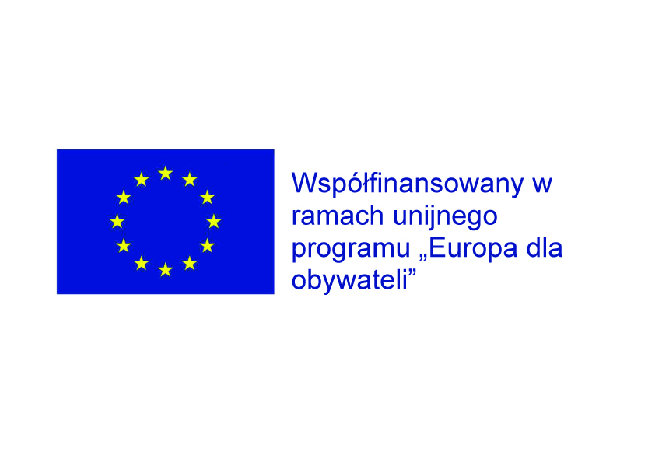
By sending this application I consent to the processing of personal data provided for purposes related to the rectuitement process and participation in the European Solidarity Corps volunteering programme of the Polish Robert Schuman Foundation. I have read the information on the use of personal data at the Foundation.

