Appendix B. Specification.
1. Sidewalk curb (total number: 190 m). Characteristics - type of curbstone: road. Product material: concrete. Weight (approximately): 40 kg. Dimensions: height 200.00 * length 1000.00 * width 80.00 (mm). Color: light gray.
2. Border "BR 100.30.18" (total number of 120 m). Characteristics - material of a product: concrete. Weight (approximately): 120 kg. Dimensions: height 300.00 * length 1000.00 * width 180.00 (mm). Color: light gray.
3. Paving slabs "Old town" or analog, thickness 60 mm, (colors - red: 200 sq.m., gray: 490 sq.m.). Technological characteristics: concrete class on durability: 400 kg / cm2. Frost resistance: up to 450 cycles. Water absorption: 4%. Deviation of geoparameters: mm ± 1; ± 3. Production: vibropressing.
4. Dry closet with washbasin (1 pc). Characteristics - the size of a cabin 1100 * 1100 * 2250 (mm). The standard complete set includes: a paper holder, a latch, a seat with a cover, a hook for clothes, showers for the lock, an accumulative tank on 250 l (it is calculated on 500-550 visits), a wash basin (a country variant on 3 l). 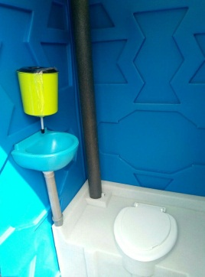

5. Dry closet for the disabled / people with disabilities (1pc).
Characteristics - made of shock-resistant plastic (300 kg / cm²), has high resistance to UV radiation. The arch and door are made of a single-layer front panel with stiffeners. Hinges on steel rivets. The accumulative tank of 150 l. (300 visits). Dimensions of MTK (m): 1.5 x 1.6 x 2.05. The standard complete set of a dry closet "for people with disabilities" includes: an internal latch, with the indicator "Busy / free"; paper holder; seat with lid; hook for clothes and other things; brackets for the padlock outside; storage tank; handrails are installed around the perimeter of the dry closet for a comfortable visit. Weight (approximately): 120 kg. 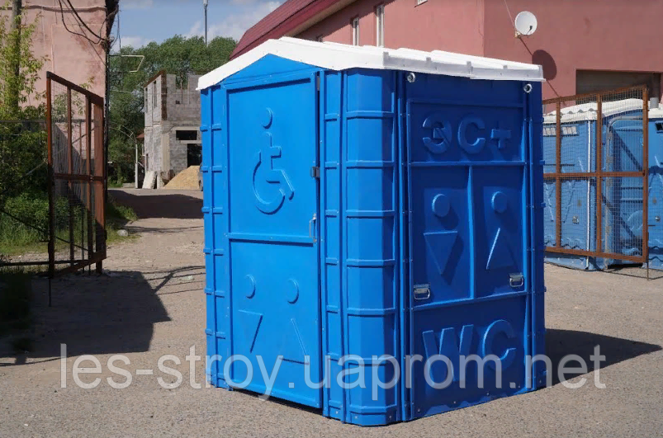

6. Bench garden and park "Lyudmila" or analog (4 pieces). Characteristics - material: wood, metal. Number of seats: 4. Color of the manufacturer: dark wood. Seat cover: paint. Maximum load: 200 kg. Features of a design: with a back, with armrests. Size and weight - length: 2 m; width: 87 cm; height: 95 cm; backrest height: 55 cm; seat height: 40 cm. Weight (approximately): 53 kg.
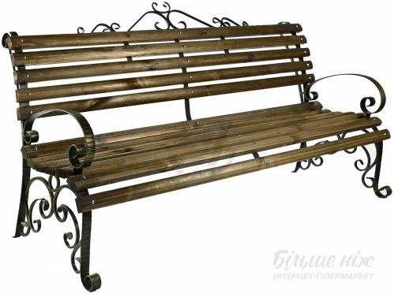
7. Container for separate garbage collection (1 piece). Characteristics - a metal structure from a profile pipe closed on three parties by a casing and covered with a cover from galvanized steel with a polymeric covering. Thus, the container is completely protected from precipitation. Inside the container are four boxes of galvanized steel with a capacity of 54 liters each. The boxes on the front side are covered with a polymer film of different colors with the inscription of the types of secondary raw materials for collection and storage. The boxes have a convenient strong handle for installation and removal from the container. Dimensions of the container for collapsible garbage collection: width - 1200 mm * depth - 400 mm * height - 750mm. 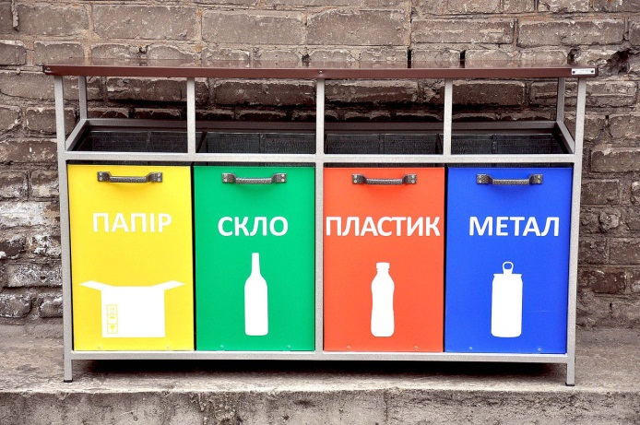

8. Container for organic waste on wheels (1pc). Characteristics - the presence of the lid protects against waste. Resistant to ultraviolet rays, low and high atmospheric temperatures. Resistant to chemical and biological influences. Wheels with rubber tires for silent container movement. Volume, l: 240. Material plastic weight, kg: 15. Load capacity, kg: 80.
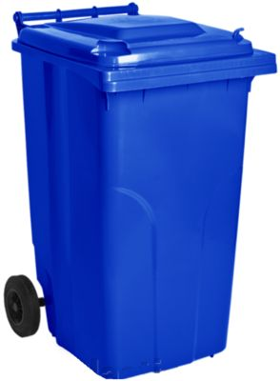

9. Rolled green fence DO or similar (total area of ​​150 sq.m).
Characteristics is an artificial grass made of special PVC, which by its properties is not flammable and resistant to ultraviolet light. This material, like all PVC - durable and environmentally friendly. In turn, the artificial grass is attached to a two-layer netting with Ø 1.6mm, which allows you to protect the fence from external influences. The diameter of the rod is 1.60 mm. Type of weaving - double. Galvanizing of a wire mesh of a chain-link fence - 50-60 gr / m2. The size of the mesh of the chain link fence is 40 mm x 40 mm. Artificial grass - PVC with 100% UV protection. Fence height - no restrictions. The standard length of the fence roll is 10 m. The standard diameter of the fence roll is 43 cm. The dimensions of the fence rolls are: height 2000 mm - 50 kg (approximately).
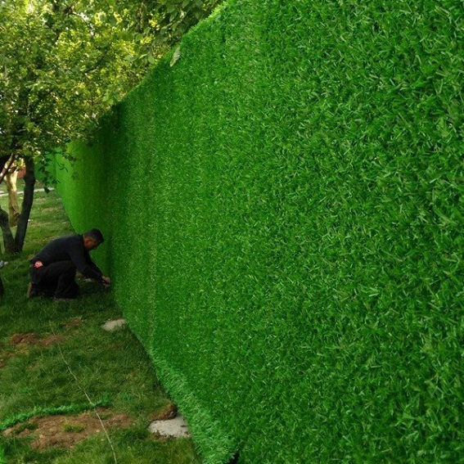

10. Garbage can "Gentleman" or similar (4 pcs). Characteristics - made of 2 mm sheet metal. Total height: 115 mm, urn with a diameter of 300 mm, depth of 450 mm. Water drain holes, swivel mechanism for garbage disposal.

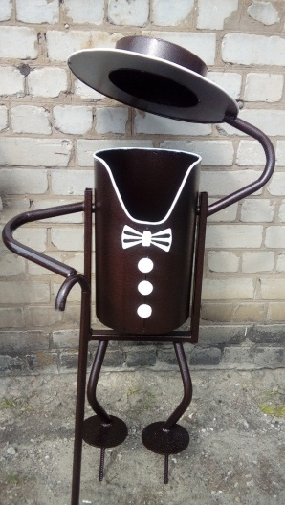

* Images are provided for information only, proposals must contain similar or similar items.

