REQUEST FOR PROPOSALS
RFP No. 384 (Eng. ver.)

Date: April 1, 2020

Subject:
Request for Proposals for procurement of outdoor equipment and construction materials for Bashtanska CC (Mykolaivska oblast) in the framework of USAID funded DOBRE Program.

From |  | To
Global Communities, implementing agency of DOBRE Decentralization Offering Better Results and Efficiency Program financed by the United States Agency for International Development (USAID) (referred to as “BUYER” hereinafter) |  | Potential suppliers (referred to as “BIDDER” hereinafter)
Proposals Submission Time and Date: | The Proposal must be submitted for the attention of:
By 12:00 Kyiv time on April 10, 2020, at the latest | Global Communities  International Technical Assistance Program  “Decentralization Offering Better Results and Efficiency”  USAID DOBRE  Address:  5b, Dilova str., Office 510, 5th Floor, Kyiv, Ukraine  Email: dobreprocurement@globalcommunities.org

- TERMS OF REFERENCE

A. Global Communities invites you to submit proposals for procurement of outdoor equipment and construction materials for Bashtanska CC (Mykolaivska oblast) as per the Specifications attached as Annexes B.1, B.2 and B.3 (proposals can be submitted for each lot separately as well as for the all lots together).

II. INSTRUCTIONS FOR POTENTIAL SUPPLIERS

- Form of Proposal

The proposal as well as all correspondence and documents exchanged between the Bidder and the Buyer under this RFP 384 shall be in English or Ukrainian.

The proposal must specify the following details and confirmations:

- The Proposal should be submitted on or before the deadline for this purpose, on a company letterhead, signed by an authorized representative and include the contact details of the Bidder.
- Conformity to technical specifications. The Bidder must confirm that all items are responsive to, or exceed, the estimated requirements.
- The Proposal must be valid for at least 60 calendar days from the proposal submission deadline date.
- Prices must be quoted in Ukrainian hryvnias (UAH).
- Prices must be quoted without the VAT. The Buyer is exempt from taxes within the customs territory of Ukraine and shall provide a certified copy of its registration card issued by the Ministry of Economic Development and Trade of Ukraine; The Buyer shall also provide a copy of its approved procurement plan.
- Price for each item. The price must be quoted as a total amount on an all-inclusive basis, including delivery to Bashtanska CC (Mykolaivska oblast).
- Eligibility for participation in the tender.
  - To be eligible to submit a proposal in response to this RFP, the Bidder must conform to the requirements in this RFP.
  - The Bidder complies with the U.S. sanctions and embargo laws, including U.S. Executive Order 13224 on Terrorist Financing and U.S. laws that prohibit transactions with, and the provision of resources and support to, individuals or entities associated with terrorism. Any person or organization taking part in this tender as a bidder or a sub-contractor must certify and confirm together with submitting other documents that the person or organization is not listed on the U.S. Department of Treasury Office of Foreign Assets Control (OFAC) Specially Designated Nationals (SDN), and is eligible for participation in the tender. Global Communities must disqualify any offers from persons or organizations listed on the said OFAC SDN list or found not to be eligible for the participation in the tender on other grounds. Companies and persons listed on the Excluded Parties List System (www.epls.gov) are not eligible for receiving funds.
- The Buyer reserves the right to accept or reject any proposal, and to cancel the tender, reject all proposals at any time prior to the award without assuming any liability and without the duty to inform Bidders about reasons for Global Communities’ actions.

- This RFP may be modified by means of amendments. Copies of amendments shall be issued to all Bidders.

- Any order of services to be made on the basis of this Request for Proposal shall be subject to Global Communities General Terms and Conditions of Goods and Service Procurement Contracts.

11. The Buyer will not send any notices to Bidders with confirmation about proposals received. The Buyer will not send any notices to unsuccessful Bidders.

- Evaluation Criteria

Proposals will be evaluated in accordance with criteria listed below. First, the Buyer will evaluate proposals for meeting obligatory criteria to determine conformity to the requirements. While evaluating the proposal, the Buyer may seek additional information from any source it considers appropriate to obtain or confirm information about the Bidder’s proposal.

- Conformity to the order list specification Acceptable/Unacceptable
- Validity of the proposal for 60 calendar days Acceptable/Unacceptable
- VAT exemption Acceptable/Unacceptable
- Eligibility for taking part in this RFP Acceptable/Unacceptable
- Warranty (not less than 12 months) Acceptable/Unacceptable
- Delivery within 45 business days after signing of an agreement Acceptable/Unacceptable
- Price 60 points
- Quality of proposal (compliance of the specification with the
requirements set, availability of certification of the equipment proposed) 30 points
- Payment terms* 10 points
* The proposed payment terms will be evaluated according to the following methodology, where the maximum number of points (10) is received by the proposal submitted by bidder who agrees to 100% post-payment within 30 calendar days after delivery; 5 points – prepayment up to 25%; 0 points - prepayment more than 25%.

- Questions with regard to this RFP

All clarification requests shall be sent in writing to the addresses specified hereinabove by 12:00 pm on April 8, 2020, at the latest. Please refrain from personal visits and phone calls. Any information provided to one Bidder with regard to this RFP will be made available to all Bidders.

Sincerely,

Global Communities
“Decentralization Offering Better Results and Efficiency” International Technical Assistance Program
USAID DOBRE

Annex A: Proposal’s Requirements

- Please confirm next mandatory requirements:
Conformity to the order list specification Acceptable/Unacceptable
Validity of the proposal for 60 calendar days Acceptable/Unacceptable
VAT exemption Acceptable/Unacceptable
Eligibility for taking part in this RFP Acceptable/Unacceptable
Warranty (12 months) Acceptable/Unacceptable
Delivery within 45 business days after signing of an agreement. Acceptable/Unacceptable

Please indicate payment terms

Postpayment | 25% prepayment | 50% prepayment | %prepayment

______days_
Please specify delivery date

- General information
Please fill the table with general information
Company name:
Code for Uniform State Register of Enterprises and Organizations (for legal entities) or Registration number of taxpayer's account (for private entrepreneur)
Address: | Postal code: | City: | Country:
P. O. Box and mailing address
Phone number:
E-mail:

Annex B.1: Specification. Sanitary module.

External overall dimensions (L / W / H, mm): 7000 * 2600 * 2500 Total area, m2: 18.2. Quantity - 1 pc. See drawing B.1.1.
Product design:
• Frame: steel profile pipe 80x40x3, 60x40x3, 40x20x2 and 60x40x2mm. The elements of the frame are welded by electric arc welding. The frame should have anti-corrosion coating (soil GF-021).
• Paneling: galvanized PR-10 corrugated board with protective-decorative coating "Rolyester" (choice of color according to RAL catalog). Decorative corners, strips and liners coated with "Rolyester" (RAL color selection).
• Roof: pitched, galvanized corrugated flooring PR-20 with protective-decorative coating "Rolyester" (color selection according to RAL catalog).
• Floor: lower part - Poliysol insulation, water barrier, insulation - ISOVER 100mm mineral wool, steam barrier, 35mm cutting board (treated with antiseptic against fungi and insects), OSB 10mm, linoleum on a warm basis, plinth and dock plates.
• Walls: water barrier, basalt wool TechnoNicol Rocklayt 100 mm. (Density 30 kg / m2), (ISOVER partitions 50mm), steam barrier, seamless plastic.
• Ceiling: water barrier, insulation - mineral wool ISOVER 100mm, steam barrier, white plastic lining 100mm wide.
• Exterior doors: 2pcs., Metal or plastic 900x2040 mm, with lock. MDF platbands.
• Internal doors: 6 pcs., Handles with latch, door leaf and MDF trims, 600x2000mm.
Electrical equipment:
• Power cable: double stranded copper stranded wire hidden in a corrugated pipe (on sockets SHVVP3h2.5, on lamps - PVS2h1)
• Lighting: 9pcs, Overhead Lights, LED (LED).
• Double sockets ~ 220V, light switches, circuit breakers 220 with grounding contact.
Electricity is supplied through the inlet box on the outside of the structure.
Additional equipment:
• 4-piece toilet bowl
• Washbasin with mixer 4pcs.
• Exhaust fan 3pcs

Drawing B.1.1:
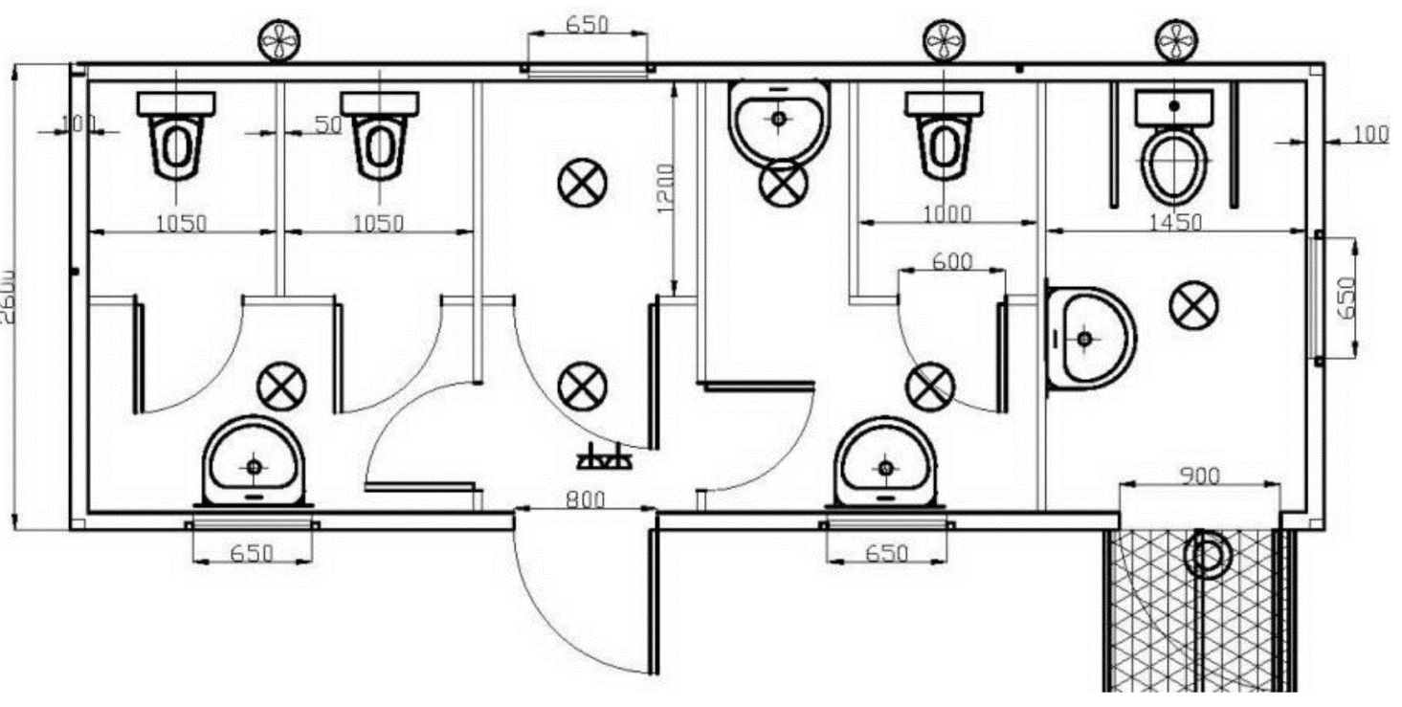

Annex B.2: Specification. Outdoor equipment.

## | Description | Image* | Unit of measure | Q-y
1. | Bench metal landscape gardening (SKP-2) or equivalent.  Features: bar material - pine. Dimensions: length: 180cm, width: 38 cm, height: 46 cm. | 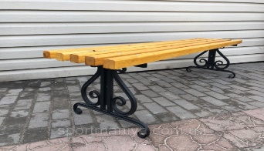 | pcs. | 5
2. | Urn.  Features: 0.8mm metal. Dimensions: 260x400.  weight 5 kg. | 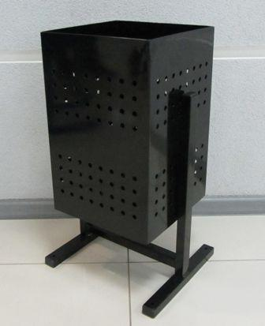 | pcs. | 5
3. | Fountain-faucet. | 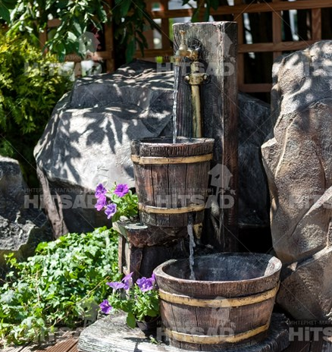 | pcs. | 1
4. | Trading stands 3 * 2,5  Material for walls - a covering board of 90х15 mm, a bar assembly 40х40 mm, a lath the external consignment note, color dark chocolate, painting with a water varnish. The floor - a board of a floor of 35 mm, logs, a bar. Roof coverings dark chocolate professional flooring.  See drawing B.2.1 | 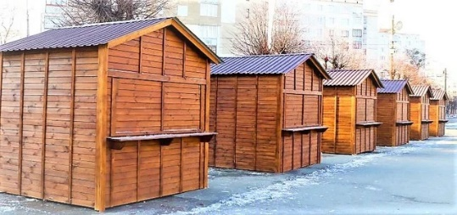 | pcs. | 7
5. | Trading stands 9 * 2,5  Material for walls - a covering board of 90х15 mm, a bar assembly 40х40 mm, a lath the external consignment note, color dark chocolate, painting with a water varnish. The floor - a board of a floor of 35 mm, logs, a bar. Roof coverings dark chocolate professional flooring.  See drawing B.2.2 | 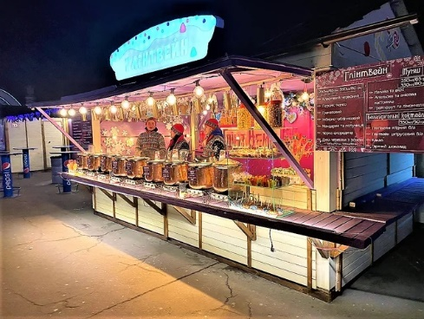 | pcs. | 2

* Images are given for reference only, proposals should include similar items.

Drawing В.2.1
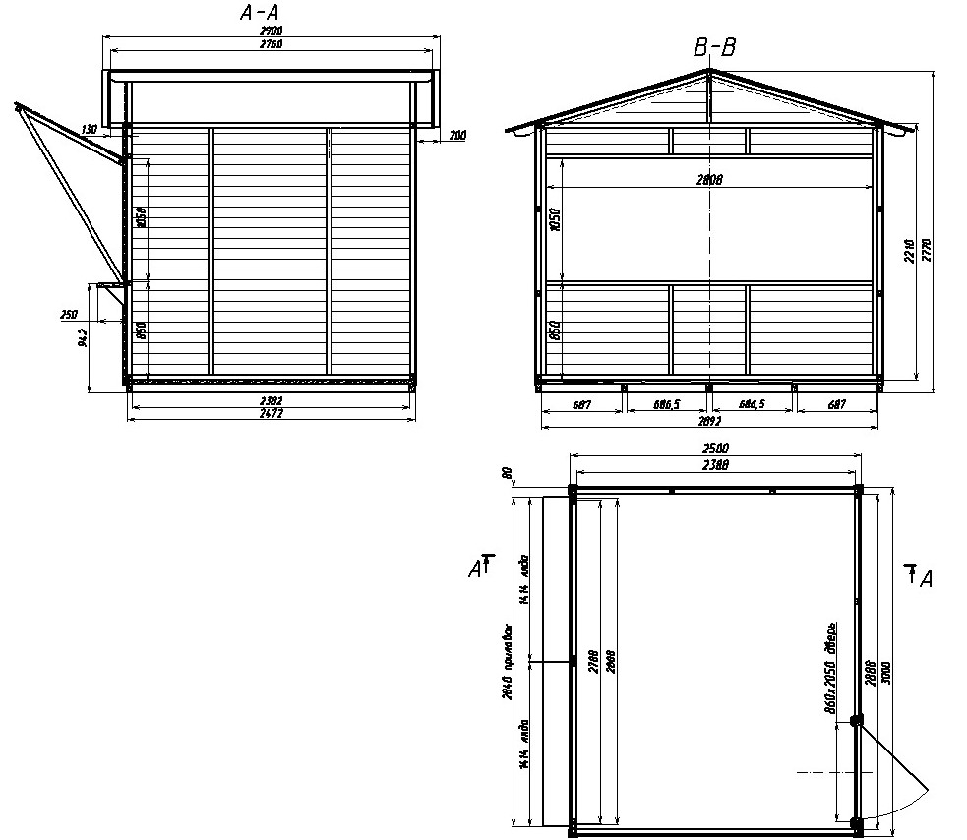

Drawing В.2.2
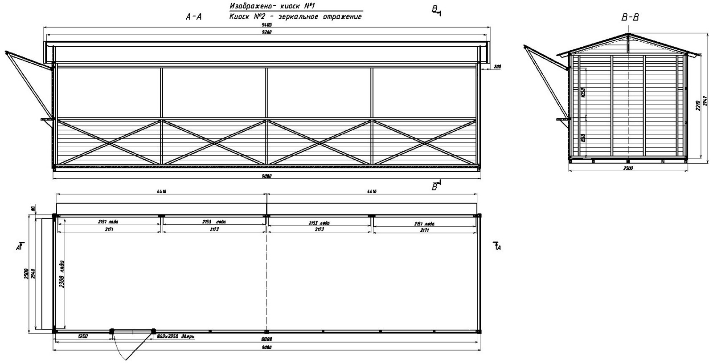
Annex B.3: Specification. Construction materials.

## | Description | Unit of measure | Q-ty
1. | Adhesive mix for ceramic tiles Cerezit СМ 11 | kg | 122.85
2. | Primer is deep penetrating Ceresit CT 17 | l | 7.132
3. | Elastic Hydroisolation Compound (component А) | kg | 178.3
4. | Elastic Hydroisolation Compound Ceresit CR 66 [component В] | l | 50.9439
5. | Brick ceramic single is full 250*120*65, Brand М100 | 1000pcs | 11.66
6. | Ceramic glazed glazed tiles for interior wall facing smooth colors [single-colored] without clogging | m2 | 4.949
7. | Mastics, frost-resistant bitumen-oil МБ-50 | t | 0.11026
8. | Roofing ruberoid with saw dust РКП-350Б | m2 | 18.128
9. | The lid "Europe" is brown 180*500*39 | pcs | 8
10. | Parapet on the Europe "fence" is brown 180*500*40 | pcs | 35
11. | Stones are on board БР100.30.15 | m | 96.2
12. | Concrete stones are on board БР100.20.8 | pcs | 321.4
13. | Polyethylene pipes for cold water РЕ 100 SDR-17(1,0 МПа), supply outer diameter 32x2 mm | m | 190.89
14. | Colin made of polyethylene diam. 32 mm / 90 deg. thermo-resistive welding of PE pipes | pcs | 1
15. | Colin made of polyethylene diam. 32 mm / 45 deg. thermo-resistive welding of PE pipes | pcs | 1
16. | Branch of polypropylene saddle dia. 75/32 mm for PE thermo-welded PE pipes | pcs | 1
17. | Trays made of polyethylene diam. 32 mm for thermo-resistor welding of PE pipes | pcs | 1
18. | Clutches made of polyethylene diam. 32 mm for thermo-resistor welding of PE pipes | pcs | 2
19. | Polyethylene ball valves diam. 32 mm | pcs | 2
20. | Counters of cold water single-stroke d = 20mm | pcs | 1
21. | Filters for water purification in pipelines of heating systems with a diameter of 25 mm | pcs | 1
22. | KS10.6 steel concrete concrete series 3.900.1-14 release 1 (volume of concrete - 0.16 m3) | pcs | 8
23. | Circle KS10.9 reinforced concrete series 3.900.1-14 edition 1 (volume of concrete - 0.24 m3) | pcs | 5
24. | Concrete cores KS15.6 steel-concrete grade 3.900.1-14 release 1 (concrete volume - 0.265 m3) | pcs | 1
25. | Corner KS15.9 Reinforced Concrete Grade 3.900.1-14 Release 1 (Concrete Volume - 0.40 m3) | pcs | 1
26. | Plates of cover 1PP15-1 Concrete Grade 3.900.1-14 Issue 1 (volume of concrete - 0.27 m3) | pcs | 2
27. | Plates covering PP10-1 steel-concrete grade 3.900.1-14 issue 1 (volume of concrete - 0,10 m3) | pcs | 7
28. | Plates cover ПТ75.30.6-15 Concrete-grade steel 3.006.1-8.1-1-2 | pcs | 6
29. | Slabs of bases ПН15 Concrete Grade 3.900.1-14 Issue 1 | pcs | 1
30. | Concrete slabs PN10 Concrete Grade 3.900.1-14 Issue 1 (volume of concrete - 0.18 m3) | pcs | 3
31. | The polymer nozzle for the wells is light | pcs | 4
32. | Polymer nozzles for wells are heavy | pcs | 5
33. | Pipes of external sewer PVC with diameter 110х2,2 mm | m | 5.04
34. | Pipes of external sewage PVC with diameter 50х2,5мм | m | 1.512
35. | Pipes of external sewage of PVC in diameter 160х3,2 mm | m | 116.766
36. | Trays of the highest quality brand LK300.30.30-1 Gray 3.006.1-8.1-1-1 | pcs | 1
37. | Trays are sorted by brand LK75.30.30-1 series 3.006.1-8.1-1-1 | pcs | 2
38. | Geotextiles | m2 | 588.5
39. | Concrete sidewalk curved slabs, thickness 70 mm, concrete В30 (М400) (МР3200) | m2 | 616.16
40. | Ceramic tiles for the sub floor smooth non-glazed single-colored with a colored dye, the size 200x200x13 mm | m2 | 14.28
41. | Metal constructions | t | 8.079
42. | Corrugated sheet from 15 - 800-07 | m2 | 7.82
43. | Corrugated painted NS44-1000-0,7 | m2 | 6.831
44. | Enamel anticorrosive PF-115 gray | t | 0.10048
45. | Alarm signal for cable protection | m | 241
46. | The cable is a four-core voltage of 600v in cross-section 4.10мм2 АВБбШВ | 1000м | 0.12
47. | Two-wire cable with a voltage of up to 660 with a cross-section of 2.4 mm 2 VHD | 1000м | 0.117
48. | Triangular cable with a voltage up to 660 with a cross section of 3.1.5mm2 VVG нг | 1000м | 0.104
49. | Triangular cable with a voltage up to 660 with a cross section of 3.2.5mm2 VVG нг | 1000м | 0.066
50. | Steel is round | t | 0.09174
51. | Counter 3f.electronic МТX 3R 30. DF.4LI - PD04 | pcs | 1
52. | Flame retardant steel of periodic profile, class A-W, diameter 8 mm | t | 0.0804
53. | Goryachekannaya reinforcing steel is smooth, class A-1, diameter 6 mm | t | 0.0213
54. | Primer GF-021 is red-brown | t | 0.02432
55. | Cover cap with a bullet on a square tube 60x60mm | pcs | 86
56. | Cover cap with a bullet on a square tube 40x40mm | pcs | 70
57. | Panels DKP Rehau Relazzo classic | m2 | 176
58. | Differential automatic machine 2r AD12 25А | pcs | 1
59. | Automatic differential 4R AD14 50A | pcs | 1
60. | Automatic differential 4AR AD14 32A | pcs | 1
61. | The switch is automatic ВА47-29 3п.40А | pcs | 1
62. | The switch is automatic ВА47-29 1п.5А | pcs | 1
63. | Вимикач автоматичний ВА47-29 1р. 25А / Automatic switch ВА47-29 1r. | pcs | 1
64. | Limiter of pulse overvoltage OPS1-1 | pcs | 1
65. | Contactor KMI 35012 50А | pcs | 1
66. | Voltage relay and bias phase of RNPP-311M | pcs | 1
67. | The time relay in the case of RV-10 / 2D1 | pcs | 1
68. | Plastic case SHURR-P3 / 7-2 | pcs | 1
69. | The socket is not open for open wiring | pcs | 2
70. | Socket outlet with black cover PKR11-016-2-K02 | pcs | 3
71. | cable VVG ng 3 * 1.5 33 CM | m | 270
72. | lamp LED DownLight LIDO 12Вт 4000К, Electrum | pcs | 18
73. | switch consignment note 1-cl white Electro-Plast Hermes IP 44, 0331-02 | pcs | 18
74. | reinforced frost-resistant HDF corrugated pipe 16 mm red, DKC | m | 270
75. | Solar lamp 48487 SOLAR or equivalent  Features: Diameter 300mm. Lamp type: LED (included). Color (body / ceiling): black / white. Height: 610 mm. | pcs | 8
76. | Concrete hemisphere Features: dimensions: 25x50cm, weight: 70kg. | pcs | 25
77. | Aluminum park support OTO-5-TL or equivalent. | pcs | 7
78. | Column Lighting Column (2.0 m) or equivalent. | pcs | 7
79. | Anchoring device ZCHF-1 or equivalent. | pcs | 7
80. | Anchoring device ZCHF-2 or equivalent. | pcs | 7
81. | AN-SSL2-200W LED Solar Lamp or equivalent. Features: solar panel - polycrystalline 12V, 40W. Dimensions - 650 * 350 * 17 mm. Type of LEDs - 200W, 5730 SMD LED, 100 lm / W; Shelf life -> 30,000 hours | pcs | 7

Annex C: Detailed Budget is attached in a separate file

