REQUEST FOR PROPOSAL (RFP)
RFP No. 382

Date: March 26, 2020

Subject:
Request for Proposals for procurement of outdoor children and sports equipment for Khorostkivska CC (Ternopil oblast) in the framework of USAID funded DOBRE Program.

From |  | Whom
Global Communities, implementing agency of DOBRE Decentralization Offering Better Results and Efficiency Program financed by the United States Agency for International Development (USAID) (referred to as “BUYER” hereinafter) |  | Potential suppliers (referred to as “BIDDER” hereinafter)
Proposals Submission Time and Date: | The Proposal must be submitted for the attention of:
By 14:00 Kyiv time on April 3, 2020, at the latest | Global Communities  International Technical Assistance Program  “Decentralization Offering Better Results and Efficiency”  USAID DOBRE  Address:  5b, Dilova str., Office 510, 5th Floor, Kyiv, Ukraine  Email: dobreprocurement@globalcommunities.org

- TERMS OF REFERENCE

A. Global Communities invites you to submit proposals for procurement of outdoor children and sports equipment for Khorostkivska CC (Ternopil oblast) in the framework of USAID funded DOBRE as per the Specification attached as Annex B.

II. INSTRUCTIONS FOR POTENTIAL SUPPLIER

- Form of Proposal
The proposal as well as all correspondence and documents exchanged between the Bidder and the Buyer under this RFP 382 shall be in English or Ukrainian.

The proposal must specify the following details and confirmations:
- The Proposal should be submitted on or before the deadline for this purpose, on a company letterhead, signed by an authorized representative and include the contact details of the Bidder.
- Conformity to technical specifications. The Bidder must confirm that all items are responsive to, or exceed, the estimated requirements.
- The Proposal must be valid for at least 60 calendar days from the proposal submission deadline date.
- Prices must be quoted in Ukrainian hryvnias (UAH).
- Prices must be quoted without the VAT. The Buyer is exempt from taxes within the customs territory of Ukraine and shall provide a certified copy of its registration card issued by the Ministry of Economic Development and Trade of Ukraine; The Buyer shall also provide a copy of its approved procurement plan.
- Price for each item. The price must be quoted as a total amount on an all-inclusive basis, including delivery to Khorostkivska CC (Ternopil oblast).
- Eligibility for participation in the tender.
  - To be eligible to submit a proposal in response to this RFP, the Bidder must conform to the requirements in this RFP.
  - The Bidder complies with the U.S. sanctions and embargo laws, including U.S. Executive Order 13235 on Terrorist Financing and U.S. laws that prohibit transactions with, and the provision of resources and support to, individuals or entities associated with terrorism. Any person or organization taking part in this tender as a bidder or a sub-contractor must certify and confirm together with submitting other documents that the person or organization is not listed on the U.S. Department of Treasury Office of Foreign Assets Control (OFAC) Specially Designated Nationals (SDN), and is eligible for participation in the tender. Global Communities must disqualify any offers from persons or organizations listed on the said OFAC SDN list or found not to be eligible for the participation in the tender on other grounds. Companies and persons listed on the Excluded Parties List System (www.epls.gov) are not eligible for receiving funds.
- The Buyer reserves the right to accept or reject any proposal, and to cancel the tender, reject all proposals at any time prior to the award without assuming any liability and without the duty to inform Bidders about reasons for Global Communities’ actions. In this case, the Buyer shall not be liable to the Applicant or the Applicants or bear any obligation to inform the Applicant or Applicants of the reasons for such Program actions.
- This RFP may be modified by means of amendments. Copies of amendments shall be issued to all Bidders.
- Any order of services to be made on the basis of this Request for Proposal shall be subject to Global Communities General Terms and Conditions of Goods and Service Procurement Contracts.
11. The Buyer will not send any notices to Bidders with confirmation about proposals received. The Buyer will not send any notices to unsuccessful Bidders.

- Evaluation Criteria
Proposals will be evaluated in accordance with criteria listed below. First, the Buyer will evaluate proposals for meeting obligatory criteria to determine conformity to the requirements. While evaluating the proposal, the Buyer may seek additional information from any source it considers appropriate to obtain or confirm information about the Bidder’s proposal.

- Conformity to the order list specification Acceptable/Unacceptable
- Validity of the proposal for 60 calendar days Acceptable/Unacceptable
- VAT exemption Acceptable/Unacceptable
- Eligibility for taking part in this RFP Acceptable/Unacceptable
- Warranty (not less than 12 month) Acceptable/Unacceptable
- Terms of delivery - up to 30 days Acceptable/Unacceptable
- Price 70 points
- Terms of payment* 30 points
* The proposed payment terms will be evaluated according to the following methodology, where the maximum number of points (10) is received by the proposal submitted by bidder who agrees to 100% post-payment within 30 calendar days after delivery; 5 points – prepayment up to 25%; 0 points - prepayment more than 25%.
- Questions with regard to this RFP
All clarification requests shall be sent in writing to the addresses specified hereinabove by 14:00 pm on April 1, 2020, at the latest. Any information provided to one Bidder with regard to this RFP will be made available to all Bidders. Please refrain from personal visits and phone calls. All questions and requests under this tender call must be addressed to Global Communities only.

Sincerely,

Global Communities
“Decentralization Offering Better Results and Efficiency” International Technical Assistance Program
USAID DOBRE

Annex A: Proposal Requirements

- Please confirm next mandatory requirements:
Conformity to the order list specification Acceptable/Unacceptable
Validity of the proposal for 60 calendar days Acceptable/Unacceptable
VAT exemption Acceptable/Unacceptable
Eligibility for taking part in this RFP Acceptable/Unacceptable
Warranty (12 months) Acceptable/Unacceptable
Terms of delivery - up to 30 days Acceptable/Unacceptable
Post payment during 30 (thirty) calendar days after delivery Acceptable/Unacceptable
Please indicate delivery terms:
Postpayment | 25% prepayment | 50% prepayment | % prepayment
days
Please specify delivery date:
- General information
Please fill the table with general information
Company name:
Code for Uniform State Register of Enterprises and Organisations (for legal entities) or Registration number of taxpayer's account (for private entrepreneur)
Address: | Postal code: | City: | Country:
P. O. Box and mailing address
Phone number:
E-mail:

Annex B: Specification
Outdoor children and sports equipment for Khorostkivska CC (Ternopil oblast)
№ | Items and description | Pictures* | Unit of measure | Quantity
1. | Swing “Twist Base”  overall dimensions: 2300 x 3050 x 1300 mm | 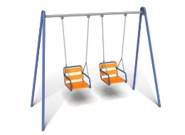 | pcs. | 1
2. | Swing on the spring “Dolphin”  overall dimensions: 900 x 1000 x 430 mm |  | pcs. | 1
3. | Swing-balancer with metal frame "Start"  overall dimensions: 900 x 2400 x 400 mm | 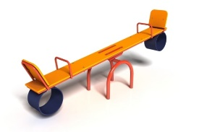 | pcs. | 1
4. | Crosses Game “Nulik”  overall dimensions: 1620 x 800 x 130 mm, material: moisture resistant pine beam | 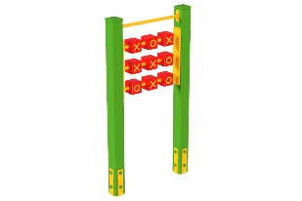 | pcs. | 1
5. | Abacus  overall dimensions: 1300 x 1100 x 300 mm, diameter of rings 12-15 cm | 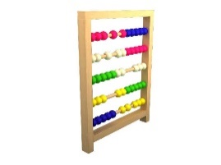 | pcs. | 1
6. | Swing Swing  overall dimensions: 2000 x 3900 x 2800 mm | 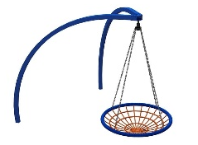 | pcs. | 1
7. | Street horizontal bar  overall dimensions: 1770 x 1770 x 2550 mm, InterAtletika SL117 or equivalent | 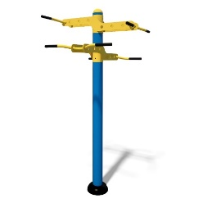 | pcs. | 1
8. | Street Leg Simulator Horizontal  overall dimensions: 1777 x 500 x 1548 mm, InterAtletika SE103 or equivalent | 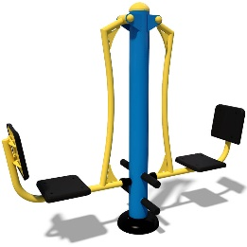 | pcs. | 1
9. | Street rowing simulator  overall dimensions: 1123 x 824 x 887 mm, InterAtletika SE135 or equivalent | 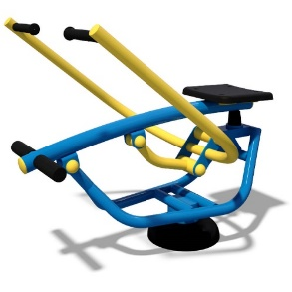 | pcs. | 1
10. | Street Simulator Thigh Extensor  overall dimensions: 1510 x 544 x 1076 mm, InterAtletika SE126 or equivalent | 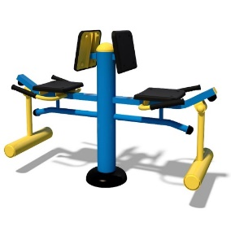
11. | Street simulator "Air walker"  overall dimensions: 489 x 1012 x 1429 mm, InterAtletika SM115 or equivalent | 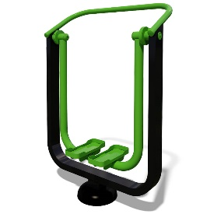
12. | Chess table  overall dimensions: 1365 x 680 x 715 mm, InterAtletika SM120 or equivalent | 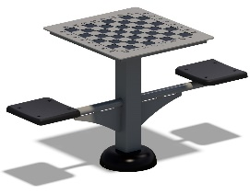
13. | Tennis table for the streets  overall dimensions: 2740 х 1500 х 760 mm, material: metal, moisture resistant plywood, M-0925 or equivalent | 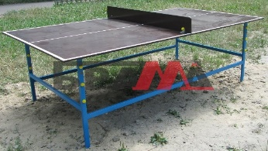

* The images are provided for information only; the proposals should contain similar or equivalent items.

Annex C: Detailed Budget

Outdoor children and sports equipment for Khorostkivska CC (Ternopil oblast)
No. | Goods/Service Item | Quantity | Terms of Delivery (working days) | Warranty  (months) | Price in  UAH, without  VAT | Total,  in UAH,  without  VAT
1.
2.
3.
4.
5.
6.
7.
8.
9.
10.
11.
12.
13.
Total in UAH, without VAT

Signature:

(Seal)

Date:

