REQUEST FOR PROPOSAL (RFP)
RFP No. 375

Date: March 30, 2020

Subject:
Request for Proposals for the procurement of outdoor and sport equipment for Buzka CC (Mykolaiv oblast) in the framework of USAID funded DOBRE Program.

From |  | Whom
Global Communities, implementing agency of DOBRE Decentralization Offering Better Results and Efficiency Program financed by the United States Agency for International Development (USAID) (referred to as “BUYER” hereinafter) |  | Potential suppliers (referred to as “BIDDER” hereinafter)
Proposals Submission Time and Date: | The Proposal must be submitted for the attention of:
By 12:00 Kyiv time on April 10, 2020, at the latest | Global Communities  International Technical Assistance Program  “Decentralization Offering Better Results and Efficiency”  USAID DOBRE  Address:  5b, Dilova str., Office 510, 5th Floor, Kyiv, Ukraine  Email: dobreprocurement@globalcommunities.org

- TERMS OF REFERENCE

A. Global Communities invites you to submit proposals for outdoor and sport equipment for Buzka CC (Mykolaiv oblast) in the framework of USAID funded DOBRE as per the Specifications attached as Annexes B.

II. INSTRUCTIONS FOR POTENTIAL SUPPLIER

- Form of Proposal
The proposal as well as all correspondence and documents exchanged between the Bidder and the Buyer under this RFP 375 shall be in English or Ukrainian.

The proposal must specify the following details and confirmations:

- The Proposal should be submitted on or before the deadline for this purpose, on a company letterhead, signed by an authorized representative and include the contact details of the Bidder.
- Conformity to technical specifications. The Bidder must confirm that all items are responsive to, or exceed, the estimated requirements.
- The Proposal must be valid for at least 60 calendar days from the proposal submission deadline date.
- Prices must be quoted in Ukrainian hryvnias (UAH).
- Prices must be quoted without the VAT. The Buyer is exempt from taxes within the customs territory of Ukraine and shall provide a certified copy of its registration card issued by the Ministry of Economic Development and Trade of Ukraine; The Buyer shall also provide a copy of its approved procurement plan.
- Price for each item. The price must be quoted as a total amount on an all-inclusive basis, including delivery to Buzka CC (Buzke village, Pervomayskyi rayon in Mykolaivska oblast).
- Eligibility for participation in the tender.
  - To be eligible to submit a proposal in response to this RFP, the Bidder must conform to the requirements in this RFP.
  - The Bidder complies with the U.S. sanctions and embargo laws, including U.S. Executive Order 13224 on Terrorist Financing and U.S. laws that prohibit transactions with, and the provision of resources and support to, individuals or entities associated with terrorism. Any person or organization taking part in this tender as a bidder or a sub-contractor must certify and confirm together with submitting other documents that the person or organization is not listed on the U.S. Department of Treasury Office of Foreign Assets Control (OFAC) Specially Designated Nationals (SDN), and is eligible for participation in the tender. Global Communities must disqualify any offers from persons or organizations listed on the said OFAC SDN list or found not to be eligible for the participation in the tender on other grounds. Companies and persons listed on the Excluded Parties List System (www.epls.gov) are not eligible for receiving funds.
- The Buyer reserves the right to accept or reject any proposal, and to cancel the tender, reject all proposals at any time prior to the award without assuming any liability and without the duty to inform Bidders about reasons for Global Communities’ actions. In this case, the Buyer shall not be liable to the Applicant or the Applicants or bear any obligation to inform the Applicant or Applicants of the reasons for such Program actions.

- This RFP may be modified by means of amendments. Copies of amendments shall be issued to all Bidders.

- Any order of services to be made on the basis of this Request for Proposal shall be subject to Global Communities General Terms and Conditions of Goods and Service Procurement Contracts.

11. The Buyer will not send any notices to Bidders with confirmation about proposals received. The Buyer will not send any notices to unsuccessful Bidders.

- Evaluation Criteria

Proposals will be evaluated in accordance with criteria listed below. First, the Buyer will evaluate proposals for meeting obligatory criteria to determine conformity to the requirements. While evaluating the proposal, the Buyer may seek additional information from any source it considers appropriate to obtain or confirm information about the Bidder’s proposal.

- Conformity to the order list specification Acceptable/Unacceptable
- Validity of the proposal for 60 calendar days Acceptable/Unacceptable
- VAT exemption Acceptable/Unacceptable
- Eligibility for taking part in this RFP Acceptable/Unacceptable
- Warranty (not less than 12 month), where it offered by the manufacturer Acceptable/Unacceptable
- Terms of delivery - up to 30 days Acceptable/Unacceptable
- Price 70 points
- Terms of payment* 30 points
* The proposed payment terms will be evaluated according to the following methodology, where the maximum number of points (10) is received by the proposal submitted by bidder who agrees to 100% post-payment within 30 calendar days after delivery; 5 points – prepayment up to 25%; 0 points - prepayment more than 25%.

- Questions with regard to this RFP

All clarification requests shall be sent in writing to the addresses specified hereinabove by 12:00 pm on April 08, 2020, at the latest. Any information provided to one Bidder with regard to this RFP will be made available to all Bidders. Please refrain from personal visits and phone calls. All questions and requests under this tender call must be addressed to Global Communities only.

Sincerely,

Global Communities
“Decentralization Offering Better Results and Efficiency” International Technical Assistance Program
USAID DOBRE

Table of content:
Annex A - Proposal Requirements
Annex B – Specification
Annex C – Detailed Budget

Annex A. Proposal Requirements

- Please confirm next mandatory requirements:
Conformity to the order list specification Acceptable/Unacceptable
Validity of the proposal for 60 calendar days Acceptable/Unacceptable
VAT exemption Acceptable/Unacceptable
Eligibility for taking part in this RFP Acceptable/Unacceptable
Warranty (12 months), where it offered by the manufacturer Acceptable/Unacceptable
Delivery no longer than within
30 business days after signing of an agreement Acceptable/Unacceptable

Please indicate payment terms
Postpayment | 25% prepayment | 50% prepayment | %prepayment

______days_
Please specify delivery date

- General information
Please fill the table with general information
Company name:
Code for Uniform State Register of Enterprises and Organizations (for legal entities) or Registration number of taxpayer's account (for private entrepreneur)
Address: | Postal code: | City: | Country:
P. O. Box and mailing address
Phone number:
E-mail:

Annex B: Specification

№ | Items and description | Pictures* | Unit of measure | Quantity
1. | Gate for mini football  300 х 200 cm PlayGame |  | pcs. | 2
2. | Volleyball racks PlayGame  Racks for beach volleyball with stretching, metal, pair kit |  | pcs. | 1
3. | Worker checkpoint  Standard gatehouse (wagon) 6 x 2.5 x 2.5 m with electricity network |  | pcs. | 1
4. | Trade jacks  1,5 x 2,5 m, metal frame, wooden paneling, mobile on wheels.  Pine wood, bar size15 mm x 50 mm,  stainless steel 2.5 m x 50 cm,  roof: profiles with a diameter of 20mm x 20mm x 2.5m, 6mm x 2.5m, rack  roof: pipe 30 mm x 60 cm; working place: 8 racks profile with a diameter of 30 mm x 30 mm x 70 cm, 4 wheels height 10 cm, profiles with a diameter of 30 mm x 30 mm x 2.5 m, profiles with a diameter of 30 mm x 30 mm x 50 cm, profiles with a diameter of 30 mm x 30 mm x 70 cm | 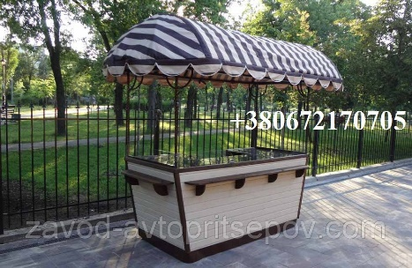 | pcs. | 5
5. | Beach Arbor (pergola) 3х4 m  frame from a tree (pergola) 3х4 m, pine wood, painting: osmo oil and antiseptic, pine beam size 100 x 100, crossbar: 55 x 90 beam, rails: bar size 20 x 50 cm,  metal glasses under the bar | 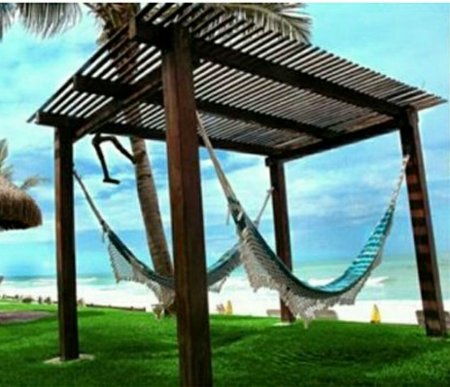 | pcs. | 4
6 | Picnic arbor 4x4 m  Wooden (pine wood), complete with table and benches, metal roof, Ruuki metal sheet 1,7 m long, water barrier,  metal mortgages (foundation on piles included), the size of a bar of a rack 100 x 100, bar size 55 x 90, 25 x 60 crossbar, coloring: osmo oil and antiseptic. The kit includes table and benches. | 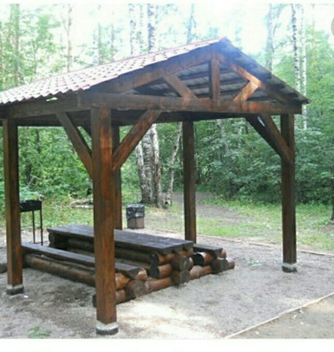 | pcs. | 6
7 | Bent bench  in "natural style" 0,6х2 m.  Wood - alder (Osmo oil painting and antiseptic), bar size 60 x 40 mm, metal base (zinc primer with powder coating) | 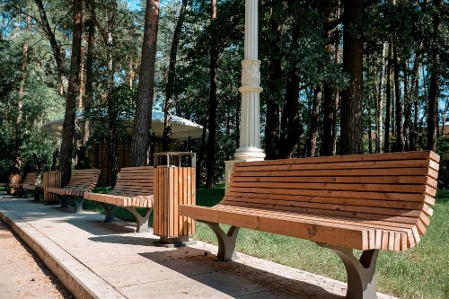 | pcs. | 25
8 | 6-sided bench  in "natural style" around the tree, 6-sided, metal, wood combined alder, oak; 35 x 90 cm beam, covered with antiseptic and osmo oil | 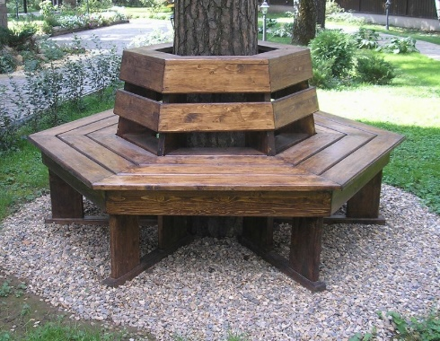 | pcs. | 2
9 | Square bench  in "natural style" around a tree, square, metal, alder wood, 35 x 90 cm beam, covered with antiseptic and "osmo" oil, zinc based powder-coated metal base | 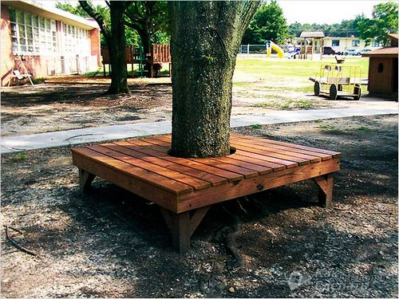 | pcs. | 2
10 | Deck chair bench  "natural style" deck chair, metal, alder wood, bar size 40 x 40 cm, covered with antiseptic and oil "osmo", metal base 2.7 m with zinc primer with powder coating | 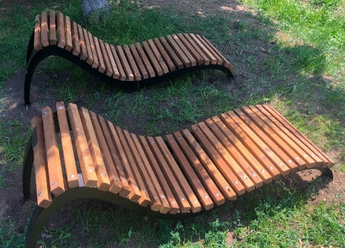 | pcs. | 10
11 | Water swing  near the water in "natural style", oak, antiseptic and oil coating »osmo» |  | pcs. | 4
12 | Beach double dresser  Beach dresser, double 2 x 4 m, metal frame, walls corrugated board, metal legs, oil painting "osmo" | 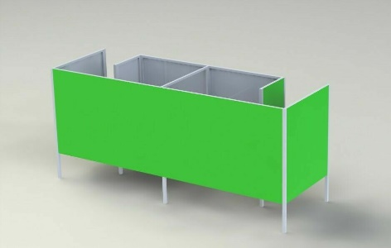 | pcs. | 1

Annex C. Detailed Budget

No. | Goods/Service Item | Quantity | Terms of Delivery (working days) | Warranty  (months) | Price in  UAH, without  VAT | Total,  in UAH,  without  VAT
1
…
…
22
 |  |  |  |  | Total:

Signature:

seal

Date:

