USAID Economic Resilience Activity
(USAID ERA)

Request For Proposals (RFP)

No. REQ-KYV-19-0072

Business Development Strategy workshops and
assistance in SME strategy design

Issue Date: September 10, 2019

WARNING: Prospective Offerors who have received this document from a source other than DAI, should immediately contact ProcurementERA@dai.com and provide their name and mailing address in order that amendments to the RFP or other communications can be sent directly to them. Any prospective Offeror who fails to register their interest assumes complete responsibility in the event that they do not receive communications prior to the closing date. Any amendments to this solicitation will be issued and posted by e-mail.

Table of Contents
1. Introduction and Purpose 4
1.1 Purpose 4
1.2 Issuing Office 4
1.3 Type of Award Anticipated 4
2. General Instructions to Offerors 4
2.1 General Instructions 4
2.2 Proposal Cover Letter 5
2.3 Questions regarding the RFP 5
2.4 Pre-Proposal Bidders’ Conference 5
3. Instructions for the Preparation of Technical Proposals 5
3.1 Services Specified 6
3.2 Technical Evaluation Criteria 6
4. Instructions for the Preparation of Cost/Price Proposals 8
4.1 Cost/Price Proposals 8
5. Basis of Award 8
5.1 Best Value Determination 8
5.2 Responsibility Determination 9
6. Anticipated post-award Deliverables 9
7. Inspection & Acceptance 10
8. Compliance with Terms and Conditions 10
8.1 General Terms and Conditions 10
8.2 Source and Nationality 10
8.3 Data Universal Numbering System (DUNS) 10
9. Procurement Ethics 11
10. Attachments 12
10.1 Attachment A: Scope of Work for Services or Technical Specifications 12
10.2 Attachment B: Proposal Cover Letter 18
10.3 Attachment C: Price Schedule 19
10.4 Attachment D: Instructions for Obtaining a DUNS Number - DAI’S Vendors, Subcontractors 23
10.5 Attachment E: Self Certification for Exemption from DUNS Requirement 31
10.6 Attachment F: Past Performance Form 32
10.7 Attachment G: Representations and Certifications of Compliance 33
List of Optional Attachments 34
10.8 Attachment H: Branding and Marking Plan 34
10.9 Attachment I: Full Terms of Contract 36
10.10 Attachment J: Proposal Checklist 36

Synopsis of the RFP
RFP No. | REQ-KYV-19-0072
Issue Date | September 10, 2019
Title | Business Development Strategy workshops and assistance in SME strategy design
Issuing Office & Email/Physical Address for Submission of Proposals | Proposals should be submitted in electronic format to the email address ProcurementERAInbox@dai.com
BIdders‘ Conference | A Pre-Proposal Bidders’ Conference is scheduled for 10 am, Kyiv, Ukraine Time, on September 17, 2019 at the USAID ERA office in Kyiv (Lva Tolstoho Street, building 9A, ground floor)
Deadline for Receipt of Questions | September 20, 2019, 06:00 pm, Kyiv, Ukraine Time to the email address ProcurementERA@dai.com  All questions received will be compiled and answers will be distributed via email to tender participants
Deadline for Receipt of Proposals | October 10, 2019, 06:00 pm, Kyiv, Ukraine Time to the email address ProcurementERAInbox@dai.com  PLEASE NOTE THAT THE EMAIL ADDRESS FOR RECEIPT OF QUESTIONS AND THE EMAIL ADDRESS FOR RECEIPT OF PROPOSALS ARE DIFFERENT
Point of Contact | ProcurementERA@dai.com
Anticipated Award Type | Firm Fixed Price Subcontract  A Firm Fixed Price Subcontract is: An award for a total firm fixed price, for the provision of specific services, goods, or deliverables and is not adjusted if the actual costs are higher or lower than the fixed price amount. Offerors are expected to include all costs, direct and indirect, into their total proposed price.  Issuance of this RFP in no way obligates DAI to award purchase order or subcontract and offerors will not be reimbursed for any costs associated with the preparation of their bid.
Basis for Award | An award will be made based on the Trade Off Method. The award will be issued to the responsible and reasonable Offeror who provides the best value to DAI and its client using a combination of technical and cost/price factors.  To be considered for award, Offerors must meet the requirements identified in sub-item 5.2 “Responsibility Determination”.

Introduction and Purpose

Purpose
DAI Global LLC (DAI) implements USAID-funded Economic Resilience Activity (USAID ERA), a five-year program (2018-2023) that supports the development of a resilient, inclusive, growth-oriented economy in eastern Ukraine by strengthening both market systems and social networks. Interventions funded by the Activity are implemented in partnership with local non-governmental organization (NGO), government, and private sector actors. Interventions under the Activity contribute to the economic stabilization of the region by supporting vulnerable populations’ participation in the economy, and providing relevant resources and training to improve human capital. The Activity also facilitates co-investments with small and medium enterprises (SMEs) to build technical skills, reach new markets, and grow through sustainable and inclusive business models.

Having conducted a series of interviews with manufacturing and engineering companies, USAID ERA Innovations for manufacturing team determined that companies currently lack the context for effective marketing efforts and consistent business development. The current situation is partially due to the economic volatility of the region, uncertainty about the future and unfamiliarity with modern approaches to business development strategy design and strategic plans. Businesses have long been functioning in survival mode and limit their planning to the short term.
Before these firms are able to be solid partners, approach investors to raise capital, target new markets, increase sales and further improve working conditions or create new jobs they require a strategic vision. DAI invites qualified consulting offerors to submit proposals to supply and provide two Business Development Strategy workshops and assistance in SME strategy design to USAID ERA partner companies who have applied for project support to provide strategic support in developing their businesses. The purpose of the Subcontract is to assist them in making the leap to strategic development and enable USAID ERA to support promising Luhansk and Donetsk oblast manufacturing and engineering businesses.

Issuing Office
The Issuing Office and Contact Person noted in the above synopsis is the sole point of contact at DAI for purposes of this RFP. Any prospective offeror who fails to register their interest with this office assumes complete responsibility in the event that they do not receive direct communications (amendments, answers to questions, etc.) prior to the closing date.

Type of Award Anticipated
DAI anticipates awarding a Firm Fixed Price Subcontract. This subcontract type is subject to change during the course of negotiations.

General Instructions to Offerors

General Instructions
“Offeror”, “Subcontractor”, and/or “Bidder” means a firm proposing the work under this RFP. “Offer” and/or “Proposal” means the package of documents the firm submits to propose the work.

Offerors wishing to respond to this RFP must submit proposals, in English, in accordance with the following instructions. Offerors are required to review all instructions and specifications contained in this RFP. Failure to do so will be at the Offeror’s risk. If the solicitation is amended, then all terms and conditions not modified in the amendment shall remain unchanged.

Issuance of this RFP in no way obligates DAI to award a subcontract or purchase order. Offerors will not be reimbursed for any costs associated with the preparation or submission of their proposal. DAI shall in no case be responsible for liable for these costs.
Proposals are due no later than October 10, 2019, 06:00 pm, Kyiv, Ukraine Time, to be submitted via procurement email ProcurementERAInbox@dai.com. The RFP number and title of the activity must be stated in the subject line of the email. Cost and technical proposals shall be submitted to the same mailbox in two different files (VOLUME I: TECHNICAL PROPOSAL and VOLUME II: COST/PRICE PROPOSAL). Late offers will be rejected except under extraordinary circumstances at DAI’s discretion.
The submission to DAI of a proposal in response to this RFP will constitute an offer and indicates the Offeror’s agreement to the terms and conditions in this RFP and any attachments hereto. DAI reserves the right not to evaluate a nonresponsive or incomplete proposal.

Proposal Cover Letter
A cover letter shall be included with the proposal on the Offeror’s company letterhead with a duly authorized signature and company stamp/seal using Attachment B as a template for the format. The cover letter shall include the following items:
- The Offeror will certify a validity period of sixty (60) calendar days for the prices provided.
- Acknowledge the solicitation amendments received.

Questions regarding the RFP
Each Offeror is responsible for reading and complying with the terms and conditions of this RFP. Requests for clarification or additional information must be submitted in writing via email to the Issuing Office as specified in the Synopsis above. No questions will be answered by phone. Any verbal information received from a DAI or USAID ERA employee or other entity shall not be considered as an official response to any question regarding this RFP.
Copies of questions and responses will be distributed in writing to all prospective bidders who are on record as having received this RFP after the submission date specified in the Synopsis above.

Pre-Proposal Bidders’ Conference
A pre-proposal bidders’ conference will be held on September 17, 2019, beginning at 10 am, Kyiv, Ukraine Time, at the USAID ERA office in Kyiv (Lva Tolstoho Street, building 9A, ground floor). Please contact ProcurementERA@dai.com if you would like to receive call-in information if you are unable to be there in person. There is a two-person limit per organization.
Information of interest to all prospective Offerors will be presented. While attendance at the pre-proposal conference is not mandatory, all interested prospective suppliers are encouraged to attend in order to prepare acceptable proposals. Questions asked at the Pre-Proposal Bidder’s Conference, that would benefit all bidders, shall be provided in an amendment to the RFP.

Instructions for the Preparation of Technical Proposals
Technical proposals shall be provided in a separate volume from cost/price proposals, and shall be clearly labeled as “VOLUME I: TECHNICAL PROPOSAL”. VOLUME I to be submitted in English in Microsoft Word format. Expected length: no more than 20 pages. Annexes may be included without a page limitation, however the evaluation committee shall review annexes at their discretion.
Technical proposals shall include the following contents
- Technical Approach - Description of the proposed services which meets or exceeds the stated technical specifications or scope of work. The proposal must show how the Offeror plans to complete the work and describe an approach that demonstrates the achievement of timely and acceptable performance of the work.
- Personnel/Management – Description of the Offeror’s staff assigned to the project. The proposal should describe how the proposed team members have the necessary experience and capabilities to carry out the Technical Approach. The Offeror shall present CVs of the Team Lead of the technical action plus any additional personnel that the offerors deems necessary to perform the services.
- Past Performance/Corporate capabilities – Provide a list of at least three (3) recent awards of similar scope and duration. The information shall be supplied as a table, and shall include the legal name and address of the organization for which services were performed, a description of work performed, the duration of the work and the value of the contract, description of any problems encountered and how it was resolved, and a current contact phone number of a responsible and knowledgeable representative of the organization. See Attachment F.

Services Specified
For this RFP, DAI is in need of the services described in Attachment A.

Technical Evaluation Criteria
Each proposal will be evaluated and scored against the evaluation criteria and evaluation sub-criteria, which are stated in the table below. Cost/Price proposals are not assigned points, but for overall evaluation purposes of this RFP, technical evaluation factors other than cost/price, when combined, are considered approximately equal to cost/price factors.
Evaluation Criteria | Evaluation Sub-criteria (if needed) | Maximum Points
Technical Approach | The proposal is evaluated as to how well it addresses the solution based on the requirements of the RFP and whether the Offeror has the technical ability to provide an acceptable solution.  The Offeror must also show that they understand both the magnitude and importance of the individual tasks to make a convincing proposal. The proposal should demonstrate your organization’s ability to address each of the tasks contained in the Scope of Work for which your organization wishes to provide services (which may be a subset of the list of tasks), and how you will achieve its goals, outputs, and deliverables.  The Offeror should demonstrate a deep knowledge and insights about the challenges and specificity of Luhansk and Donetsk business environment that USAID ERA target audience (manufacturing and engineering SMEs) operate in. | 35 points
Personnel/Management | Extent to which the proposed personnel show the capacity to carry out the proposed technical and management actions.  The Team Lead leading the activity on behalf of the organization should possess the following experience:  - strategic consulting experience in manufacturing and/or engineering of at least 10 years  - experience of conducting corporate strategy workshops including for mid-size Ukrainian companies of at least 10 years.  - proven knowledge of the best international practices in manufacturing, familiarity with manufacturing trends and technological practices  Extent to which the Offeror demonstrates how its management approach described through its staffing plan and organizational structure will lead to a rapid successful and effective implementation of the activity to achieve expected results in a cost-effective and efficient manner. | 30 points
Past Performance/  Corporate Capability | Provide an overview of your organization’s experience and capacities in addressing the issues covered by the RFP.  Experience in designing and implementing activities supporting development assistance projects.  Previous experience in supporting Eastern Ukrainian enterprises is considered an advantage. Provide and describe three specific engagements/ contracts that your organization has implemented within the that best represent your experience in addressing the tasks stemming from Attachment A: Scope of Work for Services or Technical Specifications. Provide reference contacts for these engagements.  Prove your flexibility in consulting/working with a diverse set of business executives, commitment to the success of clients and positive approach to teaching and consulting. | 35 points
Total Points |  | 100 points

Eligibility Requirements
The following are the key minimum qualifications of the Offeror:
- Demonstrable international institutional experience (in and beyond Community of Independent States - CIS) in provision of similar management consultancy and capacity building services to a network of clients in the private sector that include mid-size and big business companies including in manufacturing sector for at least 15 years. For this, the Offeror should complete Attachment F: Past Performance Form with the list of the most relevant projects undertaken in the last 15 years. Please provide up to 10 relevant projects.
- The services spectrum provided to the clients in point 1 should span such areas as marketing, production process optimisation, digitization and automation, introduction of novel technologies, personnel and finance management, planning system, procurement and logistical processes. The experience should include both business diagnostics (assessment of clients) and designing activities to address the bottlenecks determined thereby.
- Offerors must demonstrate capabilities in delivering well-coordinated and organised outputs, create team synergies and encourage their clients, effectively communicate with SME clients.
- Offerors must present evidence of their past experience in promoting business development in challenged regions (characterized by economic instability, brain and workforce drain and a lack of confidence). Offerors may include descriptions of number of such projects or other similar activities. These references should include three (3) clients’ names and telephone numbers who will serve as references.
- Experience in designing and implementing activities supporting development assistance projects.
- Demonstrated management and organizational capacities, including skills in budgeting, proposal writing, group facilitation, record-keeping, and reporting.
- Proven flexibility in consulting/working with a diverse set of business executives, commitment to the success of clients and positive approach to teaching and consulting.
Any awardee must be legally registered (present in the form of a subsidiary or else) in Ukraine. As long as it is registered, any nongovernment organization or association or private company, whether for-profit or not-for-profit, may apply. Government agencies are not eligible.

Instructions for the Preparation of Cost/Price Proposals

Cost/Price Proposals
Cost/Price proposals shall be provided in a separate volume from technical proposals and shall be clearly labeled as “VOLUME II: COST/PRICE PROPOSAL”.
Provided in Attachment C.1, as a separate attachment, is the budget template for the Cost Proposal. Offerors shall complete the template including as much detailed information as possible.
It is important to note that Value Added Tax (VAT) shall be included on a separate line. These services are eligible for VAT exemption under the DAI prime contract #72012118С00004 registered with the Ministry of Economic Development and Trade of Ukraine, having the registration card #3987-01 dated May 29, 2019, accreditation certificate #288 dated January 11, 2017 (with amendments as of November 29, 2018 and as of April 23, 2019). The Subcontractor is responsible for all applicable taxes and fees, as prescribed under the applicable laws for income, compensation, permits, licenses, and other taxes and fees due as required.

Basis of Award

Best Value Determination
DAI will review all proposals, and make an award based on the technical and cost evaluation criteria stated above and select the Offeror whose proposal provides the best value to DAI. DAI may also exclude an offer from consideration if it determines that an Offeror is "not responsible", i.e., that it does not have the management and financial capabilities required to perform the work required.
Evaluation points will not be awarded for cost. Cost will primarily be evaluated for realism and reasonableness. DAI may award to a higher priced Offeror if a determination is made that the higher technical evaluation of that offeror merits the additional cost/price.
Please note that Offerors may be asked to provide additional detail regarding their Travel, Materials, and Other Direct Costs in their cost proposal after proposal submission.
DAI may award to an Offeror without discussions. Therefore, the initial offer must contain the Offeror’s best price and technical terms.

Responsibility Determination
DAI will not enter into any type of agreement with an Offeror prior to ensuring the Offeror’s responsibility. When assessing an Offeror’s responsibility, the following factors are taken into consideration:
- Provide evidence of the required business licenses to operate in Ukraine, namely valid local business registration (company registration documents, including document from the tax authority about VAT status).
- Evidence of a DUNS number (explained below and instructions contained in Attachment D).
- The source, origin and nationality of the products or services are not from a Prohibited Country (explained below).
- Having adequate financial resources to finance and perform the work or deliver goods or the ability to obtain financial resources without receiving advance funds from DAI.
- Ability to comply with required or proposed delivery or performance schedules.
- Have a satisfactory past performance record.
- Have a satisfactory record of integrity and business ethics.
- Have the necessary organization, experience, accounting and operational controls and technical skills.
- Have the necessary production, construction and technical equipment and facilities if applicable.
- Be qualified and eligible to perform work under applicable laws and regulations.

Anticipated post-award Deliverables
Upon award of a subcontract, the deliverables and deadlines detailed in below table will be submitted to DAI. The Offeror should detail proposed costs per deliverable in the Price Schedule. All of the deliverables must be submitted to and approved by DAI before payment will be processed.
No. | Deliverable Name | Due Date
1 | WORKPLAN AND SUPPORTING DOCUMENTS | 15 days after the signature of the subcontract
2 | PRE-WORKSHOP PACKAGE | 20 days after the signature of the subcontract
3 | WORKSHOP PACKAGE | 25 days after the signature of the subcontract
4 | POST-WORKSHOP REPORTING DOCUMENTS | 45 days after the signature of the subcontract (within 10 days after the last workshop)
5 | REPORT ON CONSULTING SUPPORT FOR DESIGN OF STRATEGIES | 90 days after the signature of the subcontract
6 | STRATEGY PRESENTATIONS REPORT | 95 days after the signature of the subcontract
7 | FINAL EVALUATIONS REPORT | 115 days after the signature of the subcontract

Inspection & Acceptance
The designated DAI Project Manager will inspect from time to time the services being performed to determine whether the activities are being performed in a satisfactory manner, and that all equipment or supplies are of acceptable quality and standards. The Subcontractor shall be responsible for any countermeasures or corrective action, within the scope of this RFP, which may be required by the DAI Chief of Party as a result of such inspection.

Compliance with Terms and Conditions

General Terms and Conditions
Offerors agree to comply with the general terms and conditions for an award resulting from this RFP. The selected Offeror shall comply with all Representations and Certifications of Compliance listed in Attachment G.

Source and Nationality
Under the authorized geographic code for its contract DAI may only procure goods and services from the following countries.
Geographic Code 937: Goods and services from the United States, the cooperating country, and "Developing Countries" other than "Advanced Developing Countries: excluding prohibited countries. A list of the "Developing Countries" as well as "Advanced Developing Countries" can be found at: http://www.usaid.gov/policy/ads/300/310maa.pdf and
http://www.usaid.gov/policy/ads/300/310mab.pdf respectively.

Geographic Code 110: Goods and services from the United States, the independent states of the former Soviet Union, or a developing country, but excluding Prohibited Countries.
DAI must verify the source and nationality of goods and services and ensure (to the fullest extent possible) that DAI does not procure any goods or services from prohibited countries listed by the Office of Foreign Assets Control (OFAC) as sanctioned countries. OFAC sanctioned countries may be searched within the System for Award Management (SAM) at www.SAM.gov. The current list of countries under comprehensive sanctions include: Cuba, Iran, North Korea, Sudan, and Syria. Goods may not transit through or be assembled in comprehensive sanctioned origin or nationality countries nor can the vendor be owned or controlled by a prohibited country. DAI is prohibited from facilitating any transaction by a third party if that transaction would be prohibited if performed by DAI.
By submitting a proposal in response to this RFP, Offerors confirm that they are not violating the Source and Nationality requirements of the goods or services being offered and that the goods and services comply with the Geographic Code and the exclusions for prohibited countries outlined above.

Data Universal Numbering System (DUNS)
There is a mandatory requirement for your organization to provide a DUNS number to DAI. The Data Universal Numbering System is a system developed and regulated by Dun & Bradstreet (D&B) that assigns a unique numeric identifier, referred to as a "DUNS number" to a single business entity. Without a DUNS number, DAI cannot deem an Offeror “responsible” to conduct business with and therefore, DAI will not enter into a subcontract/purchase order or monetary agreement with any organization. The determination of a successful offeror/applicant resulting from this RFP/RFQ/RFA is contingent upon the winner providing a DUNS number to DAI. Offerors who fail to provide a DUNS number will not receive an award and DAI will select an alternate Offeror.
All U.S. and foreign organizations which receive first-tier subcontracts/ purchase orders with a value of $30,000 and above are required to obtain a DUNS number prior to signing of the agreement. Organizations are exempt from this requirement if the gross income received from all sources in the previous tax year was under $300,000. DAI requires that Offerors sign the self-certification statement if the Offeror claims exemption for this reason.
For those required to obtain a DUNS number, see Attachment D - Instructions for Obtaining a DUNS Number - DAI’S Vendors, Subcontractors
For those not required to obtain a DUNS number, see Attachment E: Self Certification for Exemption from DUNS Requirement

Procurement Ethics
Neither payment nor preference shall be made by either the Offeror, or by any DAI staff, in an attempt to affect the results of the award. DAI treats all reports of possible fraud/abuse very seriously. Acts of fraud or corruption will not be tolerated, and DAI employees and/or subcontractors/grantees/vendors who engage in such activities will face serious consequences. Any such practice constitutes an unethical, illegal, and corrupt practice and either the Offeror or the DAI staff may report violations to the Toll-Free Ethics and Compliance Anonymous Hotline at +1 855-603-6987, via the DAI website, or via email to FPI_hotline@dai.com. DAI ensures anonymity and an unbiased, serious review and treatment of the information provided. Such practice may result in the cancellation of the procurement and disqualification of the Offeror’s participation in this, and future, procurements. Violators will be reported to USAID, and as a result, may be reported to the U.S. Department of Justice to be included in a Restricted Parties list, preventing them from participating in future U.S. Government business.

Offerors must provide full, accurate and complete information in response to this solicitation. The penalty for materially false responses is prescribed in Section 1001 of Title 18 of the United States Code.
In addition, DAI takes the payment of USAID funds to pay Terrorists, or groups supporting Terrorists, or other parties in exchange for protection very seriously. Should the Terrorist, groups or other parties attempt to extort/demand payment from your organization you are asked to immediately report the incident to DAI’s Ethics and Compliance Anonymous Hotline at the contacts described in this clause.
By submitting an offeror, offerors certify that they have not/will not attempt to bribe or make any payments to DAI employees in return for preference, nor have any payments with Terrorists, or groups supporting Terrorists, been attempted.

Attachments

Attachment A: Scope of Work for Services or Technical Specifications

Statement of the problem
Having conducted a series of interviews with manufacturing and engineering companies, the USAID ERA Innovations for Manufacturing team determined that Luhansk and Donetsk companies are overall constrained by weak and short-term business development strategies and the lack of skills that would allow to design them. Without a strategic vision and plan companies lack the basis for effective marketing efforts and consistent, business development and capital raising be it investors, banks or technical assistance initiatives. This also complicates proper support efforts for businesses from USAID ERA and leads to suboptimal assistance efforts in terms of business resilience and sustainability.
This situation can in part be explained by economic volatility of the region, uncertainty about the future and unfamiliarity with modern techniques of building a strategic vision and strategic plans. Businesses have long been functioning in survival mode and limited their planning to the short term. The purpose of the current activity is to assist them to make the leap into strategic development and enable USAID ERA to support promising Luhansk and Donetsk oblast businesses.
The USAID ERA Annual Program Statement (https://www.dai-global-grants.com/UkraineERA) has solicited private sector partnerships with firms in eastern Ukraine and may provide additional support to firms in the form of technical assistance and co-financing of new equipment. The lack of strategic vision, particularly knowledge of target markets and the specific investments required to reach these markets, restricts USAID ERA’s ability to provide targeted assistance to companies in line with their business goals.
Economic volatility of the region has resulted in uncertainty about the future and a need to enter new and more stable markets which made up for pressing need in the investments to increase competitiveness. An over-reliance on previous markets has meant that these firms have not needed to develop international market knowledge or modern skills for building a strategic vision, strategy and strategic plans. Businesses have been functioning in survival mode and limited their planning to the short term. The purpose of the current activity is to assist an initial group of manufacturing firms by providing them with the skills that they can apply to developing a strategic vision to be turned into business development strategy and plan. If successful, firms will be able to apply for additional support from USAID ERA for the technical assistance and possibly co-financing needed to achieve their vision.
Strategic business planning skills
The overwhelming majority of partners acknowledge that they require a corporate strategic plan that addresses management, marketing, and sales needs, company bottlenecks and challenges. Almost all companies interviewed “follow their clients” in that they depend on client input to make changes in products and processes. While this is certainly rational and necessary, many company management teams lack the ability to strategically and impartially assess their own businesses and develop a plan responds to international market demand trends. In addition, many Luhansk and Donetsk oblast companies that traditionally traded with the Russian Federation consider it a risky market and thus need a plan how to diversify their markets and make their businesses more resilient.
Overall, 73% of companies interviewed by USAID ERA noted that they lack a business development strategy, while 60% said that they also need an export strategy. The scope of work for this assignment does not cover the cost of Business Development Strategy design for each company. However, it is expected that full-fledged strategic documents will be developed by the participants following the activity.
ERA “Innovations for manufacturing: new markets and technologies for manufacturing companies” program concentrates on the following priorities:
- Supporting companies’ pursuit of new sales opportunities, new sales channels, new niches and new markets.
- Assisting in the transfer of new technologies (best international practices, gaining the information and analysis needed to purchase the right kind of equipment to competitively meet end-market demand, etc.).
- Facilitating manufacturing companies’ ability to raise capital (debt and/or equity).
As far as sectoral coverage of Innovations for manufacturing (IM) activities is concerned, it selects companies with a demonstrated need and the motivation to develop new markets regardless of manufacturing sector.

Business Development Strategy Workshops and Assistance in SME Strategy Design
The Business Development Strategy workshops and assistance in SME strategy design is one part of USAID ERA’s support to manufacturing in eastern Ukraine. The companies selected for the program have demonstrated strong potential to upgrade and adapt their business model for new markets. However, before USAID ERA can design further partnerships, the companies must develop strategic visions that are a pre-cursor to making larger investments toward a defined market. The Program consists of a workshop and a series of individual consulting, coaching and support sessions on design of business development strategy and strategic plans. It is a limited program but companies that successfully complete it should have the foundation needed to propose how to develop their business and work with USAID ERA to achieve their strategic vision.
Business Development Strategy (BDS) and especially strategic plan will be the basis upon which firms may develop and submit full grant applications to USAID ERA. In order to qualify for additional support under the APS, the firms must be willing to raise a portion of the investment project finance themselves with the project providing assistance. The Program should help USAID ERA understand partners’ BDS, fine-tune support and jointly achieve the best possible SME performance. BDS, however, are not static and may need to be adapted in response to the changes in the external environment. Offerors should consider how this program will build the capacity of businesses to conduct in-house review and modification of the designed strategies and plans.
USAID ERA Innovations for Manufacturing program intends to build long-term partnerships with beneficiary manufacturing companies on a comprehensive and systemic basis. In addition to assistance that is developed uniquely for one firm, USAID ERA will also provide more systematic and specialized trainings and market entry assistance to the companies that participate in the program.
Innovations for Manufacturing program
USAID ERA Innovations for Manufacturing program intends to build long-term partnerships with manufacturing companies on a comprehensive and systemic basis. This calls for properly designed business development strategies and plans reflecting individual company needs. Such deliverables constitute a durable roadmap for USAID ERA interaction with local SMEs.
The way forward as seen by USAID ERA lies in offering companies an intensive Business Development Strategy (BDS) workshop with consequent assistance in design of corresponding strategic documents.
During the workshops, the Subcontractor may present some of its consulting products that fit well the needs of the target audience but should avoid creating the impression of self-promotion.
The criteria used by USAID ERA to select the beneficiary companies:
# of criteria | Name of criteria | Weight  (Maximum points)
1. | Years of operation (10 years and more = 5 points) | 1-5
2. | # of employees (30 and more = 10 points) | 1-10
3. | Turnover per year (USD 200,000 and more = 10 points) | 1-10
4. | Readiness to invest in own business/ proven own investments into business | 1-15
5. | Possession of innovations | 1-15
6. | Potential for export and new market entry (available staff, continuous learning and improvement) | 1-20
7. | Interview score (motivation to cooperate with USAID ERA, plans to develop business in LO/DO, creation of new jobs …) | 1-20
8. | Belonging to vulnerable groups/businesses | 1-5
 | TOTAL | 100

Program Structure
It is expected that two cohorts of USAID ERA-selected manufacturers (7-8 beneficiary companies in each cohort, up to 30 participants) will participate in 2 respective workshops (1 workshop per cohort). Target ratio of companies by oblast will be 2:1 meaning that for every 2 companies from Donetsk oblast there will be 1 company from Luhansk oblast. The venue of the workshop is to be proposed by the Subcontractor and agreed with USAID ERA. The venue should be practical but provide for sufficient disconnect of the company representatives from their operational activities. The duration of the workshop is expected to be 2-3 days. The exact duration must be justified by the offeror in their Technical Proposal.
Over 5-8 weeks after the completion of the workshop the beneficiary companies are supposed to work on development of their corporate strategies and strategic plans. Offerors should propose how they would provide a follow-up coaching that enables companies to apply the lessons learned to concrete tasks and tools developed. The necessary consulting support to be provided to companies will amount 1-3 consulting days on average. Offerors are encouraged to provide at least one Ukraine-based consultant who may provide ongoing support to the companies if the companies chose to hire them. Apart from hired consultants, beneficiary companies will be able to count on the ongoing support of USAID ERA team members and/or independent consultants hired by USAID ERA for that matter.
At the end of this period, the Subcontractor will host another session(s) at which beneficiary companies individually present their strategies to the panel consisting of the Subcontractor, USAID ERA and possibly other organizations’ representatives. Offerors should propose how this presentation process would work and what tools they have applied in the past to support such types of presentation.
Before the workshops the Subcontractor is encouraged to contact beneficiary companies and discuss their expectations to refine the contents of the workshops and adapt them to the needs of beneficiary companies along the lines of their strategic development. This means that the contents of the workshops may differ across some issues and capabilities.
ERA staff may attend the workshops and any coaching sessions in course of implementation of this RFP by the Subcontractor.
The beneficiary companies that shall participate in the BDS workshop will be carefully chosen using USAID ERA selection criteria and are expected to possess at least basic level of business process management, planning and other skills necessary for growth and development. Some of the beneficiary companies will be very advanced.
Workshop Curriculum
The key performance indicators for Innovations for Manufacturing intervention within USAID ERA is increasing value of sales of the beneficiary companies. Offerors should consider how to put long-term sales volume in the center of the efforts to transform the beneficiary companies and bring them up to top benchmarks across multiple business indicators. Other key performance indicators for the intervention are:
- improvement of the existing and creation of new workplaces;
- facilitating entry of Luhansk and Donetsk oblast companies into non-traditional markets (non-CIS).
Since marketing and sales skills of eastern Ukrainian companies are traditionally lagging behind those of manufacturing skills, the Subcontractor is expected to put greater emphasis on marketing and sales skills during the workshop.
Tentative list of elements to be covered in course of BDS workshop:
- Introspection
  - intrinsic motivations of the owners and top management and their role in success of the company
  - company’s mission (dream), vision and values and how to formulate them
  - self-diagnostics and independent external diagnostics
- Business Strategy Development
  - strategy development process and methodology
  - converting strategy into a strategic plan
  - maintaining competitiveness in a dynamic external environment and international market
  - analysis of external environment and international trends (opportunities and threats)
- Business optimization and strategic orientation
  - how to optimize company structure, retain staff, conduct internal branding and delegate responsibilities to free up time for strategic development
  - business in challenged regions: survival strategies
- International Best Practices and their application for Luhansk and Donetsk oblast SMEs
  - practical applications of digitalization and automation of business and manufacturing processes
  - practical applications of virtual and augmented reality technologies
  - modern outsourcing and outstaffing practices
  - industrial work safety and working conditions at modern workplace
  - importance of intellectual property and its protection
- Environment, Social and Governance (ESG)
  - how successful companies can form and lead clusters to advance local economic development
  - engaging of women and youth in business, supply chain, and marketing
  - environmental assessment requirements (to be taught by USAID ERA representative)

A Subcontractor may propose additional elements or shorten/modify this list with the goal of delivering the highest value in satisfying the needs of LO/DO SMEs in their strategic development and modernization as well as USAID ERA mandate and goals. During the BDS workshop it may use a full spectrum of training techniques including presentations, interactions with the audience, work in groups etc. The Subcontractor should propose and substantiate a reasonable balance of consultants’ presentations and skill-forming activities. This may further be discussed with USAID ERA at a later stage.
Offerors should include in their Technical Proposal their teaching methodology and consulting modalities. Such modalities should reflect an understanding of the scope of work and a clear strategy for achieving the objectives of the assignment.
Other Requirements
- During the workshop the Subcontractor must provide relevant examples of corporate strategies and strategic plans and present templates of such documents that the beneficiary companies can use. The examples should be close to the areas/sectors of the participants and also allow for varying degrees of depth according to the potential and needs of particular beneficiary company.
- In course of post-workshop cooperation with the beneficiary companies USAID ERA plans to arrange management, marketing and sales training activities with the task to design respective management, marketing and sales plans. It is expected that BDS plans will incorporate these activities.
- The language of instruction of the Business Development Workshop is Ukrainian. English can also be used as long as the audience is in a position to understand the material presented to them.
- During the workshops, the Subcontractor may present some of its consulting products that fit well the needs of the target audience but should avoid creating the impression of self-promotion.
- To support the presentations and practical exercises during the workshop, offerors may propose more consultants for any planned activity (part of the workshop) where this is warranted by the logic of workshop activities and efficiency considerations.
- While presenting information on company diagnostics and best practices, the Subcontractor’s representatives should provide sufficient exposure to the best international benchmarks. This is meant to widen the experience of the participants and give them solid and objective measurement scales which they can use to judge the relative competitiveness of various parts of their own business and to form their vision of optimal business structure (e.g. which functions shall be kept in-house and which moved outside).
The expected number of consulting days per company is from 3 to 7 days and will be decided by agreement between the Subcontractor and USAID ERA shortly after the end of BDS workshop.
Out of the companies that participate in the program, the Offeror should propose how they might work with selected best performing companies out of the pool that merit getting extra consulting days during the coaching phase that would result in a full strategy document, including strategic plan and a financial model. Those should be companies that perform best during the workshop, show the highest determination in developing their business and with the highest potential to provide impetus for the development of other economic entities in the region.
Deliverable Requirements
Deliverables:
- See the detailed descriptions/specifications of the deliverables in Attachment C. Price Schedule below.
Timeframe: Expected period of implementation - not more than 5 months from award date.

Attachment B: Proposal Cover Letter
[On Firm’s Letterhead]
<Insert date>

TO: Click here to enter text.
Development Alternatives, Inc.

We, the undersigned, provide the attached proposal in accordance with RFP No. REQ-KYV-19-0072 Business Strategy Development workshops and SME strategic assistance issued on September 10, 2019.

Our attached proposal is for the total price of <Sum in Words ($0.00 Sum in Figures) >.

I certify a validity period of 60 (sixty) calendar days for the prices provided in the attached Price Schedule/Bill of Quantities. Our proposal shall be binding upon us subject to the modifications resulting from any discussions.

Offeror shall verify here the items specified in this RFP document.

We certify our financial responsibility and acceptance of DAI payment terms, which is payment upon delivery and acceptance of the provided services.

We understand that DAI is not bound to accept any proposal it receives.

Yours sincerely,

Authorized Signature:
Name and Title of Signatory: Click here to enter text.
Name of Firm: Click here to enter text.
Address: Click here to enter text.
Telephone: Click here to enter text.
Email: Click here to enter text.
Company Seal/Stamp:

Attachment C: Price Schedule
Deliverable table/ Результати
All prices are in UAH without VAT/ Усі ціни надані в грн. без ПДВ
Deliverable number | Name | Description/Specifications | Quantity | Unit Price,  UAH | Total Price, UAH
1 | WORKPLAN AND SUPPORTING DOCUMENTS | - Written concept of the BDS workshop. Please describe your approach and methodology of knowledge transfer to the beneficiary (1 – 2 pages).  - Contents of the BDS workshop. Details topics will be covered during the workshop.  - Agenda of the BDS workshop. This document should detail the time schedule, topics, speakers, and venue.  - Logistical plan of the BDS workshop. Detail how and when participants will arrive, lodging and meals and other relevant logistical details that will lead to a professional event).  - Branding and Marking Plan – The Subcontractor will work with the ERA to ensure that the workshops meet USAID branding and marking requirements. | 1
2 | PRE-WORKSHOP PACKAGE | The Subcontractor shall present written and digital materials to the workshop participants two weeks before the start of the workshop. The materials should include:  - Invitation to participate in the Workshop.  - The documents listed in the Deliverable 1 (points 2-4) adapted towards the beneficiary companies.  - Suggested reading materials and videos for participants.  - Examples of the documents to be prepared during the training (strategy, strategic plan) according to the economic sectors of the participants.  - Presentation of the goals of the workshop and the rational of the whole activity.  The package may contain any other documents necessary to ensure that the participants are well prepared to take part in BDS workshop.
3 | WORKSHOP PACKAGE | The subcontractor shall provide all needed handouts, templates of business development strategies, strategic plan, and other materials for dissemination to be used during the Workshop.
4 | POST-WORKSHOP REPORTING DOCUMENTS | The Subcontractor shall provide documents that confirm that workshops were conducted at a high-quality level with close engagement of the beneficiary companies so that they are ready to start/started strategy design process. Workshop reporting documents should include:  - At least 10 photos of the event. These pictures should be high quality that it can be used in ERA publications.  - A signed list of participants for every workshop.  - Feedback forms from participants signed by every participant.  - Observations on capacity of participants and their companies and relevant recommendations to USAID ERA.  - Suggestions as to the possible improvements for the consequent business development strategy workshops in the future.
5 | REPORT ON CONSULTING SUPPORT FOR DESIGN OF STRATEGIES | The beneficiary companies are principally responsible for design of their strategies and strategic plans according to the templates and structures proposed by the Subcontractor.  The Subcontractor provides needs-based assistance to all companies and extended assistance to selected companies if need be.  Every beneficiary company should get at least 1 on-site visit of the Subcontractor’s consultant.  The Subcontractor submits evidence of the provided consulting services:  - At least 50 photos of all respective consulting activities. These pictures should be high quality that it can be used in ERA publications.  - Report in MS Word that describes the consulting work conducted.  - Overview of the provided consulting services, consultants’ observations and suggestions as to the way forward in working with respective companies.
6 | STRATEGY PRESENTATIONS REPORT | The Subcontractor organizes the venue for the final presentations of beneficiary companies’ strategies (preferably at a conference room within its own Ukrainian office), leads and moderates the process and takes active part in discussions around every particular BDS.  The Subcontractor should submit the following as evidence for this deliverable:  - List of participants of the conference.  - At least 20 photos of the event. These pictures should be high quality that it can be used in ERA publications.  - Completed and signed feedback forms from participants.  - A brief report on observations on capacity of participants and their companies, their particular challenges, and relevant recommendations to USAID ERA.  - A brief report on suggestions as to the possible improvements for the future business development strategy workshops.
7 | FINAL EVALUATIONS REPORT | The Subcontractor participates in critical assessment of the final Business Development Strategy submitted by the beneficiary companies.  The Subcontractor should submit the following as evidence for this deliverable:  - Written evaluations of the submitted strategies with concrete comments/suggestions/proposals.  - Grades for every submission (on 1 to 100 points scale).
GRAND TOTAL IN UAH

Delivery Period (in calendar days): Click here to enter text.

Detailed budget/ Детальний бюджет
Please, utilize the attached budget format (Attachment C.1 to RFP). Please note that Offerors may be asked to provide additional detail on their Travel, Materials, and Other Direct Costs in their cost proposal after proposal submission.

Attachment D: Instructions for Obtaining a DUNS Number - DAI’S Vendors, Subcontractors

INSTRUCTIONS FOR OBTAINING A DUNS NUMBER
Note: There is a Mandatory Requirement for your Organization to Provide a DUNS number to DAI
I. SUBCONTRACTS/PURCHASE ORDERS: All domestic and foreign organizations which receive first-tier subcontracts/ purchase orders with a value of $30,000 and above are required to obtain a DUNS number prior to signing of the agreement. Your organization is exempt from this requirement if the gross income received from all sources in the previous tax year was under $300,000. Please see the self-certification form attached.
II. MONETARY GRANTS: All foreign entities receiving first-tier monetary grants (standard, simplified and FOGs) with a value equal to or over $25,000 and performing work outside the U.S. must obtain a DUNS number prior to signing of the grant. All U.S. organizations who are recipients of first-tier monetary grants of any value are required to obtain a DUNS number; the exemption for under $25,000 applies to foreign organizations only.
NO SUBCONTRACTS/POs ($30,000 + above) or MONETARY GRANTS WILL BE SIGNED BY DAI WITHOUT PRIOR RECEIPT OF A DUNS NUMBER.
DAI’S VENDORS, SUBCONTRACTORS & GRANTEES

Note: The determination of a successful offeror/applicant resulting from this RFP/RFQ/RFA is contingent upon the winner providing a DUNS number to DAI. Organizations who fail to provide a DUNS number will not receive an award and DAI will select an alternate vendor/subcontractor/grantee.
--------------------------------------------------------------------------------------------------------------------------
Background: Summary of Current U.S. Government Requirements- DUNS

The Data Universal Numbering System (DUNS) is a system developed and managed by Dun and Bradstreet that assigns a unique nine-digit identifier to a business entity. It is a common standard world-wide and users include the U.S. Government, European Commission and the United Nations. The DUNS number will be used to better identify related organizations that are receiving U.S. federal funding, and to provide consistent name and address data for electronic application systems.

Instructions detailing the process to be followed in order to obtain a DUNs number for your organization begin on the next page.
THE PROCESS FOR OBTAINING A DUNS NUMBER IS OUTLINED BELOW:

- Log on to the D&B (Dun & Bradstreet) DUNS registration website to begin the process of obtaining a DUNS number free of charge.
http://fedgov.dnb.com/webform/index.jsp

Please note there is a bar on the left for Frequently Asked Questions as well as emails and telephone numbers for persons at Dun & Bradstreet for you to contact if you have any questions or difficulties completing the application on-line. DAI is not authorized to complete the application on your organization’s behalf; the required data must be entered by an authorized official of your organization.

- Select the Country where your company is physically located.

- You will first be asked to search the existing DUNS database to see whether a DUNS number already exists for your organization/entity. Subcontractors/grantees who already have a DUNS number may verify/update their DUNS records.

- Potential DAI subcontractors/vendors/grantees who do not already have a DUNS number will be shown the screen below. To request a new DUNS Number, the “Request a New D-U-N-S Number” button needs to be selected.

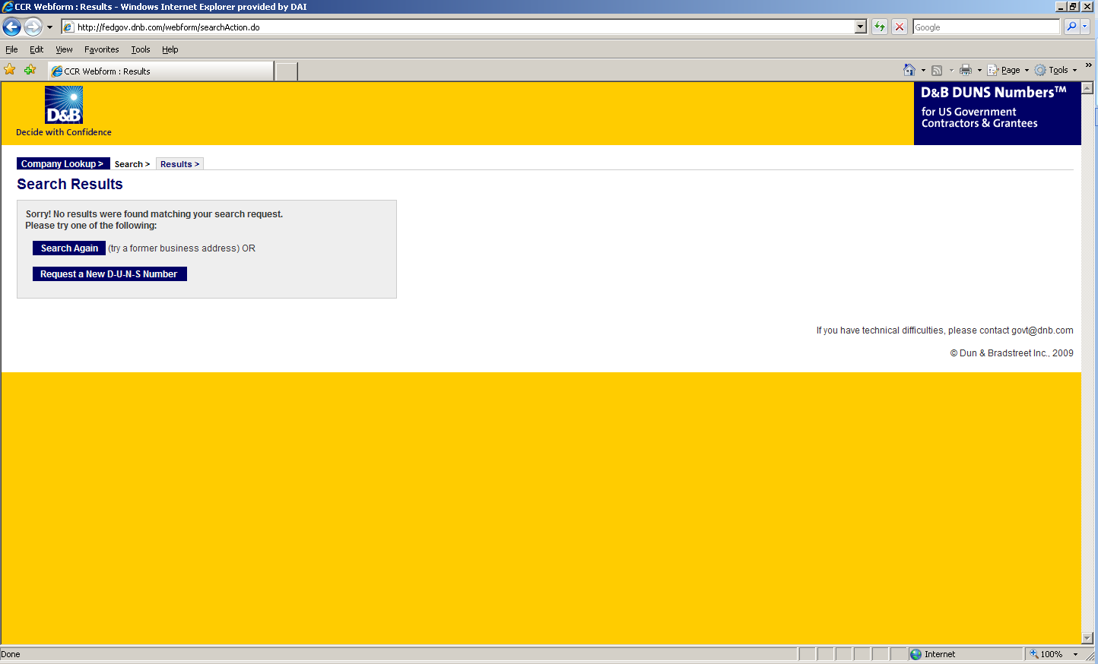

- Enter the information regarding your organization listed on the next three screens. (See screen shots below.) Make sure you have the following information available (in English) prior to beginning the process of entering this section in order to ensure successful registration.

- Legal Business Name (commas are allowed, periods are not allowed)
- Address
- Phone
- Name of Owner/Executive
- Total Number of Employees
- Annual Sales or Revenue (US Dollar equivalent)
- Description of Operations

- Note that some fields are Optional, however all other fields must be completed to proceed further with the application process. For example, all applicants must complete the Organization Information sections. The Company Name and Physical Address fields are self-populated based on information previously entered during the initial DUNS search. The question marks to the left of the field provide additional information when you click on them.
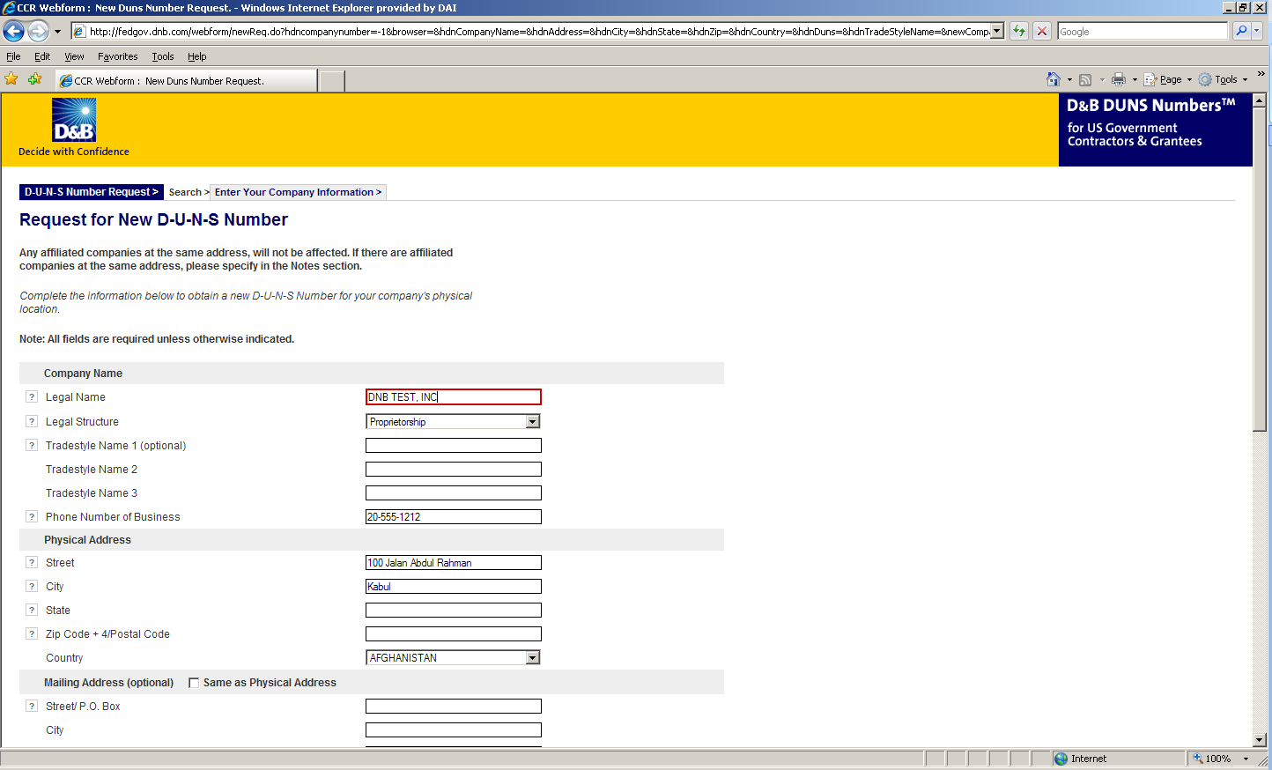

- You must select the legal structure of your organization from the pull-down menu. To assist you in selecting the appropriate structure that best represents your organization, a brief description of the various types follows:

- Corporation – A firm that meets certain legal requirements to be chartered by the state/province in which it is headquartered by the filing of articles of incorporation. A corporation is considered by law to be an entity separate and distinct from its owners. It can be taxed; it can be sued; it can enter into contractual agreements.
- Government - central, province/state, district, municipal and other U.S. or local government entities. Includes universities, schools and vocational centers owned and operated by the government.
- Limited Liability Company (LLC) - This is a type of business ownership combining several features of corporation and partnership structures. It is designed to provide the limited liability features of a corporation and the tax efficiencies and operational flexibility of a partnership. Its owners have limited personal liability for the LLC’s debts and obligations, similar to the status of shareholders in a corporation. If your firm is an LLC, this will be noted on the organization’s registration and licensing documents.
- Non-profit - An entity which exists for charitable reasons and is not conducted or maintained for the purpose of making a profit. Any money earned must be retained by the organization, and used for its own expenses, operations, and programs. Most organizations which are registered in the host country as a non-governmental organization (NGO) rather than as a commercial business are anon-profit entities.
Community based organizations, trade associations, community development councils, and similar entities which are not organized as a profit-making organization should select this status, even if your organization is not registered formally in country as an NGO.
- Partnership- a legal form of operation in which two or more individuals carry on a continuing business for profit as co-owners. The profits and losses are shared proportionally.
- Proprietorship-These firms are owned by one person, usually the individual who has day-to-day responsibility for running the business. Sole proprietors own all the assets of the business and the profits generated by it.

- One of the most important fields that must be filled in is the Primary SIC code field. (See screen shot below.) The Primary Standard Industrial Code classifies the business’ most relevant industry and function.
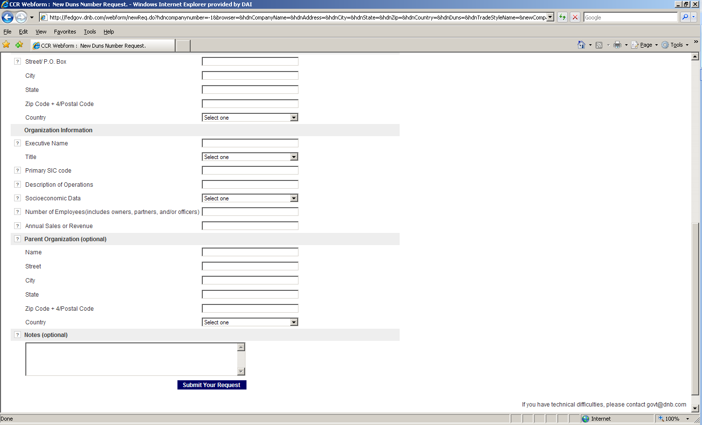
- If you are unsure of which SIC Code your organization’s core business falls under, please refer to the following website: http://www.osha.gov/oshstats/sicser.html
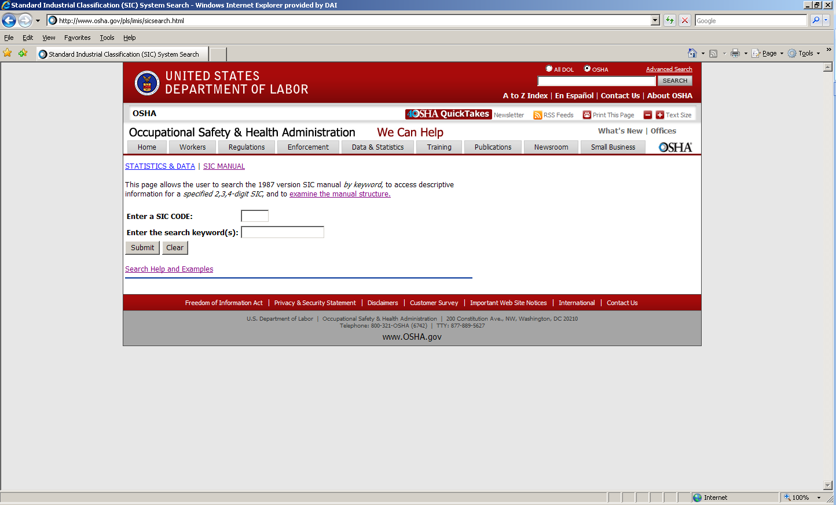

You will need to enter certain keywords to bring up the potential SIC Codes. In the case above, “Research” was entered as the keyword, and resulted in the following:
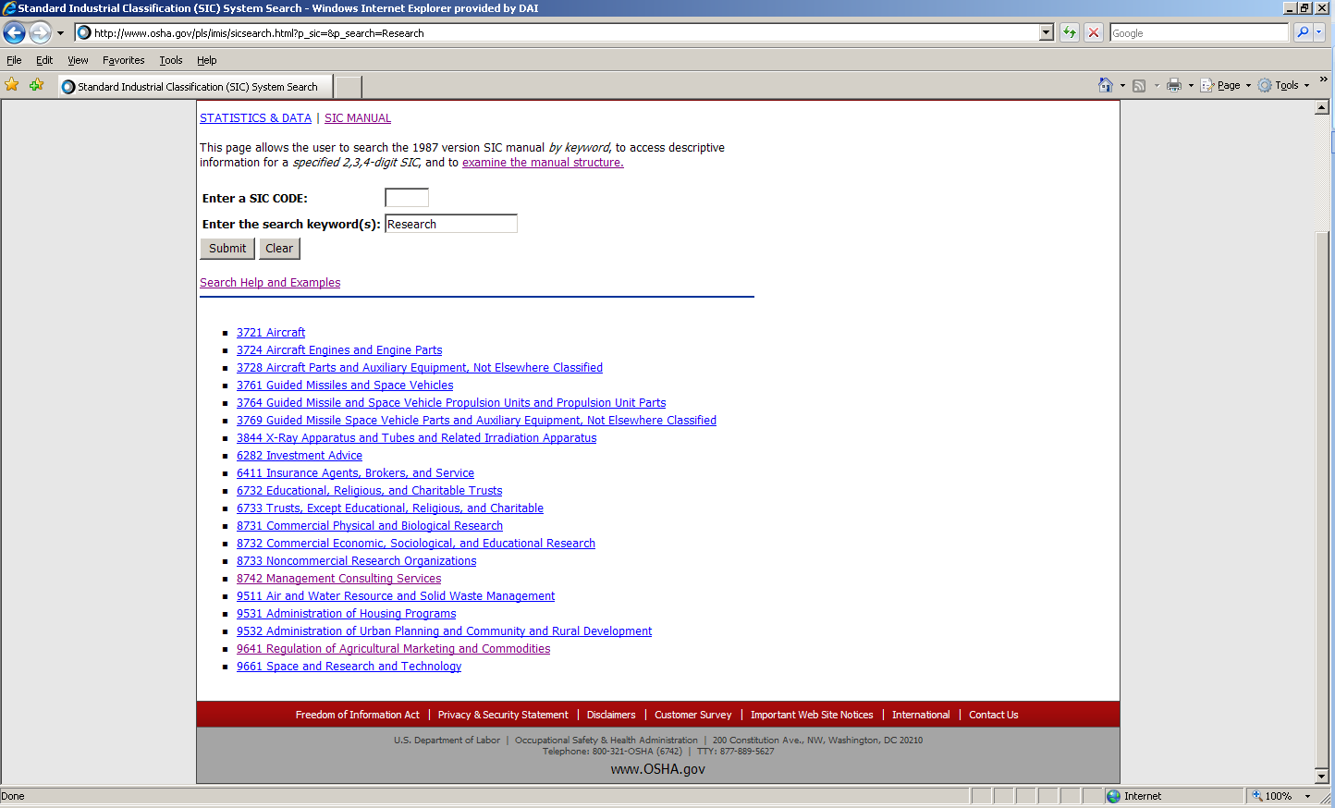

PLEASE NOTE: Many of the DAI subcontractors and grantees fall under one of the following SIC codes:
8742 Management Consulting Services
1542 General Contractors-Nonresidential Buildings, Other than Industrial Buildings and Warehouses or one of the codes within:
Industry Group 357: Computer And Office Equipment
Industry Group 355: Special Industry Machinery, Except Metalworking
Industry Group 356: General Industrial Machinery And Equipment
Industry Group 359: Miscellaneous Industrial And Commercial

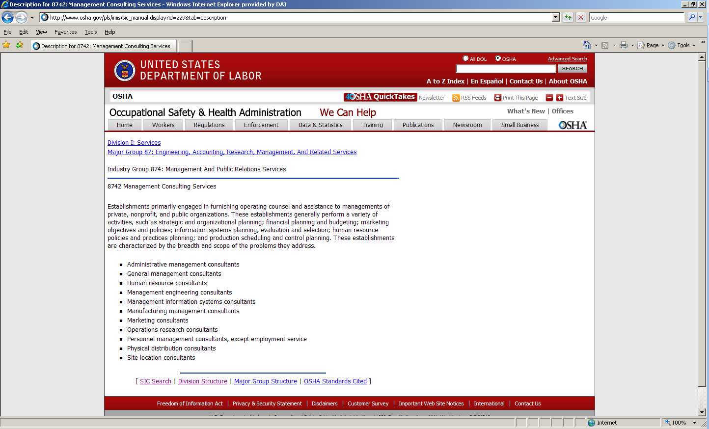
- Description of Operations- Enter a brief description of the primary services you provide the example below, “agricultural technical assistance” was chosen as the primary function of the business.
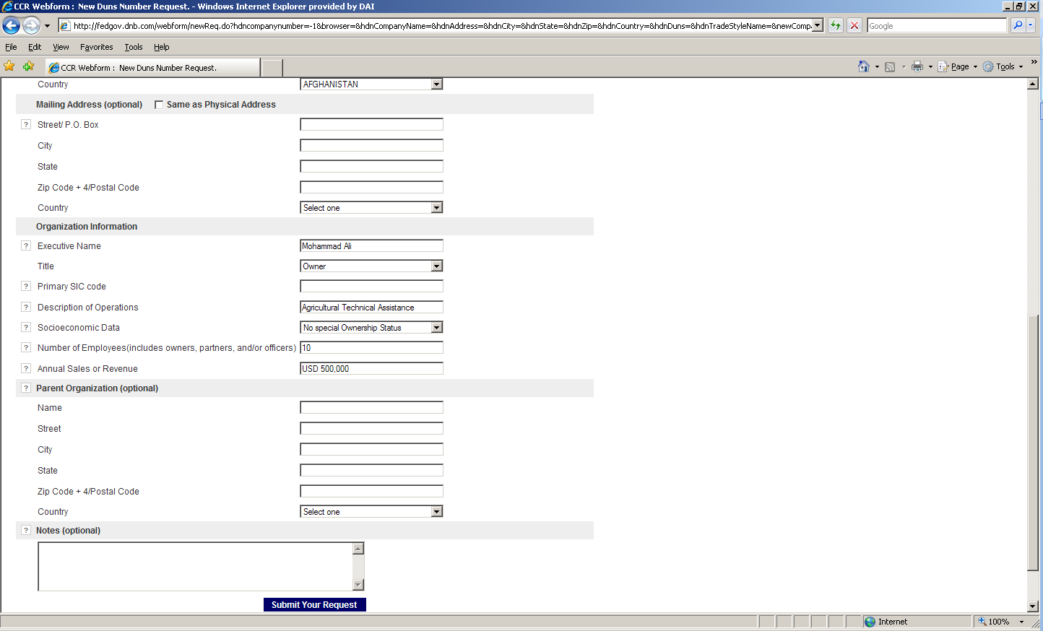
- The Annual Sales or Revenue figure should be provided in USD (US Dollar) equivalent.
- Once all of the fields have been completed, click on “Submit Your Request” to be taken to the Verification page.
- Note: Representative (Principal, Owner or Officer) needs to verify and provide affirmation regarding the accuracy of the data under criminal or civil penalties as per Title 18, Section 1001 of the US Criminal Code.
- Once “Yes, Continue” button is clicked, the registration application is sent to D&B, and a DUNS number should be available within 24-48 hours. DUNS database can be checked in 24-48 hours by entering the Business Information in the Search window – which should now display a valid result with the new DUNS number for the entity.
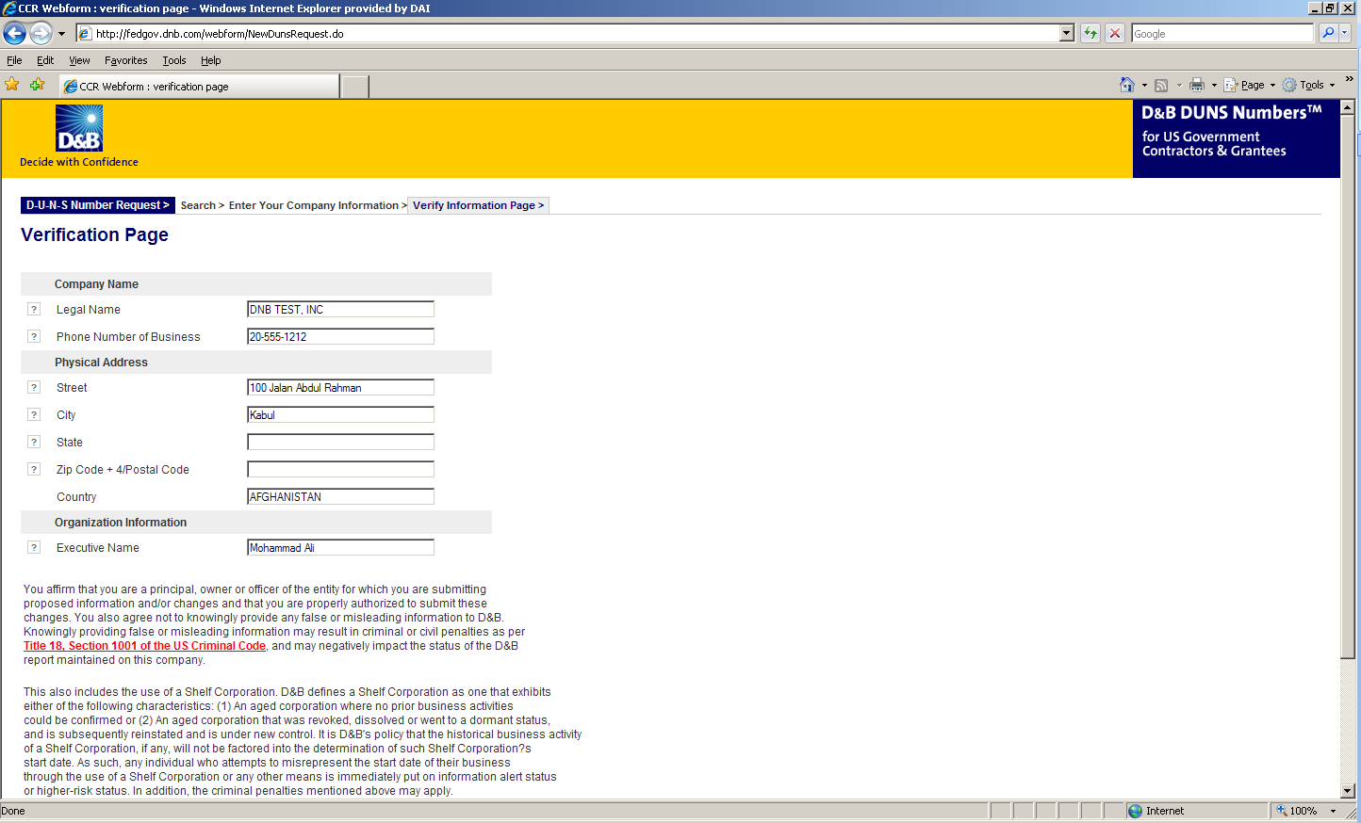

Attachment E: Self Certification for Exemption from DUNS Requirement

Self-Certification for Exemption from DUNS Requirement
For Subcontractors and Vendors
Legal Business Name:
Physical Address:
Physical City:
Physical Foreign Province (if applicable):
Physical Country:
Signature of Certifier
Full Name of Certifier (Last Name, First/Middle Names):
Title of Certifier:
Date of Certification (mm/dd/yyyy):

The sub-contractor/vendor whose legal business name is provided herein, certifies that we are an organization exempt from obtaining a DUNS number, as the gross income received from all sources in the previous tax year is under USD $300,000.
*By submitting this certification, the certifier attests to the accuracy of the representations and certifications contained herein. The certifier understands that s/he and/or the sub-contractor/vendor may be subject to penalties, if s/he misrepresents the sub-contractor/vendor in any of the representations or certifications to the Prime Contractor and/or the US Government.
The sub-contractor/vendor agrees to allow the Prime Contractor and/or the US Government to verify the company name, physical address, or other information provided herein. Certification validity is for one year from the date of certification.

Attachment F: Past Performance Form
Include projects that best illustrate your work experience relevant to this RFP, sorted by decreasing order of completion date.
Projects should have been undertaken in the past fifteen years. Please provide no more than 10 examples. Recent examples will be valued more than older examples
# | Project Title | Description of Activities | Location  Province/  District | Client  Name/Tel No | Cost in US$ | Start-End  Dates | Completed on schedule  (Yes/No) | Completion Letter Received?  (Yes/No) | Type of Agreement, Subcontract, Grant, PO (fixed price, cost reimbursable)
1
2
3
4
5
6
7
8
9
10

Attachment G: Representations and Certifications of Compliance

- Federal Excluded Parties List - The Bidder Select is not presently debarred, suspended, or determined ineligible for an award of a contract by any Federal agency.

- Executive Compensation Certification - FAR 52.204-10 requires DAI, as prime contractor of U.S. federal government contracts, to report compensation levels of the five most highly compensated subcontractor executives to the Federal Funding Accountability and Transparency Act Sub-Award Report System (FSRS)

- Executive Order on Terrorism Financing- The Contractor is reminded that U.S. Executive Orders and U.S. law prohibits transactions with, and the provision of resources and support to, individuals and organizations associated with terrorism. It is the legal responsibility of the Contractor/Recipient to ensure compliance with these Executive Orders and laws. Recipients may not engage with, or provide resources or support to, individuals and organizations associated with terrorism. No support or resources may be provided to individuals or entities that appear on the Specially Designated Nationals and Blocked persons List maintained by the US Treasury (online at www.SAM.gov) or the United Nations Security Designation List (online at: http://www.un.org/sc/committees/1267/aq_sanctions_list.shtml). This provision must be included in all subcontracts/sub awards issued under this Contract.

- Trafficking of Persons – The Contractor may not traffic in persons (as defined in the Protocol to Prevent, Suppress, and Punish Trafficking of persons, especially Women and Children, supplementing the UN Convention against Transnational Organized Crime), procure commercial sex, and use forced labor during the period of this award.

- Certification and Disclosure Regarding Payment to Influence Certain Federal Transactions – The Bidder certifies that it currently is and will remain in compliance with FAR 52.203-11, Certification and Disclosure Regarding Payment to Influence Certain Federal Transactions.

- Organizational Conflict of Interest – The Bidder certifies that will comply FAR Part 9.5, Organizational Conflict of Interest. The Bidder certifies that is not aware of any information bearing on the existence of any potential organizational conflict of interest. The Bidder further certifies that if the Bidder becomes aware of information bearing on whether a potential conflict may exist, that Bidder shall immediately provide DAII with a disclosure statement describing this information.

- Prohibition of Segregated Facilities - The Bidder certifies that it is compliant with FAR 52.222-21, Prohibition of Segregated Facilities.

- Equal Opportunity – The Bidder certifies that it does not discriminate against any employee or applicant for employment because of age, sex, religion, handicap, race, creed, color or national origin.

- Labor Laws – The Bidder certifies that it is in compliance with all labor laws.

- Federal Acquisition Regulation (FAR) – The Bidder certifies that it is familiar with the Federal Acquisition Regulation (FAR) and is in not in violation of any certifications required in the applicable clauses of the FAR, including but not limited to certifications regarding lobbying, kickbacks, equal employment opportunity, affirmation action, and payments to influence Federal transactions.

- Employee Compliance – The Bidder warrants that it will require all employees, entities and individuals providing services in connection with the performance of an DAI Purchase Order to comply with the provisions of the resulting Purchase Order and with all Federal, State, and local laws and regulations in connection with the work associated therein.

By submitting a proposal, offerors agree to fully comply with the terms and conditions above and all applicable U.S. federal government clauses included herein and will be asked to sign these Representations and Certifications upon award.

List of Additional Attachments

Attachment H: Branding and Marking Plan

Note: This is not required as part of the proposal. It is included as information for the Offeror. Upon subcontract award, this will be the first deliverable due.
Appendix N: Marking Plan
Sub Project Number and Name: _____________________________________________________
Name of Implementing Partner: _____________________________________________________
Name and Title of Partner’s Agent: __________________________________________________
Name and Title of DAI Project Manager: _____________________________________________
Instructions: This form has been created to provide implementing partners (subcontractors and grantees) and DAI Project Managers with a summary of marking requirements found in the Project’s Branding Implementation Plan (BIP). This form must be completed by the DAI Project Manager in conjunction with the agent of the implementing partner. Once completed, the Project Manager must upload the form to TAMIS.
Subproject Activities
Provide a short summary of the activities to be completed including the project location. For example, what materials or equipment will be purchased? What events will take place?

Include 2-3 sentence summary here:

Please place an “X” below for each activity that will take place as part of this Sub project. The implementing partner will be responsible for ensuring the Marking noted in the table below is implemented according to standards and templates provided.

Mark “X” | Activity/Documents | Required Marking
Activities
Documents
 | Reports
 | Certificates (training or other)
 | Invitations
 | Other (please describe)

Co- Branding and Co-Marking:

DAI logo must not appear on any USAID funded programmatic material.

Requests for Exceptions or Waivers of Marking Requirements – If you do not feel it is possible to mark one or more of the items or events listed above, please describe below (1) what marking you want to be exempt from (2) how the activity or item meets the requirement for an exception or waiver.

Include full detailed justification here:

Attachment I: Full Terms of Contract – to be provided prior during Subcontract negotiations.

Attachment J: Proposal Checklist

Offeror: __________________________________________________________________________
Have you?
Submitted your proposal to DAI to the electronic address ProcurementERAInbox@dai.com as specified in General Instructions above?
Does your proposal include the following?
Signed Cover Letter (use template in Attachment B)
Separate Technical and Cost proposals individually labeled as Volume I and Volume II respectfully
Proposal of the Product or Service that meets the technical requirements as per Attachment A
Cost proposal include templates referenced in Attachment C.1: Detailed budget
Response to each of the evaluation criteria
Documents use to determine Responsibility: valid local business registration (company registration documents, including document from the tax authority about VAT status)
Evidence of a DUNS Number OR Self Certification for Exemption from DUNS Requirement
Past Performance (use template in Attachment F)

Please take into account a “Tentative list of elements to be covered in course of BDS workshop” later in the document
Our analysis is based on a series of in-depth interviews conducted with Donetsk and Luhansk businesses in December 2018-January 2019. The 18 interviews covered eight companies in the machine building and metalworking sectors, five companies in chemicals, three producers of plastic and other non-metal products, and two companies in pharmaceuticals. The companies are located in Mariupol, Kramatorsk, Druzhkivka, Sievierodonetsk, Manhush, Rubizhne, Slovyansk, Kostyantynivka, and Vuhledar.
This implies e.g. making the top management conduct “introspection exercise” whereby they will raise to the surface those inner motivations, desires and inclinations that move them in business. This should help building a bridge between corporate culture, strategic vision and individual satisfaction of team members

