USAID Financial Sector Transformation Project (FST)
Request for Proposals (RFP)

No. REQ-KYV-19-0117

The Remittances in Ukraine Survey

Issue Date: May 16, 2019

NOTICE: Prospective Offerors who have received this document from a source other than the USAID Financial Sector Transformation Project, 33B, Shevchenka Boulevard, Kyiv, Ukraine, ProcurementFST@dai.com, are advised to contact ProcurementFST@dai.com and provide their name and mailing address to make sure that amendments to the RFP or other communications can be sent directly to them. Any amendments and updates to this solicitation will be sent to all registered participants by email.

Table of Contents
1. Introduction and Purpose 4
1.1 Purpose 4
1.2 Issuing Office 4
1.3 Type of Award Anticipated 4
2. General Instructions to Offerors 4
2.1 General Instructions 4
2.2 Proposal Cover Letter 5
2.3 Questions regarding the RFP 5
3. Instructions for the Preparation of Technical Proposals 5
3.1 Services Specified 6
3.2 Technical Evaluation Criteria 6
4. Instructions for the Preparation of Cost/Price Proposals 6
4.1 Taxes and VAT 7
5. Basis of Award 8
5.1 Best Value Determination and Selection Process 8
5.2 Responsibility Determination 8
6. Anticipated post-award Deliverables 8
7. Inspection & Acceptance 10
8. Compliance with Terms and Conditions 10
8.1 General Terms and Conditions 10
8.2 Source and Nationality 10
9. Procurement Ethics 10
10. Attachments 12
10.1 Attachment A: Scope of Work for Services or Technical Specifications 12
10.2 Attachment B: Proposal Cover Letter 15
10.3 Attachment C: Price Schedule 16
10.4 Attachment D: Past Performance Summary / References 18
10.5 Attachment E: Representations and Certifications of Compliance 19
10.6 Attachment F: Instructions for Obtaining a DUNS Number - DAI’S Vendors, Subcontractors 20
10.7 Attachment G: Self Certification for Exemption from DUNS Requirement 27
List of Optional Attachments 28
10.8 Attachment H: Proposal Checklist 29

Synopsis of the RFP
RFP No. | RFP No. REQ-KYV-19-0117
Issue Date | May 16, 2019
Title | The Remittances in Ukraine Study
Issuing Office & Email for Submission of Proposals | USAID Financial Sector Transformation Project, 33B, Tarasa Shevchenko Boulevard, Kyiv, Ukraine, ProcurementFSTInbox@dai.com
Deadline for Receipt of Questions | Questions regarding the RFP should be submitted via email to ProcurementFST@dai.com not later than May 30, 2019 18:00 Kyiv time
Deadline for Receipt of Proposals | Final proposals should be submitted electronically in PDF format via email to DAI no later than June 10, 2019 18:00 Kyiv time to the following address ProcurementFSTInbox@dai.com.  Cost proposal should be separated from the technical. Under no circumstances may cost information be included in the technical proposal. No cost information or any prices, whether for deliverables or line items, may be included in the technical proposal. Cost information must only be shown in the cost proposal
Point of Contact | ProcurementFST@dai.com
Anticipated Award Type | Firm Fixed Price Purchase Order
Basis for Award | Awards will be made based on the Trade Off Method. The award will be issued to the responsible and reasonable Offeror(s) who provides the best value to DAI and its client using a combination of technical and cost/price factors

Introduction and Purpose

Purpose
The overall goal of this RFP is to select an organization/company that will examine worker remittance flows to Ukraine in terms of a possible source of investment in SMEs, and its impact on the financial system more generally (exchange rate, formalization, transaction costs). The objective is to develop policy recommendations and possible technical assistance interventions to channel the remittances through formal, less costly channels and possibly to investments in SMEs. This means examining retail payments networks for remittance transfers, and looking at the cost of remittance transactions.

Issuing Office
The Issuing Office noted in the above synopsis is the sole point of contact at DAI for purposes of this RFP. Any prospective Offeror who fails to register their interest with this office assumes complete responsibility in the event that they do not receive direct communications (amendments, answers to questions, etc.) prior to the closing date.

Type of Award Anticipated
DAI anticipates awarding a Firm Fixed Price Subcontract/Purchase Order.
A Firm Fixed Price Purchase Order is an award for a total firm fixed price for the provision of specific services, goods, or deliverables and is not adjusted if the actual costs are higher or lower than the fixed price amount.
This RFP does not obligate DAI to execute a subcontract nor does it commit DAI to pay any costs incurred in the preparation and submission of the proposals. Furthermore, DAI reserves the right to reject any and all proposals, if such action is considered to be in the best interest of DAI.

General Instructions to Offerors

General Instructions

“Offeror”, “Subcontractor”, and/or “Bidder” means a firm proposing the work under this RFP.
“Offer” and/or “Proposal” means the package of documents the firm submits to propose the work.
“Finalist” means an Offeror who has been selected and invited to Stage 2 (Finalists Presentation) of the selection process.
Offerors wishing to respond to this RFP must submit proposals in English in accordance with the following instructions.
Offerors are required to review all instructions and specifications contained in this RFP. Failure to do so will be at the Offeror’s risk. If the solicitation is amended, then all terms and conditions not modified in the amendment shall remain unchanged.
Issuance of this RFP in no way obligates DAI to award a subcontract or purchase order. Offerors will not be reimbursed for any costs associated with the preparation or submission of their proposal. DAI shall in no case be responsible or liable for these costs.
Proposals are due no later than June 10, 2019 18:00 Kyiv time, to be submitted via procurement email ProcurementFSTInbox@dai.com. The RFP number (REQ-KYV-19-0117) and title of the activity (The Remittances in Ukraine Study) must be stated in the subject line of the email, cost and technical proposals shall be submitted in different files in PDF format. The email size should not exceed 10 MB. Late offers will be rejected except under extraordinary circumstances at DAI’s discretion.
The submission to DAI of a proposal in response to this RFP will constitute an offer and indicates the Offeror’s agreement to the terms and conditions in this RFP and any attachments hereto. DAI reserves the right not to evaluate a non-responsive or incomplete proposal.

Proposal Cover Letter
A Cover Letter shall be included with the proposal on the Offeror’s personal or company letterhead with a duly authorized signature and company stamp/seal (if applicable) using Attachment B as a template for the format. The cover letter shall include the following information:
- Name and type of the company or organization.
- Address, phone, email.
- Certification the validity period of the offer.
- Certification to comply with the proposed delivery or performance schedule.
- Certification that the company has adequate financial resources to perform the work without obtaining advances from DAI.
- Certification of understanding that these products or services are eligible for VAT exemption under the DAI prime contract.

Other required documents that shall be included as attachments to the cover letter:
- Copy of company registration or incorporation in the public registry.
- Copy of company tax registration, or equivalent document.

Questions regarding the RFP
Requests for clarification or additional information must be submitted in writing via email to the Issuing Office as specified in the Synopsis above. No questions will be answered by phone. Any verbal information received from a DAI or FST employee or other entity shall not be considered as an official response to any question regarding this RFP.
Copies of questions and responses will be distributed by e-mail to all registered Bidders after the deadline for receiving questions.

Instructions for the Preparation of Technical Proposals
Technical proposal PDF file shall be clearly named as “VOLUME I: TECHNICAL PROPOSAL”.
The technical proposal shall comprise the following parts:
Part 1: Technical Approach (5 pages).
The Offeror’s proposal must detail the Offeror’s technical approach, including the proposed methodology, sources, interview subjects, interview sites, schedule, implementation plan, and other specific survey tasks the Contractor will undertake. The proposal must clearly describe the offeror’s understanding of the survey methodological approach, methods of investigation, and planned data collection and analysis. The proposal must note planned interviews and identify resources to be utilized. The proposal shall also identify any areas of support required technical assistance. This part may not exceed 5 pages.
Part 2: Management, Key Personnel, and Staffing Plan (2 pages).
This part may not exceed 2 pages. CVs for key personnel must be included in an annex to the technical proposal and will not count against the page limit. However, no individual CV may be more than three (3) pages.
Please describe how proposed staff will work collaboratively to achieve Offeror’s proposed technical approach to the scope of work.
Offerors may suggest key personnel, specify their roles, and provide justification for each additional team member proposed.

Part 3: Corporate Capabilities, Experience, and Past Performance (3 pages).
- Part 3 must include a description of the company and organization, with appropriate reference to any parent company and subsidiaries. Offerors must include details demonstrating their experience and technical ability in implementing the technical approach/methodology and the detailed work plan. Additionally, offerors must include three 3 past performance references of similar work (under contracts or subcontracts) previously implemented as well as contact information for the companies for which such work was completed. Contact information must include at a minimum: name of point of contact who can speak to the Offeror’s performance, name and address of the company for which the work was performed, and email and phone number of the point of contact.

Services Specified

For this RFP, DAI requires the services to comply with Attachment A (Scope of Work for Services or Technical Specifications).

Technical Evaluation Criteria
Technical proposals will be evaluated against the following criteria:
- Technical Approach
- Qualification of Proposed Experts and Key Personnel
- Corporate Experience and Past Performance

Instructions for the Preparation of Cost/Price Proposals
Cost/Price proposals PDF file shall be clearly named as “VOLUME II: COST/PRICE PROPOSAL”.
The cost proposal is used to determine which proposals represent the best value and serves as a basis of negotiation before award of a subcontract.
The price of the subcontract to be awarded will be an all-inclusive fixed price. No profit, fees, taxes, or additional costs can be added after award. Nevertheless, for the purpose of the proposal, Offerors must provide a detailed budget showing major line items, e.g. salaries, allowances, travel costs, other direct costs, indirect rates, etc., as well as individual line items, e.g. salaries or rates for individuals, different types of allowances, rent, utilities, insurance, etc. Offers must show unit prices, quantities, and total price. All items, services, etc. must be clearly labeled and included in the total offered price. All cost information must be expressed in UAH.
Cost will primarily be evaluated for realism, reasonableness and structural coverage of all activities. This evaluation will consist of a review of the cost portion of an Offeror’s application to determine if the overall proposed cost is realistic for the work to be performed, if the costs reflect the Offeror’s understanding of the requirements, and if the costs are consistent with the Technical Proposal.
See Attachment C for a sample budget structure.
The cost proposal shall also include a budget narrative that explains the basis for the estimate of every cost element or line item. Supporting information must be provided in sufficient detail to allow for a complete analysis of each cost element or line item. DAI reserves the right to request additional cost information if the evaluation committee has concerns about the reasonableness, realism, or completeness of an Offeror’s proposed cost.
If it is an Offeror’s regular practice to budget indirect rates, e.g. overhead, fringe, G&A, administrative, or other rate, Offerors must explain the rates and the rates’ base of application in the budget narrative. DAI reserves the right to request additional information to substantiate an Offeror’s indirect rates.

Under no circumstances may cost information be included in the technical proposal. No cost information or any prices, whether for deliverables or line items, may be included in the technical proposal. Cost information must only be shown in the cost proposal.

Taxes and VAT
Because FST is a USAID funded project and is implemented under a bilateral agreement between the Ukraine and the U.S. Government, Offerors must not include VAT and customs duties in their cost proposal.
FST is exempt from cooperating country taxes, duties, and VAT. Therefore, FST shall pay for the cost of services exclusive of VAT.
DAI is implementing international technical assistance programs and projects in Ukraine in accordance with the Agreement between the Government of the United States of America and the Government of Ukraine about Humanitarian and Technical Economic Cooperation of May 7, 1992 (hereinafter referred to as “Agreement”). DAI has to purchase goods, works and services in order to carry out the above mentioned international technical assistance project. In accordance with the abovementioned Agreement and Procedure of engaging, using and monitoring international technical assistance approved by the Cabinet of Ministers of Ukraine Resolution no. 153 (153-2002-п) as of February 15, 2002, “On creating a unified system for engaging, using and monitoring international technical assistance”, the cost of such goods (works, services) is exempt from Value Added Tax (VAT).
Procurement of goods, works and services shall be made at the cost of the international technical assistance project and is relevant to the category (type) of goods, works and services mentioned in the procurement plan.
The project shall provide the successful Offeror with a copy of the registration card of the project for purchasing the goods, works and services, issued by the Ministry of Economic Development and Trade and certified by the project’s stamp, and a copy of the procurement plan or an extract from the procurement plan certified by the project stamp.
The Offeror shall submit a fiscal bill for goods (works, services) completed in accordance with the procedure set forth below and marked “Without VAT”. A fiscal bill shall include the grounds for VAT exemption (project name, number and date of the relevant contract). The subcontractor shall submit the declaration to the state tax authority at its location taking into account the abovementioned operations and mentioning VAT exemption code #14060049 according to the Tax Exemptions Directory.
WARNING: Offerors must affirmatively state in the offer that they understand DAI is VAT exempt and that this exception will be recognized for all invoicing. Failure to affirmatively state offerors intention to recognize the Ukrainian VAT exemption may be grounds for exclusion for consideration and award of a contract under this RFP.

Basis of Award

Best Value Determination and Selection Process

DAI will review all proposals, and make awards based on the technical evaluation criteria stated below, and the cost proposal evaluation. Each complete proposal will be scored according to the scale presented in the table below. In the overall evaluation of proposals, technical evaluation factors, in combination, are considered significantly more important than price factor.
Evaluation Criteria | Maximum Points
Technical Approach | 30
Qualification of Proposed Experts and Key Personnel | 30
Corporate Experience and Past Performance | 20
Cost Proposal (Budget) | 20
Total | 100

The Tender Committee members evaluate the technical proposals based on the selection criteria by assigning points among the highest total possible for each criterion as indicated in the above table.
The number of points for the "Cost Proposal" criterion is calculated as follows:
Кі=k*Pmin/Pi, where
k - the maximum number of points for the "Cost" criterion;
Pmin - minimum price offered by the Offerors;
Pі - the price offered by the Offerror, whose proposal is under evaluation.
Awards will be made to responsible Offerors, whose proposals receive the highest score.
DAI may also exclude an offer from consideration if it determines that an Offeror is "not responsible", i.e., that it does not have the management and technical capabilities required to perform the work required.

Responsibility Determination
DAI will not enter into any type of agreement with an Offeror prior to ensuring the Offeror’s responsibility. When assessing an Offeror’s responsibility, the following factors are taken into consideration:
- Companies or organizations, whether for-profit or non-profit, must be legally registered under the laws of Ukraine upon award of the subcontract.
- Companies or organizations must have a local presence in Ukraine at the time the subcontract is signed.
- Companies or organizations, whether for-profit or non-profit, shall be requested to provide a DUNS number if selected to receive a sub-award valued at USD$30,000 or more, unless exempted in accordance with information certified in the Evidence of Responsibility form included in the required certifications in Attachment E.
- Be qualified and eligible to perform work under applicable laws and regulations.

Anticipated post-award Deliverables
Upon award of a subcontract, the deliverables detailed in the table below will be submitted to DAI, according to the indicated time frame. In view of tasks foreseen for each stage, the Subcontractor shall submit methodology of data collection, questionnaire, report, recommendations, summaries and handouts in the format prepared for publishing (electronic and hard copies).

№ | Description | Due Date
1. | Initial Report | 5 weeks after subcontract signing
2. | Memorandum | 7 weeks after subcontract signing
3. | Report | 9 weeks after subcontract signing
4. | Final Report and Power Point presentation | September 30, 2019
USAID/FST expects several documents that will help it determine what, if any, cost-effective technical interventions it can perform to formalize the flow of remittances and reduce transaction costs and/or increase investments. These deliverables can be revised and incorporated into the overall final report. Offerors wishing to respond to this RFP must submit proposals and deliverables in English.
Deliverable No. 1
Initial Report: a document that focuses on how remittances to Ukraine are transferred, whether the flows are mainly formal or informal, who the main players are, and what are the costs of transactions. It should begin with a discussion of remittances and development theory, move to a description of the situation in Ukraine (amounts, projections, channels, how remittances are used, etc.), and then focus on questions of financial impact. It should include a section on legal/regulatory issues of the payments system if this is important in terms of channels and costs. The mix of investment versus consumption should be addressed. The paper should document the remittance network, how it relates to the financial system, and what policy measures might be taken to maximize its positive impacts. It should include an analysis of what banks and finance companies are doing regarding remittances.
Deliverable No. 2
Memorandum: a short memorandum discussing what initiatives are being undertaken in the remittance area by the Government of Ukraine and/or by international financial institutions or donors. This brief survey should also include what, if any, work is being done by academic institutions or think tanks.
Deliverable No. 3
Report: depending on the findings, 2 – 4 write-ups of possible technical assistance interventions that might be initiated by USAID/FST. These should include the objectives of the intervention, the problem being addressed, the activities necessary to carry out, outcomes, and measures of project success.
Deliverable No. 4
Final Report and Power point presentation: A final report incorporating all deliverables and a power point presentation based on the above items for discussion with USAID and FST.

Inspection & Acceptance
All deliverables are subject to approval by DAI and considered final upon DAI approval. DAI reserves up to 20 working days to provide written comments on the deliverables from the selected Offeror.

Compliance with Terms and Conditions

General Terms and Conditions
Offerors agree to comply with the provisions for Obtaining a Duns Number for an award resulting from this RFP (Attachment F). The selected Offeror shall comply with all representations and certifications of compliance listed in Attachment E.

Source and Nationality
Under the authorized geographic code for its contract DAI may only procure goods and services from the following countries.
Geographic Code 110: Goods and services from the United States, the independent states of the former Soviet Union, or a developing country, but excluding Prohibited Countries.
DAI must verify the source and nationality of goods and services and ensure (to the fullest extent possible) that DAI does not procure any goods or services from prohibited countries listed by the Office of Foreign Assets Control (OFAC) as sanctioned countries. OFAC sanctioned countries may be searched within the System for Award Management (SAM) at www.SAM.gov. The current list of countries under comprehensive sanctions include: Cuba, Iran, North Korea, Sudan, and Syria. Goods may not transit through or be assembled in comprehensive sanctioned origin or nationality countries nor can the vendor be owned or controlled by a prohibited country. DAI is prohibited from facilitating any transaction by a third party if that transaction would be prohibited if performed by DAI.
By submitting a proposal in response to this RFP, Offerors confirm that they are not violating the Source and Nationality requirements of the goods or services being offered and that the goods and services comply with the Geographic Code and the exclusions for prohibited countries outlined above.

Procurement Ethics
Neither payment nor preference shall be made by either the Offeror, or by any DAI staff, in an attempt to affect the results of the award. DAI treats all reports of possible fraud/abuse very seriously. Acts of fraud or corruption will not be tolerated, and DAI employees and/or subcontractors/grantees/vendors who engage in such activities will face serious consequences. Any such practice constitutes an unethical, illegal, and corrupt practice and either the Offeror or the DAI staff may report violations to the Toll-Free Ethics and Compliance Anonymous Hotline at +1 855-603-6987, via the DAI website, or via email to FPI_hotline@dai.com. DAI ensures anonymity and an unbiased, serious review and treatment of the information provided. Such practice may result in the cancellation of the procurement and disqualification of the Offeror’s participation in this, and future, procurements. Violators will be reported to USAID, and as a result, may be reported to the U.S. Department of Justice to be included in a Restricted Parties list, preventing them from participating in future U.S. Government business.

Offerors must provide full, accurate and complete information in response to this solicitation. The penalty for materially false responses is prescribed in Section 1001 of Title 18 of the United States Code.
In addition, DAI takes the payment of USAID funds to pay Terrorists, or groups supporting Terrorists, or other parties in exchange for protection very seriously. Should the Terrorist, groups or other parties attempt to extort/demand payment from your organization you are asked to immediately report the incident to DAI’s Ethics and Compliance Anonymous Hotline at the contacts described in this clause.
By submitting an offer, Offerors certify that they have not/will not attempt to bribe or make any payments to DAI employees in return for preference, nor have any payments with Terrorists, or groups supporting Terrorists, been attempted.

Attachments

Attachment A: Scope of Work for Services or Technical Specifications
- Purpose

This study will examine worker remittance flows to Ukraine in terms of a possible source of investment in SMEs, and its impact on the financial system more generally (exchange rate, formalization, transaction costs). The objective is to develop policy recommendations and possible technical assistance interventions to channel the remittances through formal, less costly channels and possibly to investments in SMEs. This means examining retail payments networks for remittance transfers, and looking at the cost of remittance transactions.

- Background

According to some estimates, remittances to Ukraine from workers abroad topped $14 billion in 2018, up 20% over the previous year. This is the highest figure for any receiving country in Europe or Central Asia, and it equates to about 9 % of GDP. A decade ago (2008), remittances were just $3.75 billion. The largest amounts of remittances in 2018 came from Poland, Russia, the United States, the Czech Republic and Italy. The National Bank of Ukraine is now paying closer attention to remittances because of the potential impact on the exchange rate. For example, the NBU now publishes statistics regularly on “Private Money Transfers to Ukraine” and discusses remittances. It is unclear, however, what development impact this surge in revenues from workers abroad is having on the country’s economy or financial system.
There are an estimated 4-5 million Ukrainians working abroad, many of them young and in fairly typical industries for foreign workers – construction, hospitality, health care, domestic service, and agriculture. A significant portion are also IT specialists. About 60% of migrants stated their intent to return to Ukraine in a recent survey of foreign workers. According to a 2018 study by the Centre for Economic Strategy, the profile of Ukrainians working abroad temporarily is:
• 70% were from Western Ukraine;
• About 1 million worked in Poland on a circular basis;
• Most were aged 21 to 30;
• 16% had university educations (as compared to 48% of Ukrainians generally).
• Over 60% were working without contracts
• About 13% were IT specialists and this group was the least likely to return home.
The rise of remittances has increased the availability of external financing for Ukraine (and may have introduced an economic safety factor through counter cyclical capital inflows). It is also probable that worker remittances have had a positive impact on poverty reduction and increased household incomes. Some research suggests that remittances have led to higher consumption spending on health care, education and housing. How this money is moving into Ukraine is not completely clear, nor is the exact amount. However, according to NBU methodology and data the mix is about 50/50 in terms of formal/informal flows. Informal flows are highest from Russia and Poland, as one would expect.
The development literature, especially analyses by the World Bank, the IMF, and UNCTAD, suggests that the benefits of remittances do not come without caveats. While it is generally accepted that remittances lead to poverty reduction, there is no strong evidence that they contribute to or propel economic growth. IMF experts talk about the Migration Trap – remittances leading to lower economic growth and ever higher out migration. Remittances may result in governance issues by insulating politicians from being accountable and responsive to citizen needs. Remittances may lead to “Dutch Disease.” Thus, remittances are viewed with caution by international development experts, with the consensus being that they have the potential to support the development of productive capacities (increased investment in human and physical capacities, financial deepening) but the realization of the benefits depends on the policy and institutional frameworks of a specific country. Without the capacity of the state to create a development centered macroeconomic environment, including the establishment of a viable and inclusive financial sector, economic benefits will not arrive. This means that both the country’s financial infrastructure and its legal/regulatory may need to be reformed. This may be especially true in terms of stronger competition in retail payment systems, payment platforms and payment instruments.
It should also be noted that there are other positive and negative aspects of remittances for economic development. On the positive side is the development of human capital (education spending), the reduction of unemployment, and capital inflows that might be invested. On the negative side are possible adverse fiscal impacts (loss of social and pension contributions, taxes), stratification (receivers/non-receivers), wage inflation, and possible real estate bubbles. Another important issue is cost: the global average cost of sending $200 as a remittance in 2018 was a very high 7-8% (banks, post offices, telecommunications companies). The Sustainable Development Goal for 2030 is to lower the cost to 3%.
- Tasks
- Write a brief summary of the conclusions of the economic development literature regarding remittances and poverty reduction, economic growth, and the financial system (with a focus on international experience with using remittances for investment, and issues of payment systems and transaction costs).
- Analyze the Ukrainian situation regarding remittances, including main channels (formal/informal, bank/non-bank, payment providers/informal networks), the quality of the data, transaction costs. Who are the main players in remittance payments? What are the drivers of the current situation? This may entail field research or focus group research in Western Ukraine.
- Write a brief analysis of Ukraine’s legal/regulatory framework for remittance payments. Does the current system facilitate legal, formal transactions for remittances? If not, what are the obstacles and how can they be overcome? Specifically, what reforms can the NBU initiate, and which would require new legislation?
- Analyze what private financial companies are doing to capture remittance flows. Are banks developing special programs targeting this capital source? What are payments companies doing in this area? Are FinTech companies active in developing applications to assist foreign workers?
- Analyze international experience in terms of any “model” solutions that might be applied in Ukraine. Are there successful examples of using remittances for investment in SMES? Examine whether other international financial institutions active in Ukraine are pursuing specific initiatives.
- Identify and recommend technical assistance interventions USAID/FST might consider implementing. Policy dialogue? Legal/regulatory reform initiatives to ease payment issues via p2p transactions? SME investment possibilities? Web or mobile applications? Are there ways to reduce fees? Can access by migrant workers to banking services be increased?

- Performance Period:
The desk analysis is expected to commence in the end of June, with interviews in July-August, and the final report completed by September 30, 2019.

Attachment B: Proposal Cover Letter
[On Offeror’s Letterhead]
<Insert date>

TO: USAID/FST Project, Managed by DAI Global LLC

We, the undersigned, provide the attached proposal in accordance with REQ-KYV-19-0117 The Remittances in Ukraine Study issued on June 29, 2019. Our attached proposal is for the total price of <Sum in Words (0.00 UAH Sum in Figures)>.

We certify a validity period of 90 days for the prices provided in the attached Price Schedule (Attachment C). Our proposal shall be binding upon us subject to the modifications resulting from any discussions.

We understand that these products or services are eligible for VAT exemption under the DAI
prime contract. The total amount will be paid without VAT.

We confirm that we have adequate financial resources to deliver goods and services or the ability to obtain financial resources without receiving advance funds from DAI.

We understand that DAI is not bound to accept any proposal it receives.

Yours sincerely,

Authorized Signature:
Name and Title of Signatory: [●]
Name of Offeror: [●]
Address: [●]
Telephone: [●]
Email: [●]
Company Seal/Stamp:

Attachment C: Price Schedule

№ | Deliverables | Due Date | Price, UAH
1. | Initial Report | 5 weeks after subcontract signing
2. | Memorandum | 7 weeks after subcontract signing
3. | Report | 9 weeks after subcontract signing
4. | Final Report and Power Point presentation | September 30, 2019
Total ( without VAT ):
Create a budget for the cost proposal. Each Offeror must create a budget using a spreadsheet program compatible with MS Excel. The budget period should follow the technical proposal period. A sample budget is shown on the following page.

Write Cost Notes. The spreadsheets shall be accompanied by written notes in MS Word that explain each cost line item and the assumption why a cost is being budgeted as well as how the amount is reasonable.

Sample Budget
Offeror's Name ________________
RFP #ARDS-S0-33
No. | Description | Quantity | Unit | Frequency | Calculation  purpose | Cost per unit,  UAH | Total,  UAH
1 | Services Remuneration/Salary
1,1 | Name1/Expert 1 | 1 | day | 2
1,2 | Name2/Expert 2 | 16 | hour | 5
1,3 | Name3/Assistant | 30 | hour | n/a
1,4 | XXXXXXXXXXXXXXXXX
Subtotal
2 | Business Trips
2,1 |  | 45 | participant | 2 | round trip
2,2 |  | 25 | participant | 5 | round trip
2,3 | XXXXXXXXXX
Subtotal
3 | Handouts printing
3,1 |  | 45 | participant | 2
3,2 |  | 25 | participant | 5
3,3 | XXXXXXXXXX
Subtotal
4 | XXXXXXXX
4,1
4,2
 |  |  |  |  |  | Subtotal
GRAND TOTAL

Attachment D: Past Performance Summary / References
If you are a legal entity with relevant work experience, please provide a list of three projects that best illustrate your work experience relevant to this RFP, sorted by decreasing order of completion date.
Projects should have been undertaken in the past three years. Projects undertaken in the past six years may be taken into consideration at the discretion of the evaluation committee.

# | Description of Activities | Location | Client / Reference  Name/Tel No | Cost in US$ (if applicable) | Start-End  Dates | Completed on schedule  (Yes/No) | Completion Letter Received?  (Yes/No)
1
2
3

Attachment E: Representations and Certifications of Compliance

- Federal Excluded Parties List - The Bidder Select is not presently debarred, suspended, or determined ineligible for an award of a contract by any Federal agency.

- Executive Compensation Certification- FAR 52.204-10 requires DAI, as prime contractor of U.S. federal government contracts, to report compensation levels of the five most highly compensated subcontractor executives to the Federal Funding Accountability and Transparency Act Sub-Award Report System (FSRS)

- Executive Order on Terrorism Financing- The Contractor is reminded that U.S. Executive Orders and U.S. law prohibits transactions with, and the provision of resources and support to, individuals and organizations associated with terrorism. It is the legal responsibility of the Contractor/Recipient to ensure compliance with these Executive Orders and laws. Recipients may not engage with, or provide resources or support to, individuals and organizations associated with terrorism. No support or resources may be provided to individuals or entities that appear on the Specially Designated Nationals and Blocked persons List maintained by the US Treasury (online at www.SAM.gov) or the United Nations Security Designation List (online at: http://www.un.org/sc/committees/1267/aq_sanctions_list.shtml). This provision must be included in all subcontracts/sub awards issued under this Contract.

- Trafficking of Persons – The Contractor may not traffic in persons (as defined in the Protocol to Prevent, Suppress, and Punish Trafficking of persons, especially Women and Children, supplementing the UN Convention against Transnational Organized Crime), procure commercial sex, and use forced labor during the period of this award.

- Certification and Disclosure Regarding Payment to Influence Certain Federal Transactions – The Bidder certifies that it currently is and will remain in compliance with FAR 52.203-11, Certification and Disclosure Regarding Payment to Influence Certain Federal Transactions.

- Organizational Conflict of Interest – The Bidder certifies that will comply FAR Part 9.5, Organizational Conflict of Interest. The Bidder certifies that is not aware of any information bearing on the existence of any potential organizational conflict of interest. The Bidder further certifies that if the Bidder becomes aware of information bearing on whether a potential conflict may exist, that Bidder shall immediately provide DAII with a disclosure statement describing this information.

- Prohibition of Segregated Facilities - The Bidder certifies that it is compliant with FAR 52.222-21, Prohibition of Segregated Facilities.2

- Equal Opportunity – The Bidder certifies that it does not discriminate against any employee or applicant for employment because of age, sex, religion, handicap, race, creed, color or national origin.

- Labor Laws – The Bidder certifies that it is in compliance with all labor laws.

- Federal Acquisition Regulation (FAR) – The Bidder certifies that it is familiar with the Federal Acquisition Regulation (FAR) and is in not in violation of any certifications required in the applicable clauses of the FAR, including but not limited to certifications regarding lobbying, kickbacks, equal employment opportunity, affirmation action, and payments to influence Federal transactions.

- Employee Compliance – The Bidder warrants that it will require all employees, entities and individuals providing services in connection with the performance of a DAI Purchase Order to comply with the provisions of the resulting Purchase Order and with all Federal, State, and local laws and regulations in connection with the work associated therein.

By submitting a proposal, Offerors agree to fully comply with the terms and conditions above and all applicable U.S. federal government clauses included herein, and will be asked to sign these Representations and Certifications upon award.

Attachment F: Instructions for Obtaining a DUNS Number - DAI’S Vendors, Subcontractors

DAI’S VENDORS, SUBCONTRACTORS & GRANTEES
Note: There is a Mandatory Requirement for your Organization to Provide a DUNS number to DAI
I. SUBCONTRACTS/PURCHASE ORDERS: All domestic and foreign organizations which receive first-tier subcontracts/ purchase orders with a value of $25,000 and above are required to obtain a DUNS number prior to signing of the agreement. Your organization is exempt from this requirement if the gross income received from all sources in the previous tax year was under $300,000. Please see the self-certification form attached.
II. MONETARY GRANTS: All foreign entities receiving first-tier monetary grants (standard, simplified and FOGs) with a value equal to or over $25,000 and performing work outside the U.S. must obtain a DUNS number prior to signing of the grant. All U.S. organizations who are recipients of first-tier monetary grants of any value are required to obtain a DUNS number; the exemption for under $25,000 applies to foreign organizations only.
NO SUBCONTRACTS/POs ($25,000 + above) or MONETARY GRANTS WILL BE SIGNED BY DAI WITHOUT PRIOR RECEIPT OF A DUNS NUMBER.

Note: The determination of a successful offeror/applicant resulting from this RFP/RFQ/RFA is contingent upon the winner providing a DUNS number to DAI. Organizations who fail to provide a DUNS number will not receive an award and DAI will select an alternate vendor/subcontractor/grantee.
--------------------------------------------------------------------------------------------------------------------------
Background:
Summary of Current U.S. Government Requirements- DUNS and Reporting in FSRS Database

The Data Universal Numbering System (DUNS) is a system developed and managed by Dun and Bradstreet that assigns a unique nine-digit identifier to a business entity. It is a common standard world-wide and users include the U.S. Government, European Commission and the United Nations. The DUNS number will be used to better identify related organizations that are receiving U.S. federal funding, and to provide consistent name and address data for electronic application systems.

The U.S. Government requires that all applicants for first-tier monetary grants (i) and all first-tier subcontracts/purchase orders of $25,000 or above have a DUNS number prior to DAI issuing an award to that entity.

REQUIREMENT FOR DAI TO REPORT DATA IN THE FSRS DATABASE:

In addition, in accordance with the Federal Funding Accountability and Transparency Act of 2008; FAR 52.204-10, “Reporting Executive Compensation and First-Tier Subcontract Awards” (Revised July 2010); and Subpart 4.14—“Reporting Executive Compensation and First-Tier Subcontract Awards,” effective March 1, 2011, DAI is required to report any newly awarded first-tier subcontracts $25,000 or above in the FSRS (Functional Security Requirements Specifications) database at http://www.fsrs.gov.

In accordance with AAPD 11-01 amended, all foreign entities receiving first-tier monetary grants (standard, simplified and FOGs) with a value equal to or over $25,000 and performing work outside the U.S. must obtain a DUNS number prior to signing of the grant. All U.S. organizations who are recipients of first-tier monetary grants of any value are required to obtain a DUNS number; the exemption for under $25,000 applies to foreign organizations only. In accordance with the AAPD as well as 2 CFR Parts 25 and 170, DAI is required to report on grantees in the FSRS database. The reported information for subcontracts and grants will be available for the public to view at http://usaspending.gov.

Instructions detailing the process to be followed in order to obtain a DUNs number for your organization begin on the next page.
THE PROCESS FOR OBTAINING A DUNS NUMBER IS OUTLINED BELOW:

- Log on to the D&B (Dun & Bradstreet) DUNS registration website to begin the process of obtaining a DUNS number free of charge.
http://fedgov.dnb.com/webform/index.jsp

Please note there is a bar on the left for Frequently Asked Questions as well as emails and telephone numbers for persons at Dun & Bradstreet for you to contact if you have any questions or difficulties completing the application on-line. DAI is not authorized to complete the application on your organization’s behalf; the required data must be entered by an authorized official of your organization.

- Select the Country where your company is physically located.

- You will first be asked to search the existing DUNS database to see whether a DUNS number already exists for your organization/entity. Subcontractors/grantees who already have a DUNS number may verify/update their DUNS records.

- Potential DAI subcontractors/vendors/grantees who do not already have a DUNS number will be shown the screen below. To request a new DUNS Number, the “Request a New D-U-N-S Number” button needs to be selected.

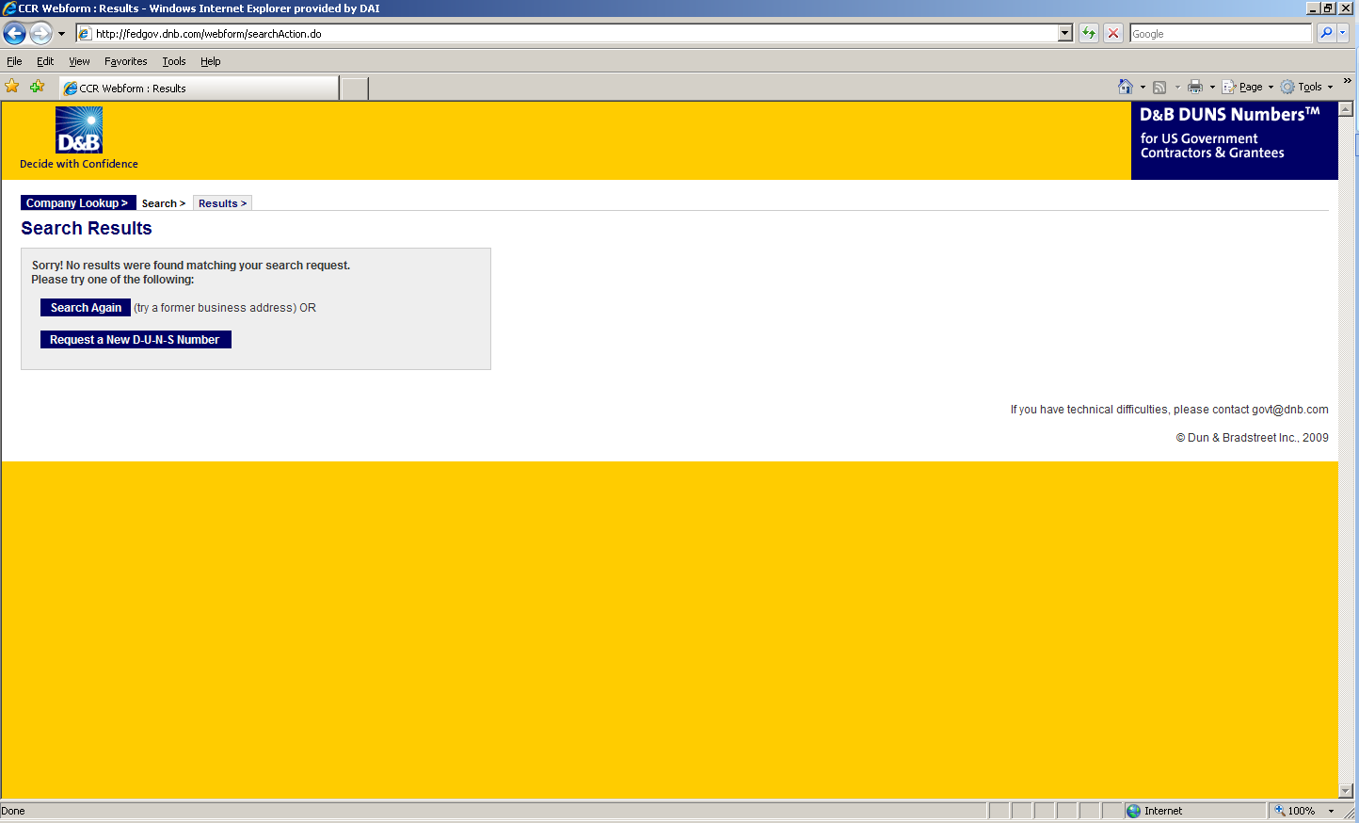
- Enter the information regarding your organization listed on the next three screens. (See screen shots below.) Make sure you have the following information available (in English) prior to beginning the process of entering this section in order to ensure successful registration.

- Legal Business Name (commas are allowed, periods are not allowed)
- Address
- Phone
- Name of Owner/Executive
- Total Number of Employees
- Annual Sales or Revenue (US Dollar equivalent)
- Description of Operations

- Note that some fields are Optional, however all other fields must be completed to proceed further with the application process. For example, all applicants must complete the Organization Information sections. The Company Name and Physical Address fields are self-populated based on information previously entered during the initial DUNS search. The question marks to the left of the field provide additional information when you click on them.
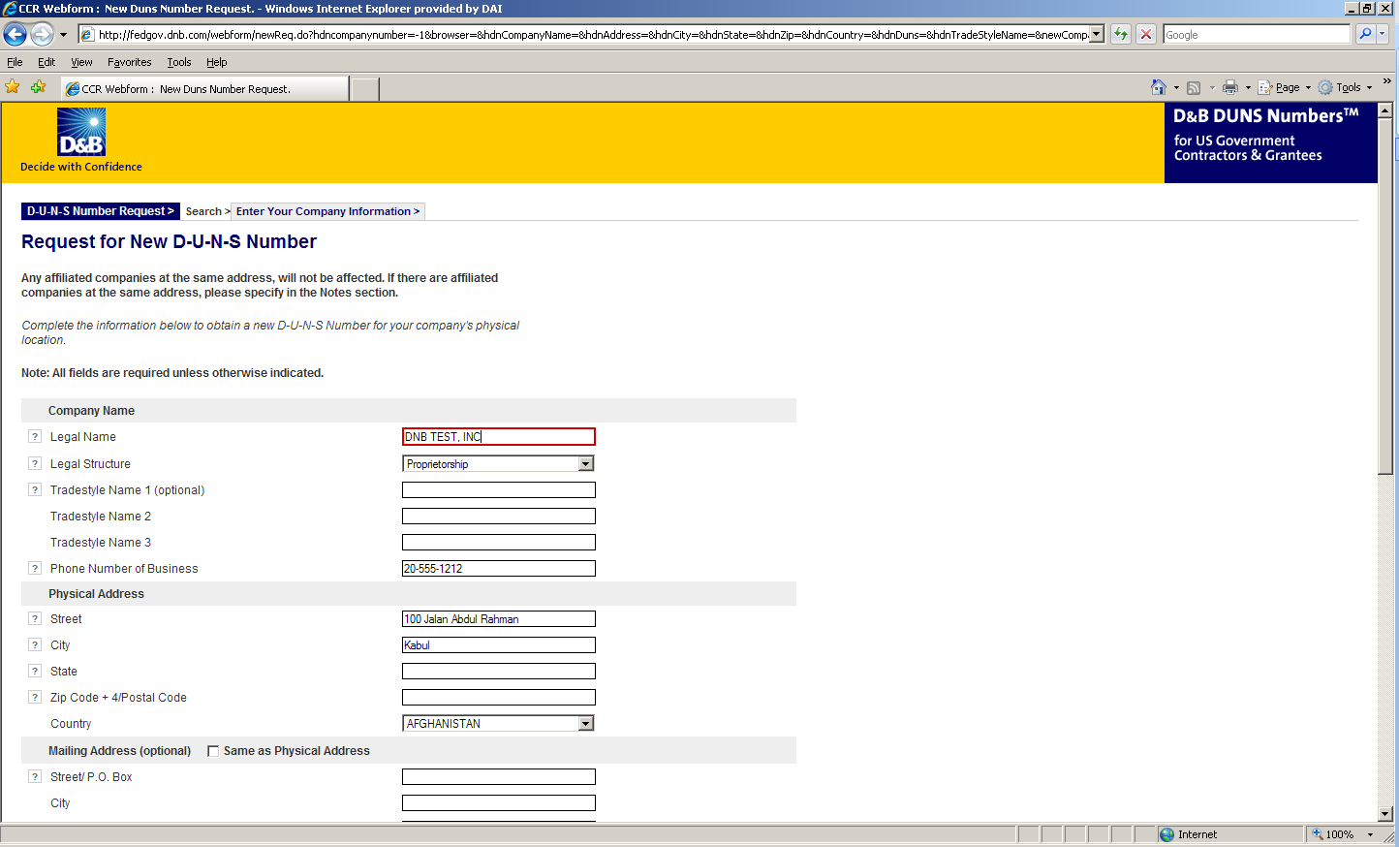

- You must select the legal structure of your organization from the pull down menu. To assist you in selecting the appropriate structure that best represents your organization, a brief description of the various types follows:

- Corporation – A firm that meets certain legal requirements to be chartered by the state/province in which it is headquartered by the filing of articles of incorporation. A corporation is considered by law to be an entity separate and distinct from its owners. It can be taxed; it can be sued; it can enter into contractual agreements.
- Government - central, province/state, district, municipal and other U.S. or local government entities. Includes universities, schools and vocational centers owned and operated by the government.
- Limited Liability Company (LLC) - This is a type of business ownership combining several features of corporation and partnership structures. It is designed to provide the limited liability features of a corporation and the tax efficiencies and operational flexibility of a partnership. Its owners have limited personal liability for the LLC’s debts and obligations, similar to the status of shareholders in a corporation. If your firm is an LLC, this will be noted on the organizations registration and licensing documents.
- Non-profit - An entity which exists for charitable reasons and is not conducted or maintained for the purpose of making a profit. Any money earned must be retained by the organization, and used for its own expenses, operations, and programs. Most organizations which are registered in the host country as a non-governmental organization (NGO) rather than as a commercial business are anon-profit entities.
Community based organizations, trade associations, community development councils, and similar entities which are not organized as a profit making organization should select this status, even if your organization is not registered formally in country as an NGO.
- Partnership- a legal form of operation in which two or more individuals carry on a continuing business for profit as co-owners. The profits and losses are shared proportionally.
- Proprietorship-These firms are owned by one person, usually the individual who has day-to-day responsibility for running the business. Sole proprietors own all the assets of the business and the profits generated by it.

- One of the most important fields that must be filled in is the Primary SIC code field. (See screen shot below.) The Primary Standard Industrial Code classifies the business’ most relevant industry and function.
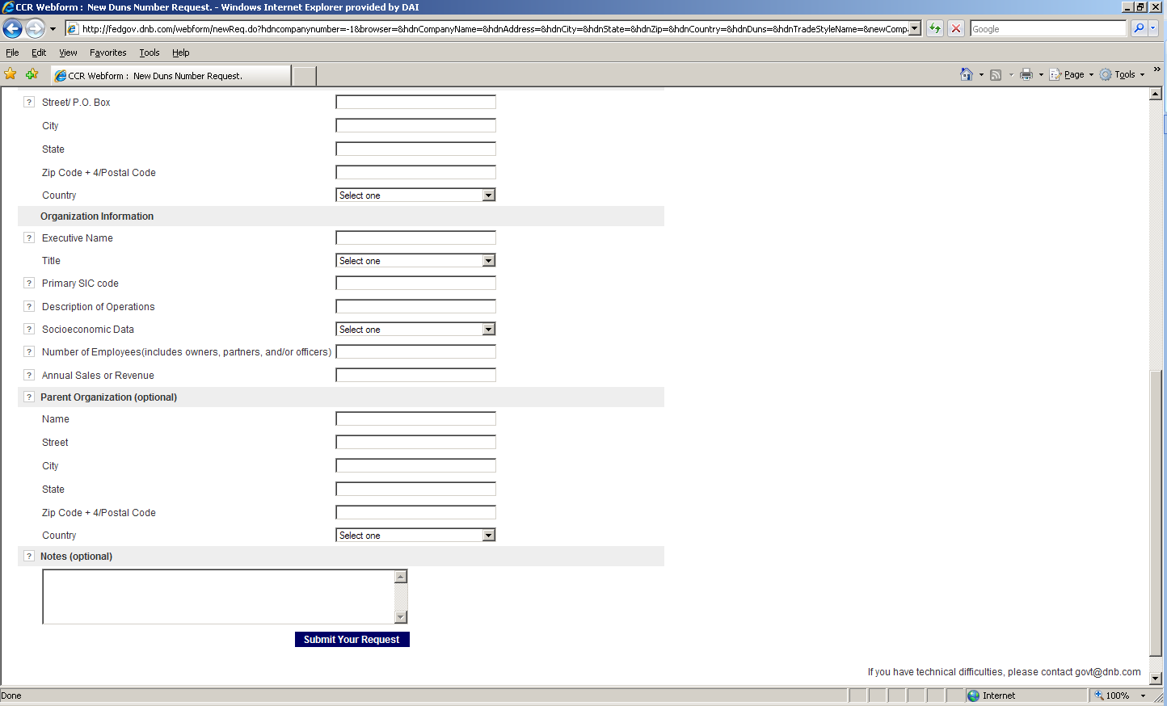
- If you are unsure of which SIC Code your organization’s core business falls under, please refer to the following website: http://www.osha.gov/oshstats/sicser.html
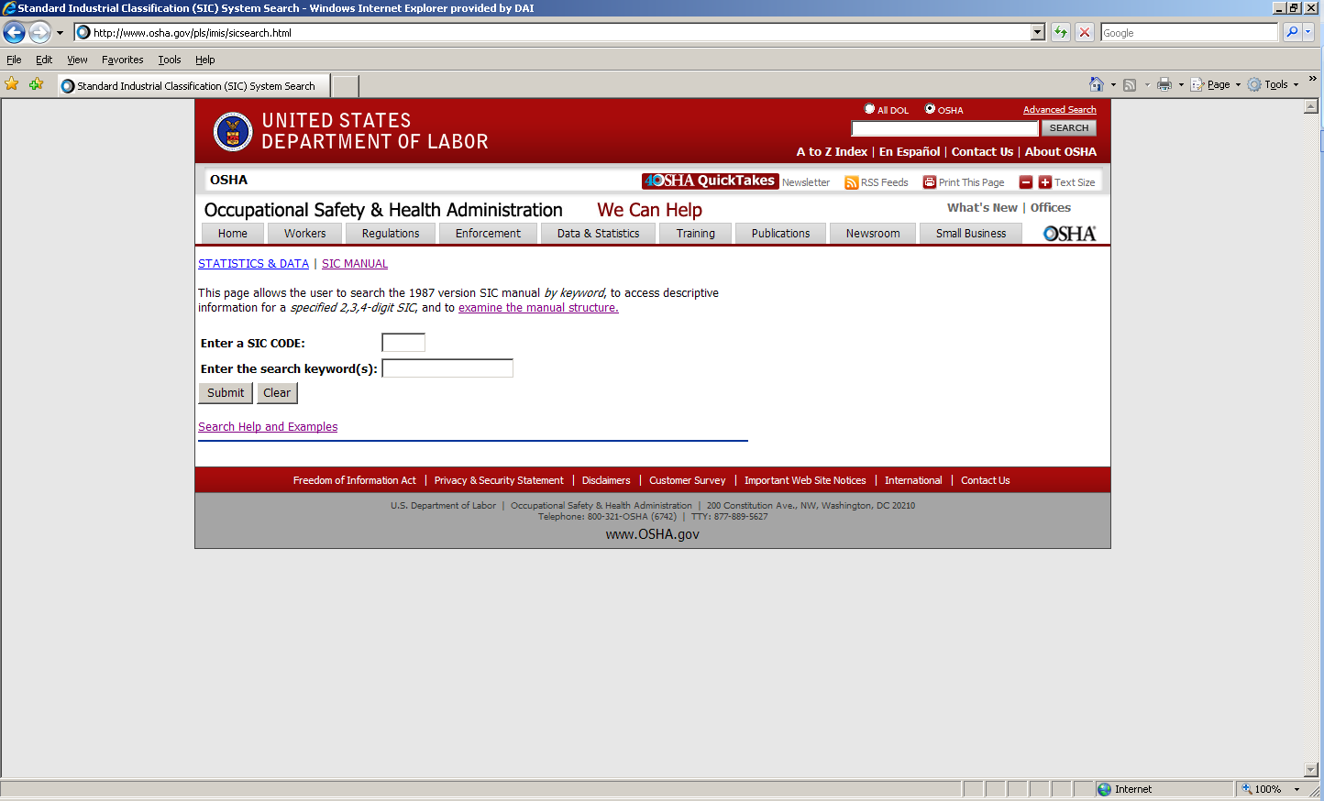

You will need to enter certain keywords to bring up the potential SIC Codes. In the case above, “Research” was entered as the keyword, and resulted in the following:
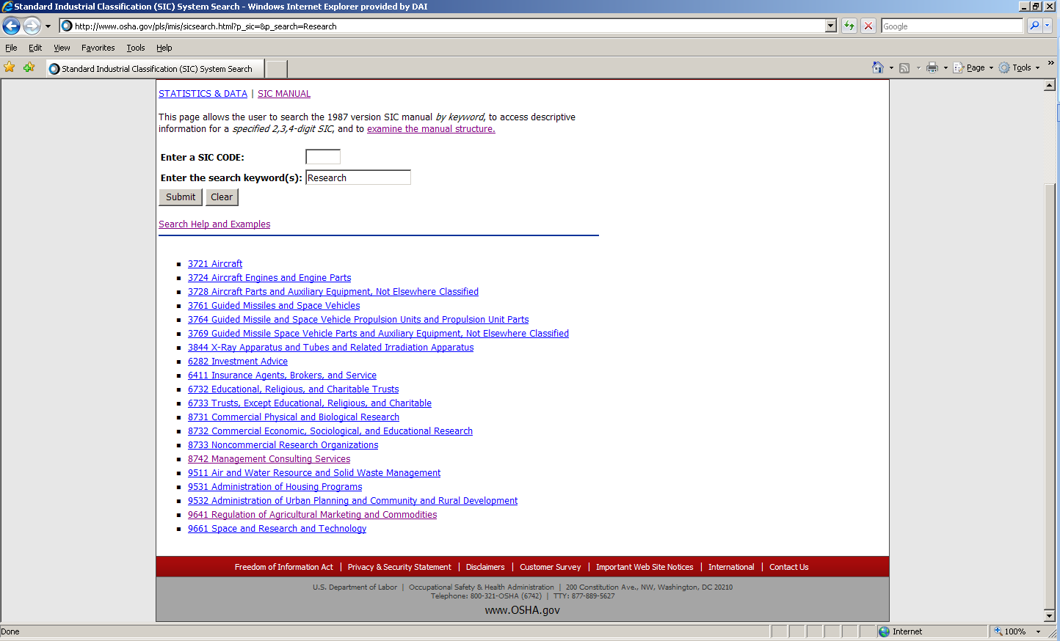

PLEASE NOTE: Many of the DAI subcontractors and grantees fall under one of the following SIC codes:
8742 Management Consulting Services
1542 General Contractors-Nonresidential Buildings, Other than Industrial Buildings and Warehouses or one of the codes within:
Industry Group 357: Computer And Office Equipment
Industry Group 355: Special Industry Machinery, Except Metalworking
Industry Group 356: General Industrial Machinery And Equipment
Industry Group 359: Miscellaneous Industrial And Commercial

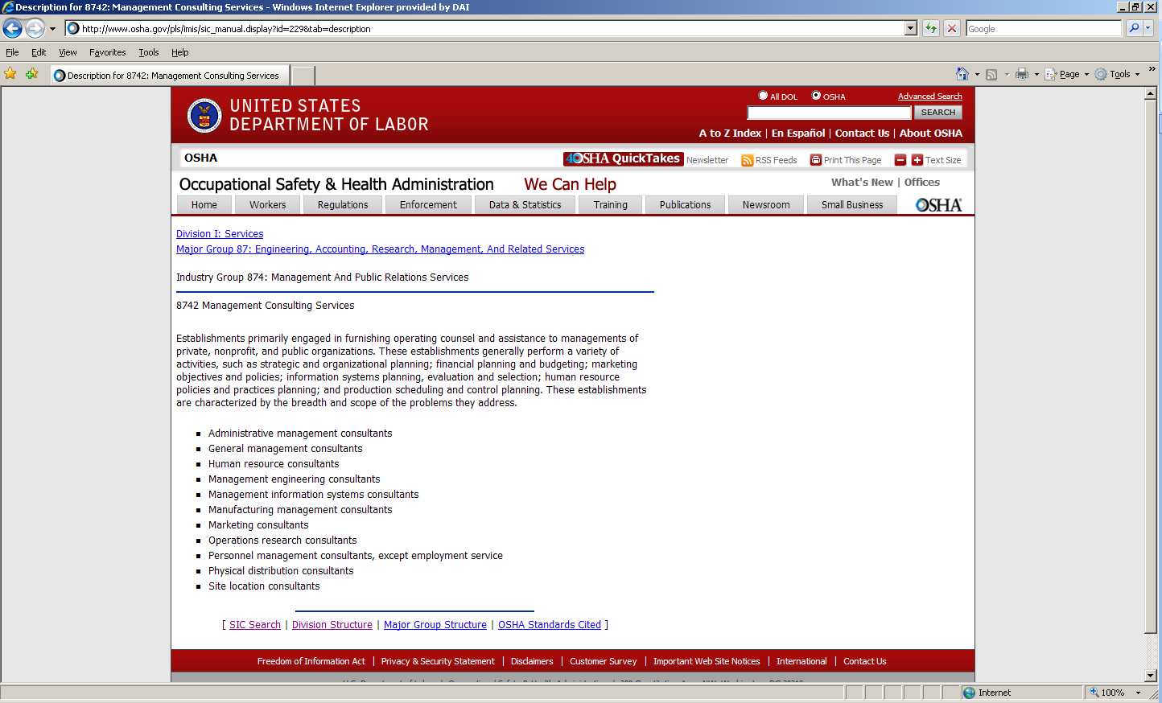

- Description of Operations- Enter a brief description of the primary services you provide the example below, “agricultural technical assistance” was chosen as the primary function of the business.
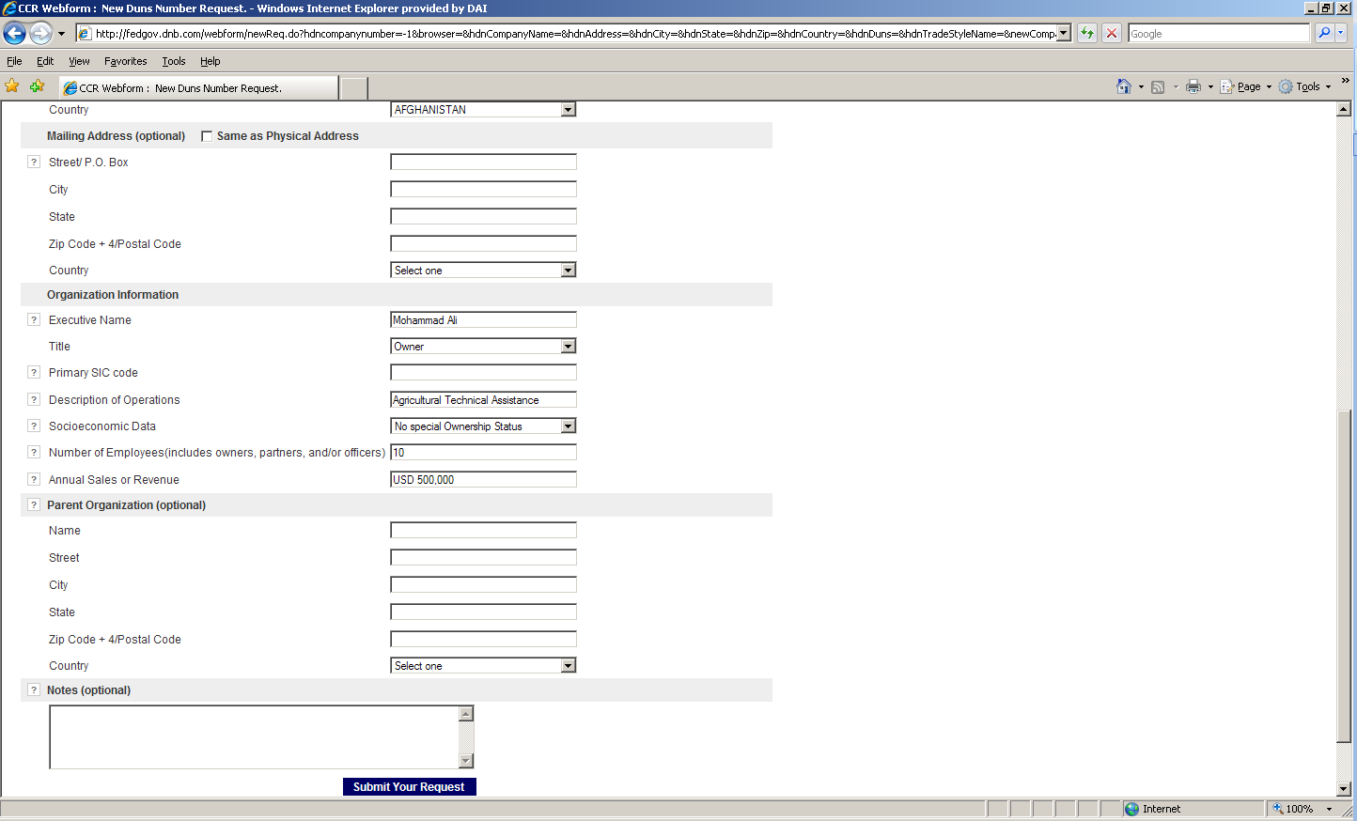

- The Annual Sales or Revenue figure should be provided in USD (US Dollar) equivalent.
- Once all of the fields have been completed, click on “Submit Your Request” to be taken to the Verification page.
- Note: Representative (Principal, Owner or Officer) needs to verify and provide affirmation regarding the accuracy of the data under criminal or civil penalties as per Title 18, Section 1001 of the US Criminal Code.
- Once “Yes, Continue” button is clicked, the registration application is sent to D&B, and a DUNS number should be available within 24-48 hours. DUNS database can be checked in 24-48 hours by entering the Business Information in the Search window – which should now display a valid result with the new DUNS number for the entity.
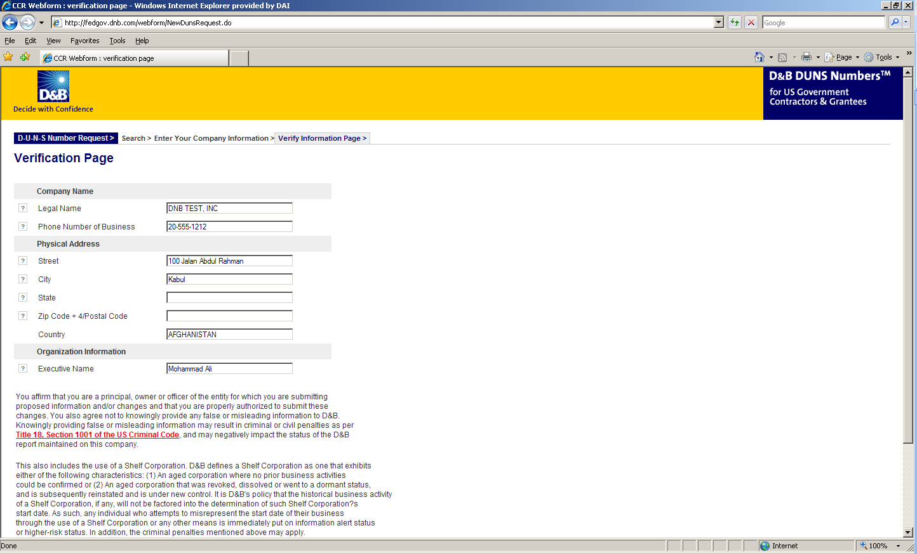

Attachment G: Self Certification for Exemption from DUNS Requirement

Legal Business Name:
Physical Address:
Physical City:
Physical Foreign Province (if applicable):
Physical Country:
Signature of Certifier
Full Name of Certifier (Last Name, First/Middle Names):
Title of Certifier:
Date of Certification (mm/dd/yyyy):

The sub-contractor/vendor whose legal business name is provided herein, certifies that we are an organization exempt from obtaining a DUNS number, as the gross income received from all sources in the previous tax year is under USD $300,000.

*By submitting this certification, the certifier attests to the accuracy of the representations and certifications contained herein. The certifier understands that s/he and/or the sub-contractor/vendor may be subject to penalties, if s/he misrepresents the sub-contractor/vendor in any of the representations or certifications to the Prime Contractor and/or the US Government.
The sub-contractor/vendor agrees to allow the Prime Contractor and/or the US Government to verify the company name, physical address, or other information provided herein. Certification validity is for one year from the date of certification.

List of Optional Attachments

Attachment H: Proposal Checklist

Offeror: __________________________________________________________________________
Have you?
Submitted your proposal to DAI in an electronic format as specified in the General Instructions above?
Does your proposal include the following?
Signed Cover Letter and required attachments (use template in Attachment B).
Separate Technical Cost Proposal:
- Technical Approach.
- Management, Key Personnel, and Staffing Plan.
- Corporate Capabilities, Experience, and Past Performance (use template in Attachment D).
Separate Cost Proposal (use template in Attachment C):
Registration documents as specified in the cover letter.

