REQUEST FOR PROPOSALS
RFP No. 243 (Eng. ver.)

Date: May 21, 2019

Subject:
Request for Proposals for procurement of equipment for sports ground for Dmytrivska CC (Kirovogradska oblast) in the framework of USAID funded DOBRE.

From |  | To
Global Communities, implementing agency of DOBRE Decentralization Offering Better Results and Efficiency Program financed by the United States Agency for International Development (USAID) (referred to as “BUYER” hereinafter) |  | Potential suppliers (referred to as “BIDDER” hereinafter)
Proposals Submission Time and Date: | The Proposal must be submitted for the attention of: |  | Conditions of Payment:
By 12:00 Kyiv time on June 04, 2019, at the latest | Global Communities  International Technical Assistance Program  “Decentralization Offering Better Results and Efficiency”  USAID DOBRE  Address:  5b, Dilova str., Office 510, 5th Floor, Kyiv, Ukraine  Email: dobreprocurement@globalcommunities.org |  | Post payment during 30 calendar days after delivery. If it is unacceptable, please indicate yours.

- TERMS OF REFERENCE

A. Global Communities invites you to submit proposals for procurement of equipment for sports ground for Dmytrivska CC (Kirovogradska oblast) as per the Specification attached as Annex B.

II. INSTRUCTIONS FOR POTENTIAL SUPPLIERS

- Form of Proposal

The proposal as well as all correspondence and documents exchanged between the Bidder and the Buyer under this RFP 243 shall be in English or Ukrainian.

The proposal must specify the following details and confirmations:

- The Proposal should be submitted on or before the deadline for this purpose, on a company letterhead, signed by an authorized representative and include the contact details of the Bidder.
- Conformity to technical specifications. The Bidder must confirm that all items are responsive to, or exceed, the estimated requirements.
- The Proposal must be valid for at least 30 calendar days from the proposal submission deadline date.
- Prices must be quoted in Ukrainian hryvnias (UAH).
- Prices must be quoted without the VAT. The Buyer is exempt from taxes within the customs territory of Ukraine and shall provide a certified copy of its registration card issued by the Ministry of Economic Development and Trade of Ukraine; The Buyer shall also provide a copy of its approved procurement plan.
- Price for each item. The price must be quoted as a total amount on an all-inclusive basis, including delivery to Dmytrivska CC (Kirovogradska oblast).
- Eligibility for participation in the tender.
  - To be eligible to submit a proposal in response to this RFP, the Bidder must conform to the requirements in this RFP.
  - The Bidder complies with the U.S. sanctions and embargo laws, including U.S. Executive Order 13224 on Terrorist Financing and U.S. laws that prohibit transactions with, and the provision of resources and support to, individuals or entities associated with terrorism. Any person or organization taking part in this tender as a bidder or a sub-contractor must certify and confirm together with submitting other documents that the person or organization is not listed on the U.S. Department of Treasury Office of Foreign Assets Control (OFAC) Specially Designated Nationals (SDN), and is eligible for participation in the tender. Global Communities must disqualify any offers from persons or organizations listed on the said OFAC SDN list or found not to be eligible for the participation in the tender on other grounds. Companies and persons listed on the Excluded Parties List System (www.epls.gov) are not eligible for receiving funds.
- The Buyer reserves the right to accept or reject any proposal, and to cancel the tender, reject all proposals at any time prior to the award without assuming any liability and without the duty to inform Bidders about reasons for Global Communities’ actions.

- This RFP may be modified by means of amendments. Copies of amendments shall be issued to all Bidders.

- Any order of services to be made on the basis of this Request for Proposal shall be subject to Global Communities General Terms and Conditions of Goods and Service Procurement Contracts.

11. The Buyer will not send any notices to Bidders with confirmation about proposals received. The Buyer will not send any notices to unsuccessful Bidders.

- Evaluation Criteria

Proposals will be evaluated in accordance with criteria listed below. First, the Buyer will evaluate proposals for meeting obligatory criteria to determine conformity to the requirements. While evaluating the proposal, the Buyer may seek additional information from any source it considers appropriate to obtain or confirm information about the Bidder’s proposal.

Following is an illustrative example of the criteria that might apply to evaluate proposals/bids.

- Conformity to the order list specification Acceptable/Unacceptable
- Validity of the proposal for 60 calendar days Acceptable/Unacceptable
- VAT exemption Acceptable/Unacceptable
- Eligibility for taking part in this RFP Acceptable/Unacceptable
- Warranty (not less than 12 months) Acceptable/Unacceptable
- Price 40 points
- Quality of proposal 15 points
- Terms of delivery 15 points
- Payment terms - Post payment during 30 calendar days after delivery 30 points

- Questions with regard to this RFP

All clarification requests shall be sent in writing to the addresses specified hereinabove by 12:00 pm on May 31, 2019, at the latest. Please refrain from personal visits and phone calls. Any information provided to one Bidder with regard to this RFP will be made available to all Bidders.

Sincerely,

Global Communities
“Decentralization Offering Better Results and Efficiency” International Technical Assistance Program
USAID DOBRE.

Annex A: Proposal Requirements

- Please confirm next mandatory requirements:
Conformity to the order list specification Acceptable/Unacceptable
Validity of the proposal for 60 calendar days Acceptable/Unacceptable
VAT exemption Acceptable/Unacceptable
Eligibility for taking part in this RFP Acceptable/Unacceptable
Warranty (12 months) Acceptable/Unacceptable
Post payment during 30 calendar days after delivery. Acceptable/Unacceptable
If payment conditions are unacceptable, please indicate yours

Please indicate delivery terms

- General information
Please fill the table with general information

Company name:
Code for Uniform State Register of Enterprises and Organisations (for legal entities) or Registration number of taxpayer's account (for private entrepreneur)
Address: | Postal code: | City: | Country:
P. O. Box and mailing address
Phone number:
E-mail:

Annex B: Specification.

## | Item descriptions | Images* | Unit of measure | Quantity
1. | «Orbitrek»  InterAtletika SM116 or equivalent. Characteristics:  length - 1396 mm, width - 566 mm, height - 1779 mm. | 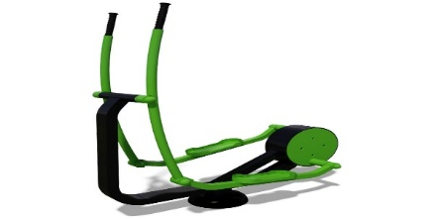 | pcs. | 2
2. | "Simulator for rowing"  InterAtletika SM135 or equivalent. Characteristics:  length - 987 mm, width - 824 mm, height - 902 mm. | 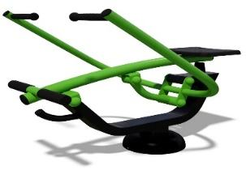 | pcs. | 2
3. | "Exercise-Bike"  InterAlettika SM139 or equivalent. Characteristics:  length - 1290 mm, width - 490 mm, height - 699 mm. | 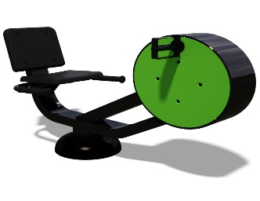 | pcs. | 2
4. | Interactive “Walkman”  InterAlettika SM115 or equivalent. Characteristics: length - 489 mm, width - 1012 mm, height - 1429 mm. | 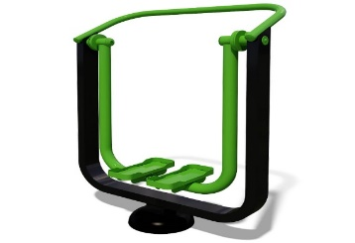 | pcs. | 2
5. | Simulator “Seating benched & Thrust on top.  InterAtletika SM101-102 or equivalent.  Characteristics:  length - 1563 mm, width - 930 mm, height - 1918 mm. | 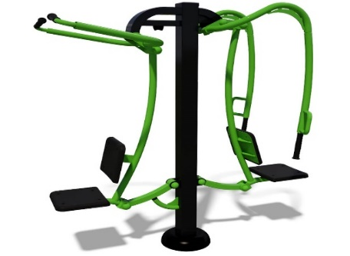 | pcs. | 2
6. | Exerciser for slit muscles and hip muscles  InterAtletika SM104 or equivalent. Characteristics:  length - 1055 mm, width -797 mm, height -1426 mm. | 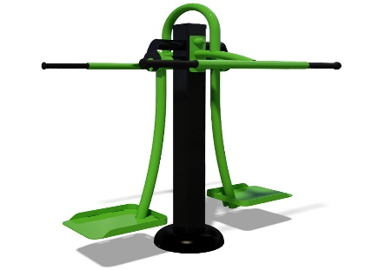 | pcs. | 2
7. | Multifitness-Gym  InterAtletika MF 5.4 or equivalent. Characteristics:  height - 2705 mm. | 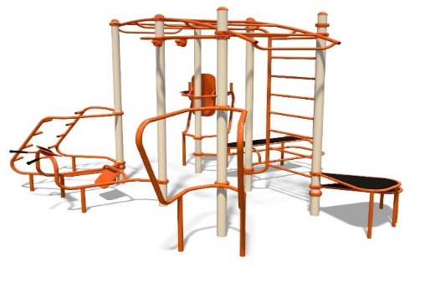 | pcs. | 2

* Images are given for information only, offers must contain similar items.

Annex C: Detailed Budget.

No. | Goods/Service Item | Quantity | Terms of Delivery (working days) | Warranty  (months) | Price in  Hryvnia  (UAH, without  VAT) | Total,  in Hryvnia  (UAH,  without  VAT)
1.
2.
3.
4.
5.
6.
7.
Total in UAH, without VAT

Signature:
(Seal)
Date:

