REQUEST FOR PROPOSAL (RFP)
RFP No. 238

Date: June 11, 2019

Subject:
Request for Proposals for procurement equipment for fairgrounds in Domanivska CC (Mykolaiivska oblast) in the framework of USAID funded DOBRE Program.

From |  | Whom
Global Communities, implementing agency of DOBRE Decentralization Offering Better Results and Efficiency Program financed by the United States Agency for International Development (USAID) (referred to as “BUYER” hereinafter) |  | Potential suppliers (referred to as “BIDDER” hereinafter)
Proposals Submission Time and Date: | The Proposal must be submitted for the attention of: |  | Conditions of Payment:
By 12:00 Kyiv time on June 19, 2019, at the latest | Global Communities  International Technical Assistance Program  “Decentralization Offering Better Results and Efficiency”  USAID DOBRE  Address:  5b, Dilova str., Office 510, 5th Floor, Kyiv, Ukraine  Email: dobreprocurement@globalcommunities.org |  | Post payment during 30 calendar days after delivery. If it is unacceptable, please indicate yours.

- TERMS OF REFERENCE

A. Global Communities invites you to submit proposals for procurement of equipment for fairgrounds in Domanivska CC (Mykolaiivska oblast) in the framework of USAID funded DOBRE as per the Specifications attached as Annexes B.1 and B.2 (by separate lots). The bidders can submit their offers on all the lots, as well as on each lot separately

II. INSTRUCTIONS FOR POTENTIAL SUPPLIER

- Form of Proposal
The proposal as well as all correspondence and documents exchanged between the Bidder and the Buyer under this RFP 238 shall be in English or Ukrainian.

The proposal must specify the following details and confirmations:

- The Proposal should be submitted on or before the deadline for this purpose, on a company letterhead, signed by an authorized representative and include the contact details of the Bidder.
- Conformity to technical specifications. The Bidder must confirm that all items are responsive to, or exceed, the estimated requirements.
- The Proposal must be valid for at least 60 calendar days from the proposal submission deadline date.
- Prices must be quoted in Ukrainian hryvnias (UAH).
- Prices must be quoted without the VAT. The Buyer is exempt from taxes within the customs territory of Ukraine and shall provide a certified copy of its registration card issued by the Ministry of Economic Development and Trade of Ukraine; The Buyer shall also provide a copy of its approved procurement plan.
- Price for each item. The price must be quoted as a total amount on an all-inclusive basis, including delivery and assembly to Domanivska CC (Mykolaiivska oblast).
- Eligibility for participation in the tender.
  - To be eligible to submit a proposal in response to this RFP, the Bidder must conform to the requirements in this RFP.
  - The Bidder complies with the U.S. sanctions and embargo laws, including U.S. Executive Order 13238 on Terrorist Financing and U.S. laws that prohibit transactions with, and the provision of resources and support to, individuals or entities associated with terrorism. Any person or organization taking part in this tender as a bidder or a sub-contractor must certify and confirm together with submitting other documents that the person or organization is not listed on the U.S. Department of Treasury Office of Foreign Assets Control (OFAC) Specially Designated Nationals (SDN), and is eligible for participation in the tender. Global Communities must disqualify any offers from persons or organizations listed on the said OFAC SDN list or found not to be eligible for the participation in the tender on other grounds. Companies and persons listed on the Excluded Parties List System (www.epls.gov) are not eligible for receiving funds.
- The Buyer reserves the right to accept or reject any proposal, and to cancel the tender, reject all proposals at any time prior to the award without assuming any liability and without the duty to inform Bidders about reasons for Global Communities’ actions. In this case, the Buyer shall not be liable to the Applicant or the Applicants or bear any obligation to inform the Applicant or Applicants of the reasons for such Program actions.

- This RFP may be modified by means of amendments. Copies of amendments shall be issued to all Bidders.

- Any order of services to be made on the basis of this Request for Proposal shall be subject to Global Communities General Terms and Conditions of Goods and Service Procurement Contracts.

11. The Buyer will not send any notices to Bidders with confirmation about proposals received. The Buyer will not send any notices to unsuccessful Bidders.

- Evaluation Criteria

Proposals will be evaluated in accordance with criteria listed below. First, the Buyer will evaluate proposals for meeting obligatory criteria to determine conformity to the requirements. While evaluating the proposal, the Buyer may seek additional information from any source it considers appropriate to obtain or confirm information about the Bidder’s proposal.

Following is an illustrative example of the criteria that might apply to evaluate proposals/bids.

- Conformity to the order list specification Acceptable/Unacceptable
- Validity of the proposal for 60 calendar days Acceptable/Unacceptable
- VAT exemption Acceptable/Unacceptable
- Eligibility for taking part in this RFP Acceptable/Unacceptable
- Warranty (not less than 12 months) Acceptable/Unacceptable
- Prices 40 points
- Delivery time 15 points
- Quality of proposal 15 points
- Terms of payment – Post payment during 30 banking days after delivery 30 points

- Questions with regard to this RFP

All clarification requests shall be sent in writing to the addresses specified hereinabove by 12:00 pm on June 14, 2019, at the latest. Please refrain from personal visits and phone calls. Any information provided to one Bidder with regard to this RFP will be made available to all Bidders.

Sincerely,

Global Communities
“Decentralization Offering Better Results and Efficiency” International Technical Assistance Program
USAID DOBRE

Annex A Proposal Requirements

- Please confirm next mandatory requirements:
Conformity to the order list specification Acceptable/Unacceptable
Validity of the proposal for 60 calendar days Acceptable/Unacceptable
VAT exemption Acceptable/Unacceptable
Eligibility for taking part in this RFP Acceptable/Unacceptable
Warranty (12 months) Acceptable/Unacceptable
Post payment during 30 (thirty) calendar days after delivery. Acceptable/Unacceptable
If payment conditions are unacceptable, please indicate yours

Please specify delivery date

- General information
Please fill the table with general information
Company name:
Code for Uniform State Register of Enterprises and Organisations (for legal entities) or Registration number of taxpayer's account (for private entrepreneur)
Address: | Postal code: | City: | Country:
P. O. Box and mailing address
Phone number:
E-mail:

Annex B.1: Specification. Commercial booths.
## | Descriptions of the goods | Images* | Unit of measure | Quantity
1. | Stylized, wooden, commercial booths size 4x3 m:  Characteristics:  The thickness of the wall is 43mm.  Height of walls - 2m.  The maximum height is 2.7 m.  The ceiling is a lintel.  Chemical processing and decorative wood coating - "Adler" (Austria) or analogue. The booths should be made of high quality coniferous wood. The kit includes: walls, roof (bitumen or metal skinned), fastening materials, treatment with protective and decorative impregnations, electrical wiring.  Project doesn’t include installation services. The winner should provide the structure installation layout. | 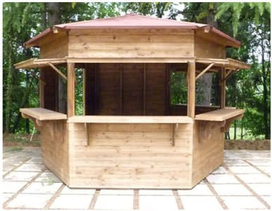 | pcs | 8
 |  | 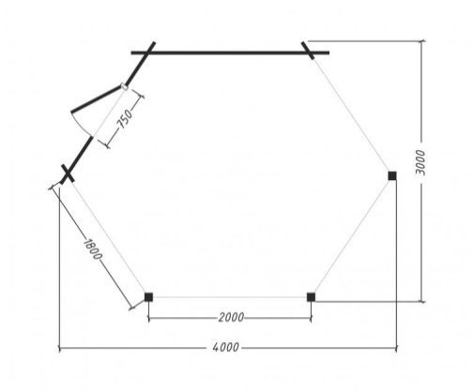

* The images are provided for information only, the proposals must contain similar or equivalent items.

Annex B.2: Specification. Scene.
## | Descriptions of the goods | Images* | Unit of measure | Quantity
1. | Scene for events with portals:  The kit should consist of:  - scenes: metal construction L 6 * W 8 * H 6 m;  - flooring podium: moisture-resistant plywood in the thickness of 18mm (48 m2);  - roof: PVC fabric (54 m2);  - portals (2 pieces): metal construction  2.5 * 2.5 * 6m;  - ladders with a handrail.  Characteristics: podium height 1m. with regulating supports up to 15 cm. Frame material - steel profile tube. Anticorrosion coating - three-component hammer paint.  Complete technical specification:  Farmstead podium main - 20pcs;  Farmhouse Podium auxiliary - 6 pcs;  The farm had a podium - 4 pcs;  Jumper for podium - 45 pcs;  Plywood laminated - 15pcs;  Leg support (1m.) - 16pcs;  Farm arch - 8 pcs;  Roof side farm - 4pcs;  Bolt 8x6mm - 4pcs;  Nut m 8 - 50pcs;  Blocks - 4 pcs;  Awning covering roof - 6m x 9m;  Roof clamp - 4 pcs.  Stairs with handrails - 1 set;  Farm Stand 400x400x3000 - 8pcs;  Cross supports - 4 pcs;  Portals design - 2 pcs. | 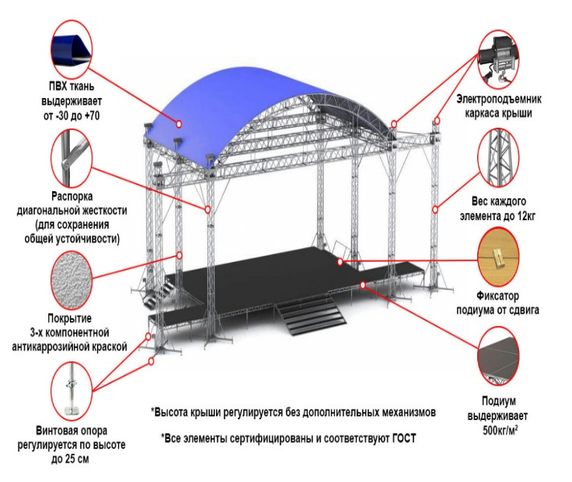 | pcs | 1

* The images are provided for information only, the proposals must contain similar or equivalent items.

Annex C.1: Detailed Budget

No. | Goods/Service Item | Quantity | Terms of Delivery (working days) | Warranty  (months) | Price in  Hryvnia  (UAH, without  VAT) | Total,  in Hryvnia  (UAH,  without  VAT)
1.
2.
3.
Total in UAH, without VAT

Annex C.2: Detailed Budget

No. | Goods/Service Item | Quantity | Terms of Delivery (working days) | Warranty  (months) | Price in  Hryvnia  (UAH, without  VAT) | Total,  in Hryvnia  (UAH,  without  VAT)
1.
2.
3.
Total in UAH, without VAT

Signature:

seal

Date:

