Find your path!

We are looking for a partner: EVS accredited sending organizations for “Find your path!” project. It’s a long term, 12 months project. The main idea is to create a space and support in personal development in “mini-projects” described as a path, for every interested volunteer.
Flexibility is one of common expectations among the employer nowadays. That’s why our future volunreers can combine different “mini-projects” into one or participate only in parts.

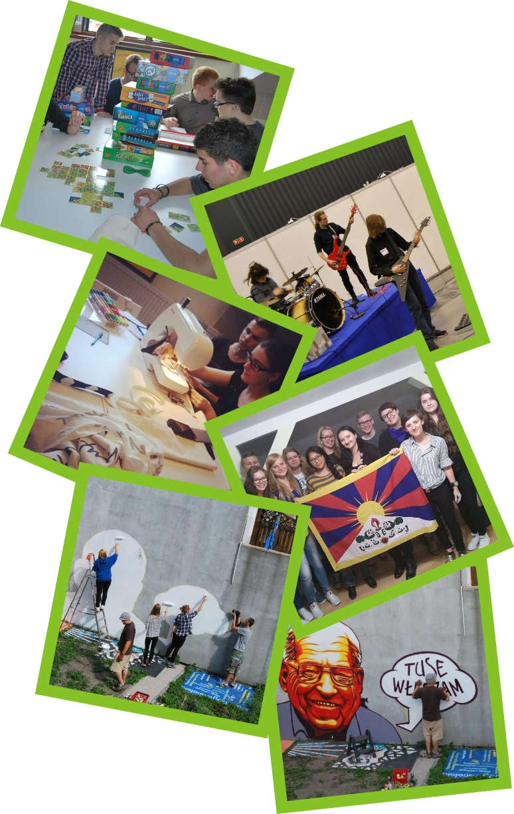
Human Rights
- organizing Amnesty Internationals “Letter Writing Marathon” event
- organizing „16 days against gender violence” event
- organizing a „Human Library” event
- organizing a “Free Tibet Day” event
- planning and conducting a social campaign
- planning and conducting workshops and meetings

Animation Zone
- organizing „Street Fest” – outdoor city event
- multicultural workshops
- outdoor city happenings and events
- local community activation
- street-art

Voluntary Service
- promotional campaign
- recruitment campaign
- open lessons in schools
- one-time voluntary actions
- European voluntary service

Social Inclusion
- youth intervention/prevention actions
- support in training flat
- social campaign

ArtLab
- serigraphy and appropriable crafts workshop
- art. classes
- art. encouragment workshops

VOLUNTEER PROFILE

We are searching for open minded people aged between 18-29! If You like to work in a new environment, take part in many different activities and learn using non-formal methods – we are indeed searching for You!

Tczew is a lovely small town in Poland situated about 40 minute train ride from Tricity – a big region of three cities near the Baltic Sea. We operate on daily basis in our city and in regions all around, we have many partners, many initiatives and a LOT to do!

The project entitled “Find Your Path” is a year long activity for You to combine several mini-projects into one and learn as much as possible from us, Your peers and other groups! Human Rights, Animation Zone, Voluntary Service, Social inclusion and ArtLab – these are the mini-projects titles – please look at the enclosed Volunteer Offer for details.

We are looking for 4 volunteers who are curious, sensitive and enjoy getting to know new things. If You are eager to help, open-minded, communicative, easy-going and have a certain vision of Your own development – please apply! We are looking for someone to reinforce our team!

The main angle and objective of the Project is to build Your social and professional competences through independent implementation of actions regarding social inclusion and social activity – all based on an Individual Development Plan.

Individual Development Plan will be a part of Your path – a personal plan adjusted for You with a help of a Mentor. Mentor will help You along the way of Your path and so will other members of our team.

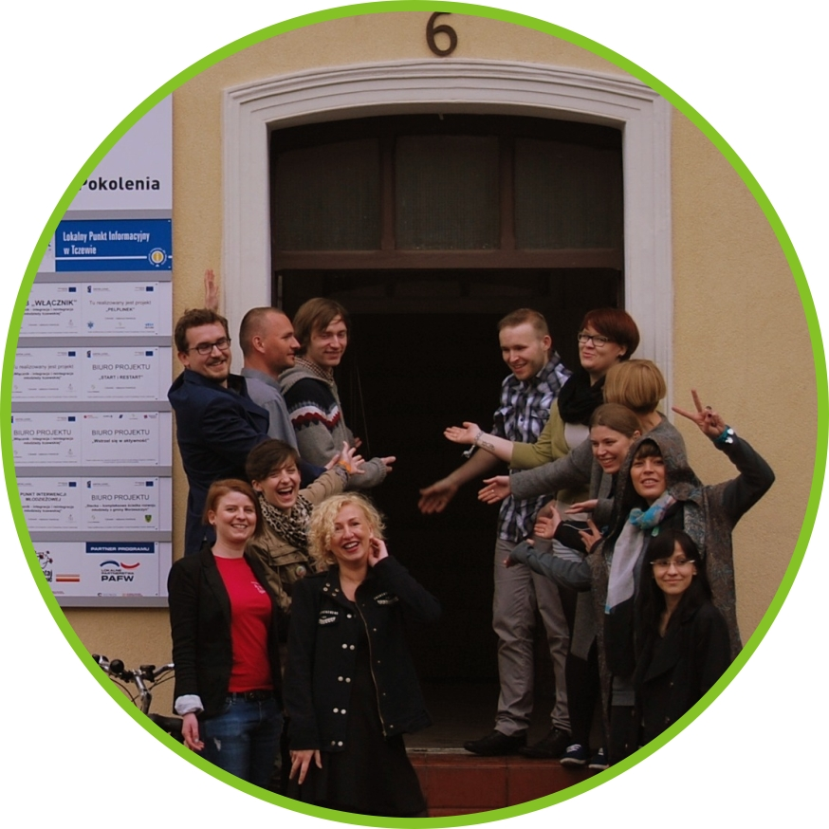
Who WE are?

We are “Generations Foundation”, an
energetic, 13 year old, NGO that works
on behalf of civil society, youth and other
organizations. We are based in Tczew-Poland.

Our actions focus on two main areas: supporting the youth alongside NGO’s and informal groups. We conduct training courses, meetings and seminars. We work as a Centre for the NGOs, supporting local initiatives also by conducting two big grant programmes. We build, help and support local communities and leaders not only in our city but also in the rural regions.

The second main area of our activities is helping the youth through various and innovative actions. We combine many tools like three scholarship programmes and many European Union projects supporting socially excluded youth and young people endangered by social exclusion. Both groups come from relegated area of Tczews Old Town or structurally weak areas of Tczew County.

In our Team we have a street-art artist running our serigraphy and appropriable crafts workshop, where young people can create something on their own. We also assist in the time of need for the youth providing a place where they can stay during emergencies. We also have a group of streetworkers and partyworkers taking care of the young in the clubs and on the street.

Non-formal education is always present in our actions, when it comes to projects, initiatives and youth activities. We encourage different forms of learning, typically by praxis, believing that young people can achieve better effects through hands-on approach. Trainings, workshops, communication and self-development – these are areas that we actively support.

Local Amnesty International group is operating within our organization, organizing events like Letter Writing Marathon, Watch Docs movie festival and other initiatives defending human rights and making sure young people know and care about the issue. By these actions, including youth exchange programmes, and study visits, we also support important multicultural angle of our youth actions.

We also promote active citizenship and political life, by permanently taking part in “Masz Głos, Masz Wybór” programme. One of organizations that we are incubating is Volunteer Centre Foundation. We are cooperating during the events, crowd animation and many, many initiatives.

CONTACT US FOR AN ADVENTURE OF YOUR LIFETIME!
E: biuro@fundacjapokolenia
T: (+48) 58 352 45 46
F: www.facebook.com/fundacja.pokolenia

